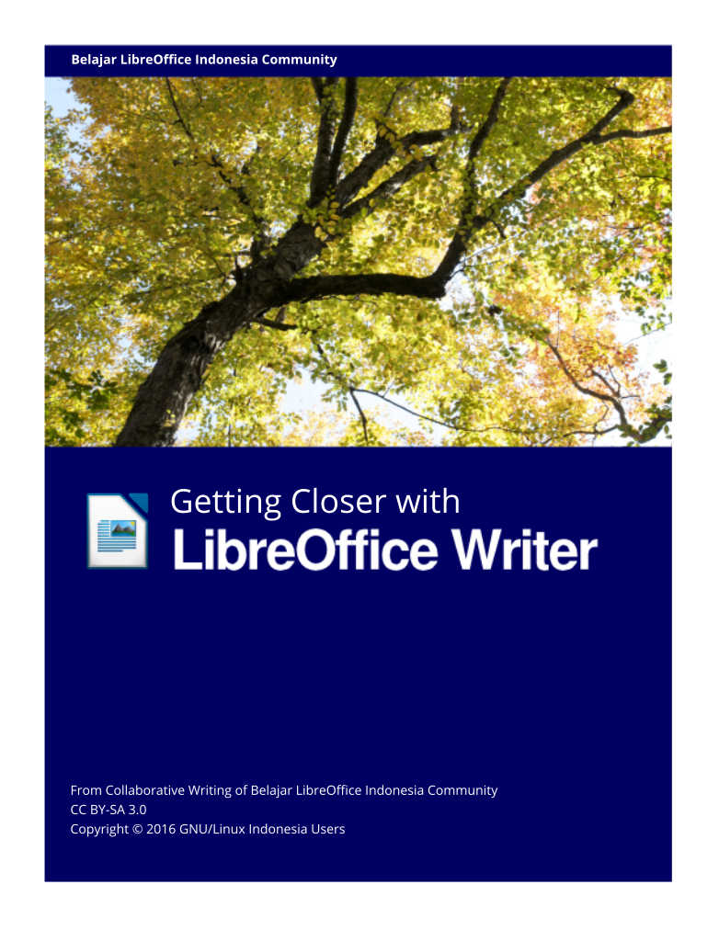

Getting Closer With LibreOffice Writer

From Collaborative Writing of Belajar LibreOffice Indonesia Community
CC BY-SA 3.0
Copyright © 2016 GNU/Linux Indonesia Users

PREFACE

Bismillahirrahmaanirrahim.

This book aims to be one of resources for people who want to go deep into and get more knowledge in term of LibreOffice Writer. It titled “Getting Closer With LibreOffice Writer” which we dedicate for All Indonesian people. This book has two versions, mobile and ready-to-print version which mobile has … pages and ready-to-print has 225 pages. This book has been collaboratively written by 1 cover contributor, 6 Language editors, 3 book editors, 15 chapter writers and 12 chapter Translator.

Change Log
- Coordinator of project Taufik Hidayat <yumtaufik1997@gmail.com> was planning Collaborative book project “Getting Closer With LibreOffice Writer”
- The project was introduced on Belajar GNU/Linux Indonesia Telegram group on 29 June 2016.
- The Collaborative book project was started on 16 July 2016 by Taufik Hidayat <yumtaufik1997@gmail.com> and was officially launched on Belajar GNU/Linux Indonesia Telegram group to invite all members contribute to this project.
- Each chapter in the book was composed systematically based on contributor’s submission. This was done to maintain respectful from all contributors.

Objective
The main goal of this project is to serve handy book for beginner especially for those who just started learning Office Suite software in GNU/Linux. Besides, it also promotes Free software to avoid illegal usage of software (worst explanation is “piracy”) issues through using Free Software LibreOffice. We believe the issues have significant implication in our belief and personality.

Method
This book has been cooperatively written by all contributor from different region in Indonesia. It has inspired and motivated us to conduct this project continuously.

Deadline
Deadline project was on 30 October 2016.

Expectancy
Through this E-book, People from all region in Indonesia can print ant share it easily with no high cost. We expect this book will inspire other Community-based organization conducting similar collaborative projects. Just imagine, every FOSS-based community in Indonesia conduct the same, it will give enough local resources to educate people in term of “importance of FOSS”.

Closure
Finally, we really appreciate all contributor respectively for IRC #ubuntu-indonesia, Inkscape Indonesia community on Facebook, Belajar GNU/Linux Indonesia community on Telegram, collaborative book project contributor and all people which we can not mention it one by one.
We do apologize to all reader if we have made any mistakes through this book. We deliberately understand that this book need improvement. We really consider your feedback to get this book better.

Sincerely,
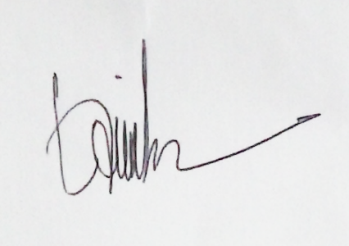

Taufik Hidayat
(Coordinator Project)

THE CONTRIBUTORS

This book was collaboratively composed by LibreOffice Indonesia community through Internet as medium. The contributors was introduced below.

Cover Designer
Ade Malsasa Akbar <teknoloid@gmail.com>

Language Editors
- Ahmad Romadhon Hidayatullah <reaamina@gmail.com> (Chapter 1 dan Chapter 4)
- Ade Malsasa Akbar <teknoloid@gmail.com> (Chapter 1 dan Chapter 2)
- Nugroho <nugroho.redbuff@gmail.com> (Chapter 21)
- Faiq Aminuddin <dampuawang@gmail.com> (Chapter 1 s/d Chapter 29)
- Taufik Hidayat <yumtaufik1997@gmail.com> (Chapter 4 dan Chapter 7)
- Andhika Prasetyo <chupunk3@gmail.com> (Chapter 5)

Book Editors
- Taufik Hidayat <yumtaufik1997@gmail.com>
- Nur Kholis <khokunsmile@gmail.com>
- Abdul Aziz <ingejosmu1048576@gmail.com>

The Writers
- Ade Malsasa Akbar <teknoloid@gmail.com> (Chapter 1, Chapter 2, Chapter 6, Chapter 7 dan Chapter 18)
- Muhammad Yuga Nugraha <myugan59@gmail.com> (Chapter 3)
- Mochammad Nur Afandi <muh.afandi.fandi@gmail.com> (Chapter 8)
- Mukafi <kakafi30@gmail.com> (Chapter 4 dan Chapter 9)
- Taufik Hidayat <yumtaufik1997@gmail.com> (Chapter 5, Chapter 10, Chapter 12, Chapter 13, Chapter 14 dan Chapter 17)
- Anto Samalona <ansamsoftdev@gmail.com> (Chapter 11)
- Sasongko Bawono <sasongko262@gmail.com> (Chapter 15 dan Chapter 16)
- Nur Kholis <khokunsmile@gmail.com> (Chapter 19, Chapter 25 dan Chapter 27)
- Azis Rahmat Pratama <azis.pratama@gmail.com> (Chapter 20)
- Azid <paindustry@yahoo.com> (Chapter 21)
- Sukamto <kamtono@gmail.com> (Chapter 22)
- Buono <kangbuono@gmail.com> (Chapter 23 dan Chapter 26)
- Rahmat Kafabih (Kafabih/KR) <kafalterbang@gmail.com> (Chapter 24)
- Muhammad Irwan Andriawan <andriawan2014@gmail.com> (Chapter 28)
- Taufik Mulyana <nothinux@nothinux.id> (Chapter 29)

The Translators
- <ari> (Chapter 26)
- Thoriq Kemal <thoriqcemal@gmail.com> (Chapter 12, Chapter 13, Chapter 25)
- Astrida Atni Ayu Mahardini <astriddini7@gmail.com> (Chapter 5, Chapter 17, Chapter 18, Chapter 19, Chapter 22)
- Azis R. Pratama <azis.pratama@gmail.com> (Chapter 20, Chapter 23
- Faiq Aminuddin <faiq.aminuddin.demak@gmail.com> (Chapter 15)
- Ilham Akbar <ilhamsahil05@gmail.com> (Chapter 6, Chapter 7, Chapter 14)
- kucingsebelah <meongpus@hi2.in> (Chapter 11, Chapter 16)
- Mochammad Nur Afandi <localanu@gmail.com> (Chapter 8)
- Muhammad Fathurridlo <mfathurridlo@gmail.com> (Chapter 1, Chapter 3, Chapter 4)
- Muhammad Irwan Andriawan <andriawan2014@gmail.com> (Preface, The Contributors, Technical Book Preparation, Chapter 24, Chapter 27, Chapter 28, Chapter 29)
- Raymon Rahmadhani <raymon.rahmadhani@gmail.com> (Chapter 2, Chapter 9, Chapter 10)
- Risma Fahrul Amin <rismafahrulamin@gmail.com> (Chapter 21)

TECHNICAL BOOK PREPARATION

This part was written as technical guide for all designate writers of this book.
Deadline | 30 October 2016
Book scope | LibreOffice Writer
Pages count | 220 pages
Font | Liberation Serif
Font size | 12 pt
Space | 1,5
Alignment | Justified
Format | This Document should be written in .odt format (LibreOffice, OpenOffice, Calligra Office)
LibreOffice Version | 4.x s/d 5.x
Minimum Contribution | One chapter per contributor

If you desire to write a chapter, we recommend using standard LibreOffice Writer version 4.x s/d 5.x. You are not confined using any kind of GNU/Linux distros in contributing a chapter.
Heading of chapter should use heading 1, for example chapter 1 Introducing LibreOffice. For sub-chapter, you should use heading 2, for example explaining LibreOffice History. Under sub-chapter, you should enclose Copyright © 2016 <your name> <your email>. Just write down your experience. Never wait something which does not exist yet. For further explanation, please refer to each existing chapter.

TABLE OF CONTENTS
PREFACE iii
THE CONTRIBUTORS vi
Cover Designer vi
Language Editors vi
Book Editors vi
The Writers vii
The Translators vii
TECHNICAL BOOK PREPARATION ix
TABLE OF CONTENTS x
CHAPTER 1 INTRODUCTION TO LIBREOFFICE 1
LibreOffice 1
The History of LibreOffice 2
LibreOffice’s License 3
LibreOffice and Microsoft Office Program Comparison 4
LibreOffice Features 4
Interface 5
LibreOffice Versions 6
Important References 7
User Guides from The Community 8
CHAPTER 2 INTRODUCING TO OPENDOCUMENT FORMAT 9
Introduction 9
The Table of ODF and Its Programs 10
Comparison between ODF and Microsoft Format 11
The Table of the Alternative ODF Based Programs 12
The Table of Free Office Suite Program as a LibreOffice Alternative 12
The Table of Proprietary Softwares which Support ODF 13
CHAPTER 3 INTRODUCTION TO LIBREOFFICE WRITER INTERFACE 14
CHAPTER 4 INTRODUCTION TO LIBREOFFICE WRITER SIDEBAR 16
Sidebar 16
Properties 17
Character 17
Paragraph 19
Page 20
CHAPTER 5 GETTING ACQUAINTED WITH THE MENU BAR IN LIBREOFFICE WRITER 21
The File Menu 21
Sub-Sub Menu New 23
Sub-Sub Menu Recent Documents 25
Sub-Sub Menu Wizards 25
Sub-Sub Menu Templates 26
Sub-Sub Menu Send 27
The Menu Edit 29
Sub-Sub Menu Selection Mode 30
Sub-Sub Menu Changes 31
The View Menu 32
Sub-Sub Menu Toolbars 34
Sub-Sub Menu Zoom 36
The Insert Menu 37
Sub-Sub Menu Fields 38
Sub-Sub Menu Header 40
Sub-Sub Menu Footer 41
Sub-Sub Menu Indexes and Tables 42
Sub-Sub Menu Image 43
Sub-Sub Menu Object 44
The Menu Format 45
Sub-Sub Menu Change Case 47
Sub-Sub Menu Autocorrect 48
Sub-Sub Menu Anchor 49
Sub-Sub Menu Wrap 50
Sub-Sub Menu Alignment 51
Sub-Sub Menu Arrange 52
Sub-Sub Menu Flip 53
Sub-Sub Menu Rotate 54
Sub-Sub Menu Group 55
Sub-Sub Menu Object 56
The Menu Table 57
Sub-Sub Menu Insert 59
Sub-Sub Menu Delete 59
Sub-Sub Menu Select 60
Sub-Sub Menu AutoFit 61
Sub-Sub Menu Convert 62
The Tools Menu 63
Sub-Sub Menu Language 65
Sub-Sub Menu Update 67
Sub-Sub Menu Macros 68
Menu Window 69
Menu Help 70
CHAPTER 6 HEADING 72
Heading 72
Applying Heading 72
Appearance of The Writing 73
Appearance of Automatic Index 73
Appearance of PDF 74
CHAPTER 7 SHORTCUTS ON LIBREOFFICE WRITER 76
CHAPTER 8 COMPATIBILITY 78
LibreOffice Writer 78
LibreOffice Calc 78
LibreOffice Impress 78
CHAPTER 9 HOW TO WRITE ARABIC IN LIBREOFFICE WRITER 79
CHAPTER 10 CREATING AN AUTOMATIC TABLE OF CONTENT 83
CHAPTER 11 PAGE FORMATTING 88
Setting Margins 88
Setting the Line Spacing 89
Page Numbers 92
CHAPTER 12 INSERTING PICTURE ON LIBREOFFICE WRITER 95
CHAPTER 13 CREATING TABLE ON LIBREOFFICE WRITER 97
CHAPTER 14 SAVING THE DOCUMENT AS A PDF FILE 100
CHAPTER 15 INSERTING HEADER AND FOOTER IN LIBREOFFICE WRITER 106
Inserting Header 106
Removing Header 110
Inserting Footer 113
Removing Footer 115
CHAPTER 16 SAVING DOCUMENT 119
CHAPTER 17 MAKING LINE SPACING ON LIBREOFFICE WRITER 123
CHAPTER 18 FIND AND SMART REPLACE WITH REGULAR EXPRESSION 126
How To Enable Regex Capabilities 126
Example 1 127
Example 2 129
Advanced Reference: 131
CHAPTER 19 MAIL MERGE IN LIBREOFFICE WRITER 132
Preparing the Template Document and Database Receiver 132
Inserting the receiver into the Mail Database 134
Saving and Printing the Results of a Mail Merge 136
CHAPTER 20 EYE PROTECTION PAPER IN LIBREOFFICE WRITER 140
Bonus: Dracula Theme Configuration for Libre Office 143
Credit and Further Reading 143
CHAPTER 21 INTRODUCING TO GRAPHIC IN LIBREOFFICE WRITER 144
Manipulating Picture in LibreOffice Writer 144
Importing Picture to LibreOffice Writer 145
Saving Picture on to Document from Link 146
Inserting Picture from Clipboard or Copy-Paste 147
Inserting Picture from Scanner 147
Adding Picture from Gallery 148
Modifying Picture 149
Graphics Mode 149
Flip 151
Filter 151
Color 152
Transparency 152
Crop Picture 153
Resize Picture 153
Rotating Picture/Rotate 154
Applying Drawing Tools in LibreOffice Writer 154
CHAPTER 22 PRINTING ADDRESS LABELS IN LIBREOFFICE WRITER 156
Introduction 156
Ready, Go ! 157
Define Database! 158
Paper Layout! 159
Mail Merge 160
CHAPTER 23 ARABIC BUCKWALTER CONFIGURATION IN LIBRE OFFICE WRITER 162
Step by steps adding new keyboard-layout (in GNU/Linux box): 162
“Arabic Qwerty” layout Vs. “Arabic Buckwalter” layout 164
Beginning Typing using Arabic Buckwalter - Keyboard Layout 166
CHAPTER 24 LIBREOFFICE MOBILITY 169
LibreOffice Viewer di Android 169
The Contributors 170
Interface of LibreOffice Viewer on Android 171
CHAPTER 25 INSERTING MATH FORMULA ON LIBREOFFICE WRITER 172
Inserting Math Formula 172
Method Click and Edit Syntax (on Math Interface) 173
Directly Typing Method (on Math Interface) 174
Directly Typing Method (Outside of Math Interface) 174
Various Math Formula on LibreOffice Math 175
Basic Operators 176
Fractions 176
Roots 177
Powers and Index 177
Brackets 178
Limit, Sum, Product, and Integral 179
Trigonometry 180
Logarithm 181
Matrix 181
Symbols 182
Inserting New Rows, Space, and Formula 184
Inserting certain attributes 186
Discovering another Syntax Math Formula 187
CHAPTER 26 PRINTING DOCUMENTS ON LIBREOFFICE WRITER 189
Steps on Printing Documents 189
Printer Settings 190
Printing Documents 191
Adding F4 Paper on Printer Settings 193
CHAPTER 27 WORKING WITH LIBREOFFICE EXTENSION 196
Getting Extensions 196
Installing Extension 197
Managing Extension 199
Several Example of LibreOffice Writer Extension 200
Clipart Gallery of Danger Signs 200
TexMath 200
Dummy Text Generator 201
Dmath 201
Writer Rotation Tool 202
CHAPTER 28 WORKING WITH TRACK CHANGES 203
Track Changes 203
Recording changes in a document 203
Making collaborative editing easier 207
CHAPTER 29 MAKING CHART IN LIBREOFFICE WRITER 208
CHANGELOG 213
CHANGELOG TRANSLATION 223

“Mari Menggunakan Aplikasi Free and Open Source Software dan Selamatkan Bangsa dari Pembajakan Perangkat Lunak”
(Virgo Tri Septo Anggoro – Anggota BLOI)

CHAPTER 1 INTRODUCTION TO LIBREOFFICE
CHAPTER 1
INTRODUCTION TO LIBREOFFICE

Copyright © 2016 Ade Malsasa Akbar <teknoloid@gmail.com>
Translated by Muhammad Fathurridlo <mfathurridlo@gmail.com>

LibreOffice
LibreOffice is a free software as office software (office suite) which developed from OpenOffice.org by The Document Foundation organization and available for GNU/Linux, Windows, and Mac.
As an office software, LibreOffice has word processor, spreadsheet, and presentation programs by the name of Writer, Calc, and Impress. The native document format of the three programs is ODT, ODS, and ODP respectively. By default, LibreOffice supports ISO standard document format, that is OpenDocument Format (ODF) as a standard (and also supports Microsoft OOXML document formats).
When mentioning about functionality, LibreOffice is equal to Microsoft Office software (which are only available for Windows and Mac). LibreOffice is the most popular office software which becomes built-in program in many GNU/Linux distributions. The official website of The Document Foundation is https://www.documentfoundation.org and the official website of LibreOffice is http://libreoffice.org.

The History of LibreOffice
LibreOffice was developed in 2010 based on a free software source code called OpenOffice.org. This is because Oracle (a popular proprietary software
company) acquired Sun Microsystem company that maintain OpenOffice.org in early 2010.
The former developers of OpenOffice.org are worried that Oracle will turn the free software into proprietary software, so some of them resign from Oracle project and then create a derivative of OpenOffice.org called LibreOffice. The former developers of OpenOffice.org then formed an organization called The Document Foundation which currently leads LibreOffice software development project.
Years | Events
1985 | StarWriter 1.0 was started by Marco Borries (founder of StarDivision company).
1985 and up | StarWriter changed its name to StarOffice.
1999 | Sun Microsystem acquired StarDivision company.
2000 | Sun announced StarOffice 5.2 software as free software (LGPL). The first http://openoffice.org site appeared.
2001 | OpenOffice reached 1 million downloads.
2002 | OpenOffice.org 1.0 released.
2010 | Oracle acquired Sun Microsystem.
2010 | The announcement of The Document Foundation formation.
2011 | The Document Foundation released an early version of LibreOffice. LibreOffice has reached 7,5 million downloads in January – October period.
Table 1: LibreOffice’s timeline
Here is a picture about LibreOffice’s History
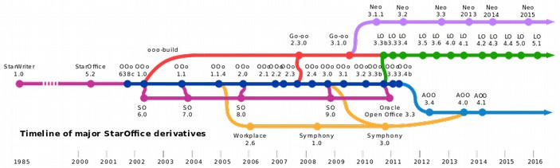
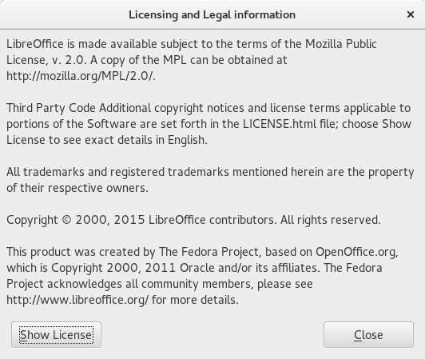
Picture 1: LibreOffice’s history

LibreOffice’s License
LibreOffice is a free software which licensed under Mozilla Public License 2.0 as officially stated in https://www.libreoffice.org/about-us/licenses and in every copy of LibreOffice program itself, accessed through Help > License Information menu, or inside of LICENSE file.
The third-party software components included in LibreOffice are licensed under the GNU General Public License, the GNU Lesser General Public License, the Apache License, and the CreativeCommons Attribution-ShareAlike. All of LibreOffice’s license component can be read in the same place as already mentioned above.

Picture 2: LibreOffice license information

LibreOffice and Microsoft Office Program Comparison
LibreOffice major components are similar with Microsoft Office:
Component | LibreOffice | Microsoft Office
Word Processor | Writer | Word
Spreadsheet | Calc | Excel
Presentation | Impress | PowerPoint
Table 2: The comparison between LibreOffice and Microsoft Office components

LibreOffice Features
- Save and open ODF (Open Document Format) files perfectly.
- Export ODF document into flat XML.
- Import Microsoft Visio and Microsoft Publisher documents.
- Open, edit, and save Microsoft OOXML documents (.docx, .xlsx, .pptx). These document formats are popular on Microsoft Office 2007 until Microsoft Office 2016.
- Open, edit, and save binary-proprietary document format from Microsoft (.doc, .xls, .ppt). These document formats are popular on older Microsoft Office version (before Microsoft Office 2007).
- Save documents as PDF format.
- Add comments and annotations inside the document.
- Remote control application for presentation purpose.
- Use CMIS Protocol for collaboration, newest feature that allows user for collaborating with other user when doing online projects.

Interface
Here are some interfaces of LibreOffice Writer on GNU/Linux operating system:
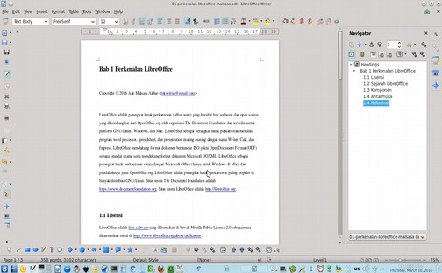

Picture 3: LibreOffice Writer version 4.3.0.4 interface on GNU/Linux Ubuntu
12.04 LTS with KDE 4.10.3 Desktop Environment

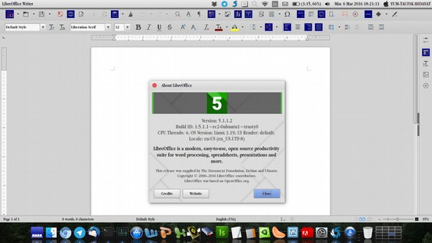
Picture 4: LibreOffice Writer version 5.1.1.2 on GNU/Linux Ubuntu
14.04 LTS with Unity 7.2.6 Desktop Environment

LibreOffice Versions
LibreOffice is available in two different major versions, apart from the development versions (numbered release candidates and dated nightly builds). The versions are designed and customized for different user needs. The numbering convention of each release is set with three numbers separated by periods. The first number is a large branch number, the second number usually signifies minor changes, and the third indicates a minor release focusing on bug fixes. LibreOffice specifies two versions of the release as:
- "Fresh" – "Fresh" - releases the latest bug fixes from the current big (branch) version, which contains various latest feature additions, but there may be bugs not found in the "Still" release.
- "Still" (formerly known as "Stable") – recent bug fixes from previous major versions. which have been through several months of bug fixes and recommended for users who are more concerned with stability than enhancements (feature enhancements). For example, in September 2015, 5.0.2 is a Fresh release, and 4.4.5 is a Still release. When this section is written, LibreOffice latest version is version 5.2, with some improvements, such as:
- Newer user interface.
- Support for writing files to cloud servers (cloud computing)
- Carries support for ODF 1.2 document format standards.
- LibreOffice Calc has significantly improved features.

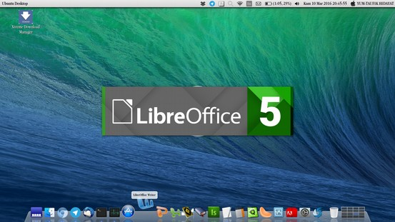
Picture 5: LibreOffice version 5.1 startup interface (splash screen) on Ubuntu 14.04 LTS

Important References
Here the author convey a number of internet links related to LibreOffice. This link is divided into official links, official documentation links, unofficial documentation links, and some additions.
- LibreOffice official website (the software): http://libreoffice.org
- The Document Foundation official website (organization): http://documentfoundation.org
- LibreOffice at Wikipedia: https://en.wikipedia.org/wiki/LibreOffice
- Official LibreOffice documentation books: http://www.libreoffice.org/get-help/documentation/
- Official LibreOffice documentation books (ultimate version): https://wiki.documentfoundation.org/Documentation/Publications
- LibreOffice source code (website): https://www.libreoffice.org/about-us/source-code/
- LibreOffice source code (Git server): https://cgit.freedesktop.org/libreoffice
- Paid technical LibreOffice support (professional): https://www.libreoffice.org/get-help/professional-support/
- Official LibreOffice mailing list: https://www.libreoffice.org/get-help/mailing-lists/
- Contributing to LibreOffice guides: https://www.libreoffice.org/community/get-involved/
- Donate to LibreOffice project: https://www.libreoffice.org/donate/

User Guides from The Community

- The Frugal Computer Guy http://thefrugalcomputerguy.com provides so many videos about LibreOffice tutorials.
- GoFree http://www.gofree.com provides written guidance about LibreOffice.
- Tutorials for OpenOffice http://www.tutorialsforopenoffice.org provides written guidance about OpenOffice.org.
Note: LibreOffice is developed from OpenOffice.org source code.

CHAPTER 2 INTRODUCING TO OPENDOCUMENT FORMAT
CHAPTER 2

INTRODUCTION TO OPENDOCUMENT FORMAT

Copyright © 2016 Ade Malsasa Akbar <teknoloid@gmail.com>
Translated by Raymon Rahmadhani <raymon.rahmadhani@gmail.com>

LibreOffice embraces the standard digital documentation format called OpenDocument Format (ODF) which is published by OASIS organization. The ODF standard itself had been standardized by ISO (International Standardization Organization) as an International office suite document standard. The ODF standard has three main formats, that are .odt (word processor), .ods (spreadsheet), and .odp (presentation). All of them are manifested into three LibreOffice programs; Writer, Calc, and Impress.

Introduction
The consideration of software, hardware, and standard are commonly acknowledge in the world of computer science. So does in developing an office suite application which is not built without any consideration at all, but it should embrace a certain document standard. In term of this book, the writer compared between two platforms, which are Microsoft Office and LibreOffice. Therefore, as a software, both of them are compared as Microsoft Office and LibreOffice. Meanwhile, as a standard, both are compared as OOXML and ODF. For those who plan to migrate to LibreOffice platform seriously should understand the following considerations. Here is the table that shows a brief explanation of both standard.

Platform Microsoft |  | Platform LibreOffice
Standard name | Microsoft OOXML | Standard name | OpenDocument Format
Publisher | Microsoft | Publisher | OASIS
Software name | Microsoft Office | Software name | LibreOffice
Software Developer | Microsoft | Software Developer | The Document Foundation
Publication of specification | http://www.ecma-international.org/publications/standards/Ecma-376.htm | Publication of specification | https://www.oasis-open.org/committees/office
Standard number | ISO/IEC 29500 | Standard number | ISO/IEC 26300
ISO approval | http://www.iso.org/iso/home/store/catalogue_tc/catalogue_detail.htm?csnumber=61750 | ISO approval | http://www.iso.org/iso/home/store/catalogue_tc/catalogue_detail.htm?csnumber=43485
Table 3: Standard comparison between Microsoft and LibreOffice Platform

The Table of ODF and Its Programs
Format | Program | Function
.odt | LibreOffice Writer | Word processor
.ods | LibreOffice Calc | Number processor
.odp | LibreOffice Impress | Presentation processor
.odg | LibreOffice Drawing | Picture processor
Table 4: The Table of ODF and Its Programs

Comparison between ODF and Microsoft Format
In this case, the term “Standard” is a standard which is created by OASIS and Microsoft in the other hand. Microsoft has two kinds of standard format, they are closed document format (.doc, etc.) and OOXML document format (.docx, etc.). Meanwhile, OASIS has 1 standard format only, that is ODF. This section is trying to show the difference between Microsoft and OASIS standard format. Furthermore, it also compares between programs which embrace Microsoft standard and OASIS standard.

Table of Closed Format versus ODF:
Microsoft’s Closed Formats | ODF Format
.doc | .odt
.xls | .ods
.ppt | .odp
Table 5: Closed Format and ODF Comparison

The Table of OOXML versus ODF Format:
OOXML Format | ODF Format
.docx | .odt
.xlsx | .ods
.pptx | .odp

Table 6: OOXML and ODF Format Comparison

The Table of the OOXML based programs versus ODF based programs:
OOXML based programs | ODF based programs
Microsoft Word | LibreOffice Writer
Microsoft Excel | LibreOffice Calc
Microsoft PowerPoint | LibreOffice Impress
Table 7: OOXML and ODF Based Programs Comparison

The Table of the Alternative ODF Based Programs
The following table presents the information about softwares which support OpenDocument format as an alternative to LibreOffice. Furthermore, it presents free software only wthout inclusion of proprietary software.
Format | Function | LibreOffice | LibreOffice Alternative
.odt | Word Processor | Writer | OpenOffice Writer, Calligra Words, Abiword
.ods | Number Processor | Calc | OpenOffice Calc, Calligra Sheets, Gnumeric
.odp | Presentation Processor | Impress | OpenOffice Impress, Calligra Stage
Table 8: LibreOffice’s Alternative with ODF Based Programs

The Table of Free Office Suite Program as a LibreOffice Alternative
The following table presents the office suite programs, which are licensed as free software, as the LibreOffice alternative. Moreover, all of the following programs support OpenDocument format.
Name | License | Descriptions
Apache OpenOffice | Apache License 2.0 | - Provides word processor, spreadsheet, and presentation;  - Developed by Sun OpenOffice.org, Sun StarOffice.  - LibreOffice starts up development.  - Available in all GNU/Linux distribution.  - Actively Developed.
Calligra Suite | GNU GPL, GNU LGPL | - Provides word processor, spreadsheet, and presentation;  - Developed by Koffice;  - Available in all GNU/Linux distribution.  - Actively Developed.
KOffice | GNU GPL, GNU LGPL | - Provides word processor, spreadsheet, and presentation;  - Additional features.  - Has been terminated.
NeoOffice | GNU GPL | - Provides word processor, spreadsheet, and presentation;  - Developed by Sun OpenOffice.org.  - Built especially for Apple OS X.  - Actively Developed.
Table 9: Free Office Suite Program as a LibreOffice Alternative

The Table of Proprietary Softwares which Support ODF
Program’s Name | Description
Microsoft Office | Supports ODF since 2010 to 2016 version.
Google Docs | Supports ODF partially.
SoftMaker Office | Supports ODF partially.
IBM Lotus Symphony | Supports ODF.
Corel WordPerfect Office | Supports ODF since X4 versions.
Table 10: Proprietary Softwares which Support ODF

Reference:
https://en.wikipedia.org/wiki/OpenDocument
https://en.wikipedia.org/wiki/Comparison_of_Office_Open_XML_and_OpenDocument
https://linuxdreambox.wordpress.com/2016/01/10/support-open-document-format/

CHAPTER 3 INTRODUCTION TO LIBREOFFICE WRITER INTERFACE
CHAPTER 3
INTRODUCTION TO LIBREOFFICE WRITER INTERFACE

Copyright © 2016 Muhammad Yuga Nugraha <myugan59@gmail.com>
Translated by Muhammad Fathurridlo <mfathurridlo@gmail.com>
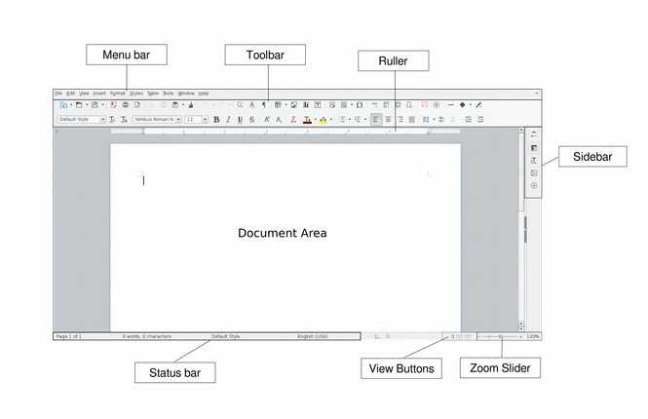
Picture 6: LibreOffice Writer interface

Picture description:
Interface | Description
Menu Bar | Runs LibreOffice Writer commands
Toolbar | Buttons that can be used to run LibreOffice commands.
Ruler | Ruler for knowing real document size.
Side Bar | Shows buttons from Properties, Styles and Formatting, Gallery, and Navigator.
Document Area | Work space
Status Bar | Shows current document informations such as total page, total words, and total characters.
View Buttons | Changes document view model.
Zoom Slider | Works as Zoom In and Zoom Out button (enlarging or shrinking document view).
Table 11: Picture information about LibreOffice Writer interface

CHAPTER 4 INTRODUCTION TO LIBREOFFICE WRITER SIDEBAR
CHAPTER 4
INTRODUCTION TO LIBREOFFICE
WRITER SIDEBAR

Copyright © 2016 Mukafi (kakafi30@gmail.com)
Translated by Muhammad Fathurridlo <mfathurridlo@gmail.com>
Sidebar is a dock that located on the right of document area. Sidebar contains tool properties, styles and formatting, gallery and navigator. To enable sidebar, click on View Menu, and then choose Sidebar. The features of Sidebar are shown on the pictures below.

Sidebar
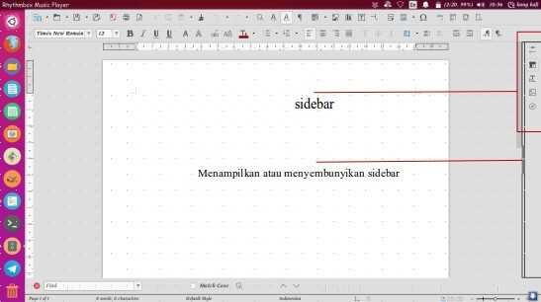
Picture 7: Sidebar position on LibreOffice Writer
Sidebar has four features, there are: Properties, Character, Paragraph and Page.
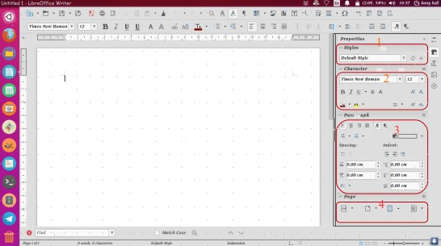
Picture 8: Sidebar features

Properties
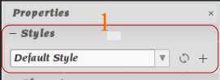
Picture 9: Properties Features

Description:
Styles: Change the style of writing. For example, we will write the phrase "INTRODUCTION TO LIBREOFFICE" and want to be a chapter title, then highlight the "title" option in the Style option. Then the text will be the title with the centering format and bold without additional effort pressing the Ctrl + E combination and Ctrl + B on the keyboard.

Character
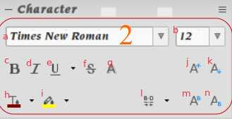
Picture 10: Character features

Descriptions:
a. | Font Type | To change the font type
b. | Font size | To change the font size
c. | Bold | To change the typing to thick-typing
d. | Italic | To change the typing to tilt-typing
e. | Underline | To convert the text to underlined text
f. | Strikethrough | To give a strike into the text
g. | Shadows | To give a shadow on a text
h. | Font color | To change the color on a text
i.. | Highlight color | To give background color on a text
j. | Increase font size | To increase the font size
k. | Decrease font size | To decrease the font size
l. | Character spacing | To change the space between characters
m. | Superscript | To change the characters into slightly above of the normal text line.
n. | Subscript | To change the characters into slightly below of the normal text line.

Paragraph
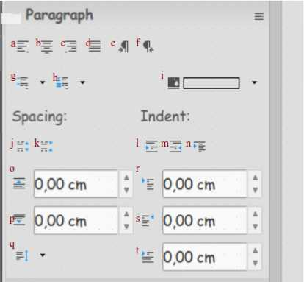
Picture 11: Paragraph features

Descriptions:
a. | Align left | Set the typing to be flat on the left side
b. | Center horizontally | Set the typing to be flat on the center side
c. | Align right | Set the typing to be flat on the right side
d. | Justified | Set the typing to be flat on the right and left side.
e. | Left to Right | Start typing from left to right direction.
f. | Right to Left | Start typing from to right to left direction.
g. | Bullet | Create a symbolic list
h. | Numbering | Create an alphabetic or numeric list
i. | Background color | Give color to the background
j. | Increase paragraph spacing | Increase paragraph spacing
k. | Decrease paragraph spacing | Decrease paragraph spacing
l. | Increase indent | Increase the left indent of the current paragraph so the text will indented inside
m. | Decrease indent | Restore / decrease the left indent of the current paragraph
n. | Switch to hanging indent | Make a hanging paragraph
o. | Above paragraph spacing | Set paragraph spacing with previous paragraph
p. | Below paragraph spacing | Set paragraph spacing with the next paragraph
q. | Line spacing | Set spacing distance between lines
r. | Before text indent | Set indent before the text
s. | After text indent | Set indent after the text  Mengatur tabulasi setelah tulisan
t. | First line indent | Set indent only the first line

Page
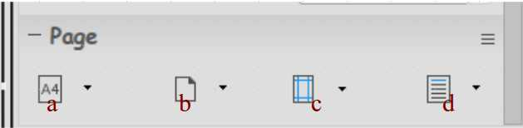
Picture 12: Page features

Descriptions:
a. | Size | Set the document paper size
b. | Orientation | Set the document orientation (potrait or landscape)
c. | Margin | Set the document margin
d. | Columns | Set the document column

CHAPTER 5 GETTING ACQUAINTED WITH THE MENU BAR IN LIBREOFFICE WRITER
CHAPTER 5
GETTING ACQUAINTED WITH THE MENU BAR IN LIBREOFFICE WRITER

Copyright © 2016 Taufik Hidayat <yumtaufik1997@gmail.com>
Translated by Astrida Atni Ayu Mahardini <astriddini7@gmail.com>

Out of sight, out of mind, this phrase actually is a reality. If we don't be familiar with something, then it is impossible for us to love or having interest with it. Because everything has to go through the stages of getting to know in advance, we can be next new familiar and loved it/favored him. Likewise with LibreOffice, impossible to use it continuously if we don't ' get acquainted ' first with him.
In this chapter, the author will discuss the sub-Sub menus on the Menu Bar in LibreOffice Writer. Each Sub Menu on LibreOffice Writer is a unity that cannot be separated and intertwined each other. The author uses LibreOffice Writer 4.2.8.2 version with operating system OS Grombyang (GrOS).
Please note that the author uses LibreOffice Writer consists of 9 Menu: File, Edit, View, Insert, Format, Table, Tools, Window, and Help. In this chapter, the author frequently used the word "Menu", "Sub Menu" and "Sub-Sub Menu". It is located on the Menu Bar menu, Sub Menu is the Menu that is present on the Menu and Sub Menu is the Menu that is present on the Sub Menu.

The File Menu
The file menu has functionality to open, close, save, print, export and preview the document. Below is a picture and description of the Sub Menu on the File menu. Sub Menu File: New, Open, Recent Documents, Wizards, Templates, Close, Save, Save As, Save As, Save Copy All, Reload, Versions, Export, Export a PDF, Send Us,
Properties, Digital Signatures, Preview in a Web Browser, the Page Preview, Print, Printer Settings and Exit LibreOffice.
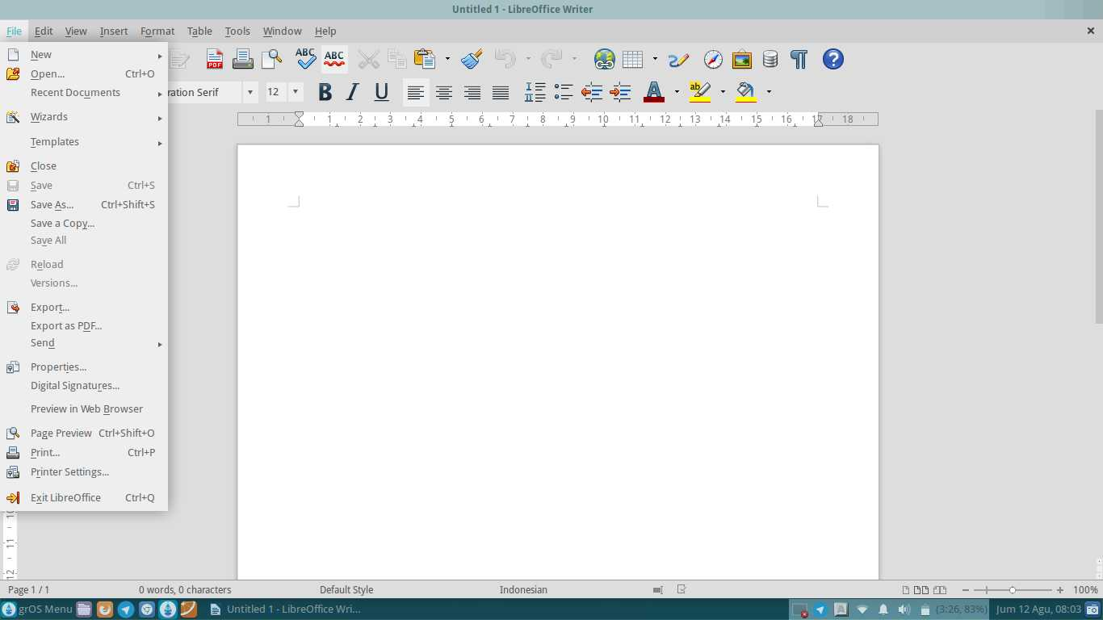
Picture 13: The Menu File

Descriptions:
1. | New | Start a new document.
2. | Open | Create document that are never stored.
3. | Recent Documents | Create document that never opened before.
4. | Wizards | Display the wizard.
5. | Templates | Create template document on LibreOffice Writer.
6. | Close | Close the active document.
7. | Save | Save the active document.
8. | Save As | Save the active document with a name and format or a different location.
9. | Save As Copy | Save and copy document.
10. | Save All | Save all document.
11. | Reload | Refresh/refresh the document.
12. | Versions | Save the document with read-only format.
13. | Export | Export the document with different formatting.
14. | Export As Pdf | Exporting a PDF formatted documents.
15. | Send | Send the document to other media such as e-mail.
16. | Properties | View and manage the information document.
17. | Digital Signatures | Add a digital signature.
18. | Preview In Web Browser | Preview the document in the web browser.
19. | Page Preview | Preview the document before printing.
20. | Print | To print the document.
21. | Printer Settings | Set the tool print (Printer).
22. | Exit LibreOffice | Out of LibreOffice.

Each Sub Menu in the File menu, has a Sub Sub Menu or options respectively. The following is a function of the options/Sub-Sub menus on the Sub Menu in the File Menu.

Sub-Sub Menu New
Sub's menu new is used to start a new document. Suppose you want to create a new document, you can select Sub Menu New as an option. New sub menus have a Sub-Sub menus like: Text Document (LibreOffice Writer), Spreadsheet (LibreOffice Calc), Presentation (LibreOffice Impress), Drawing (LibreOffice Draw), Database (LibreOffice Base), HTML Document (LibreOffice Writer/Web), an XML Form Document (XML Document Form LibreOffice), Master Document (LibreOffice
Writer), Formula (LibreOffice Math), Labels (LibreOffice Writer), Business Card (LibreOffice Writer) and Templates.
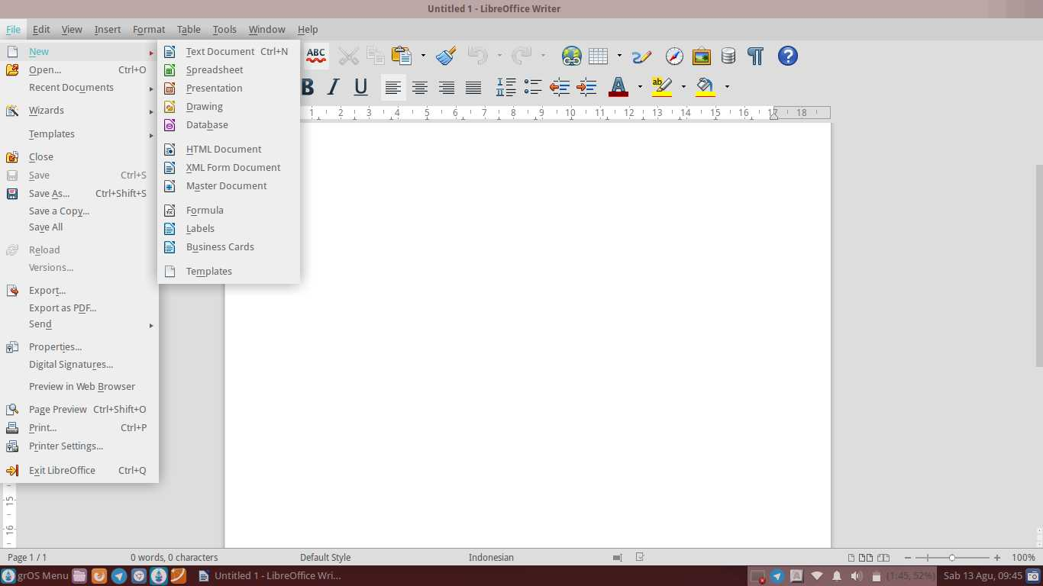
Picture 14: Sub-Sub Menu New

Descriptions:
1. | Text Document | Create documents with LibreOffice Writer
2. | Spreadsheet | Create a document/workbook with LibreOffice Calc
3. | Presentation | Create presentations with LibreOffice Impress
4. | Drawing | Create documents with LibreOffice Draw
5. | Database | Create a database with LibreOffice Base
6. | HTML Document | Create HTML documents with LibreOffice Writer/Web
7. | XML Form Document | Create an XML document with an XML Document Form LibreOffice
8. | Master Document | Create and manage documents, example a book with many chapters with LibreOffice Writer
9. | Formula | Create mathematical formulas with LibreOffice Math
10. | Labels | Create labels with LibreOffice Writer
11. | Bussiness Cards | Make business cards with LibreOffice Writer
12. | Templates | Create a document template with LibreOffice Writer

Sub-Sub Menu Recent Documents
Sub's menu recent document serves to open documents that never opened or created before. The Sub Menu functions can be as a shortcut to open the documents that have been made before.
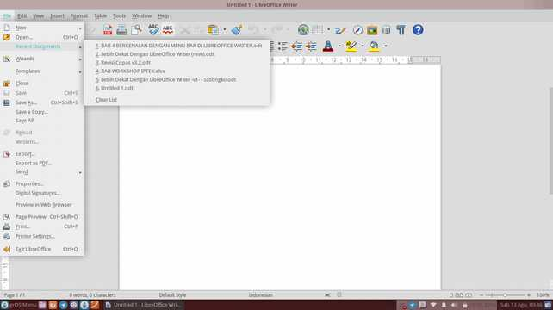
Picture 15: Sub-Sub Menu Recent Documents

Sub-Sub Menu Wizards
Sub's menu wizards has functionality to display wizards. This Sub Menu is used to create a document in the format you want in available the template. Suppose you want to create a letter, you can select the option Letter as template. You can try a wide kind of templates provided by LibreOffice Writer to create documents according to your needs.
Sub's Menu on Wizards: Letter, Fax, Agenda, Presentation, Web Page, Document Converter, Euro Converter and the Address of the Data Source.
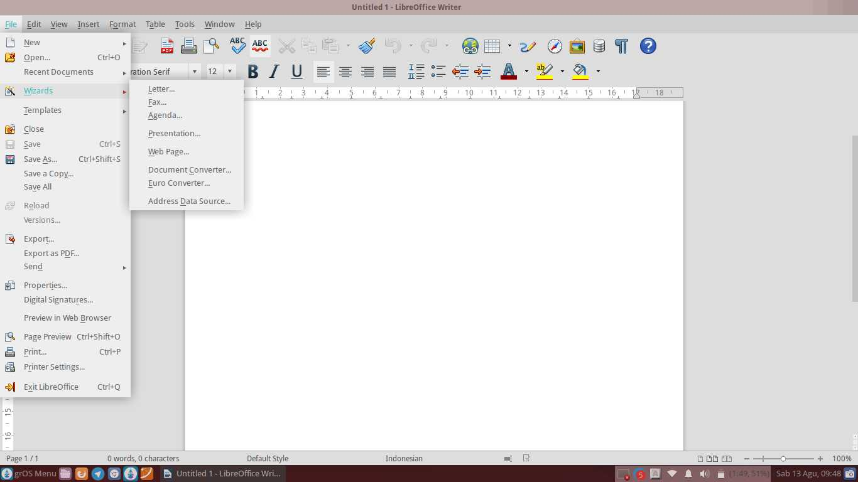
Picture 16: Sub-Sub Menu Wizards

Descriptions:
1. | Letter | Create a letter with the specified template
2. | Fax | Create a fax document with the specified template
3. | Agenda | Create an agenda with the specified template
4. | Presentation | Create presentations with the specified template
5. | Web Page | Publish the document to the cloud with a specified template
6. | Document Converter | Convert the document to other formats form
7. | Euro Converter | Convert the document to format currencies other European countries
8. | Address Data Source | Insert the address of the data source into a document

Sub-Sub Menu Templates
Sub's menu templates serves to create a document template on LibreOffice Writer. For example, you want to make a CV (Curriculum Vitae) to apply for a job. With the template provided by the LibreOffice Writer, you do not need to create and design your own CV. This will greatly facilitate the beginner to create their own CV. You can also set/change Your template by converting the format on the options Filter.
Sub's Menu Templates: Save As Templates and Manage.
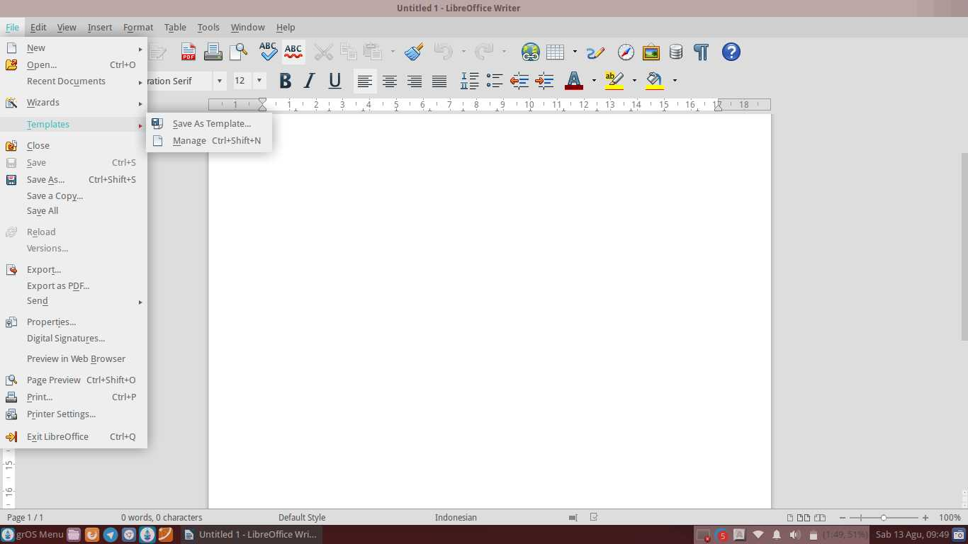
Picture 17: Sub-Sub Menu Templates
Descriptions:
1. | Save As Templates | Save the document as a template
2. | Manage | Create a document with a template that has been provided

Sub-Sub Menu Send
Sub's menu send has functionality to send the document to other media. Suppose you want to send a document via e-mail or bluetooth. In addition, if you
want to create an abstract or paper for scientific paper, you can take advantage of the features of AutoAbstract.
Sub's Menu-Send consists of an E-mail, the Document is the E-mail as Text Document, Email us the E-mail as Microsoft Word, PDF, Send Via Bluetooth, Create a Master Document, Create an HTML Document, Outline to Presentation, Outline to the Clipboard, Create AutoAbstract and AutoAbstract to Presentation.
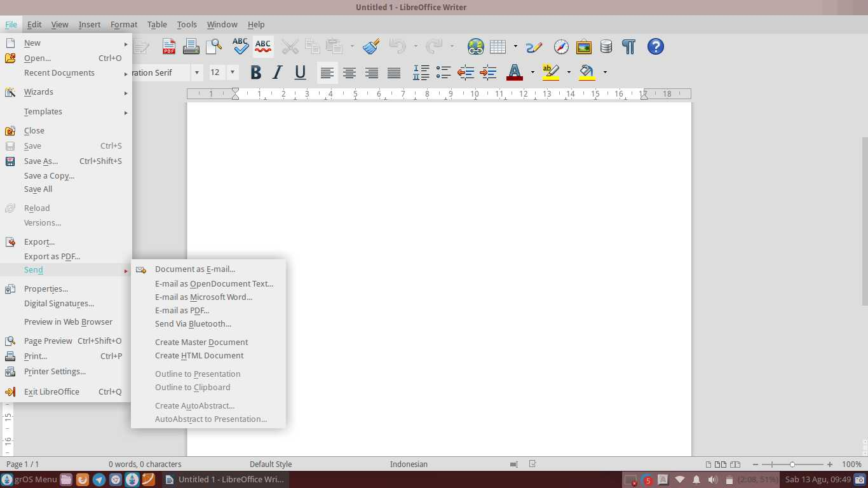
Picture 18: Sub-Sub Menu Send

Descriptions:
1. | Document as E-mail | Send documents as electronic mail
2. | E-mail as Document Text | Send the document through electronic mail  as the document shaped ODT
3. | Email as Microsoft Word | Send the document through electronic mail  in Microsoft Word format
4. | E-mail as PDF | Send the document through electronic mail  as PDF
5. | Send Via Bluetooth | Send documents via Bluetooth
6. | Create Master Document | Create a Master Document
7. | Create HTML Document | Create a document in HTML form
8. | Outline to Presentation | Create a document presentation form
9. | Outline to Clipboard | Make the document shaped the Clipboard
10. | Create AutoAbstract | Make abstract
11. | AutoAbstract to Presentation | Make the abstract to the form of presentation

The Menu Edit
The menu edit is used to edit, copy, paste, find, replace, find and replace, insert a table of contents and bibliography, linking, selecting and comparing documents.
Sub's the edit menu: Undo, Redo, Repeat, Cut, Copy, Paste, Pate Special, Select Text, Selection Mode, Select All, Changes, Compare Document, Find, Find and Replace, AutoText, Exchange Database, the Fields, the Footnote/Endnote, Bibliography Entry, Index Entry, hyperlinks, Links, Plug-ins, ImageMap and Object.
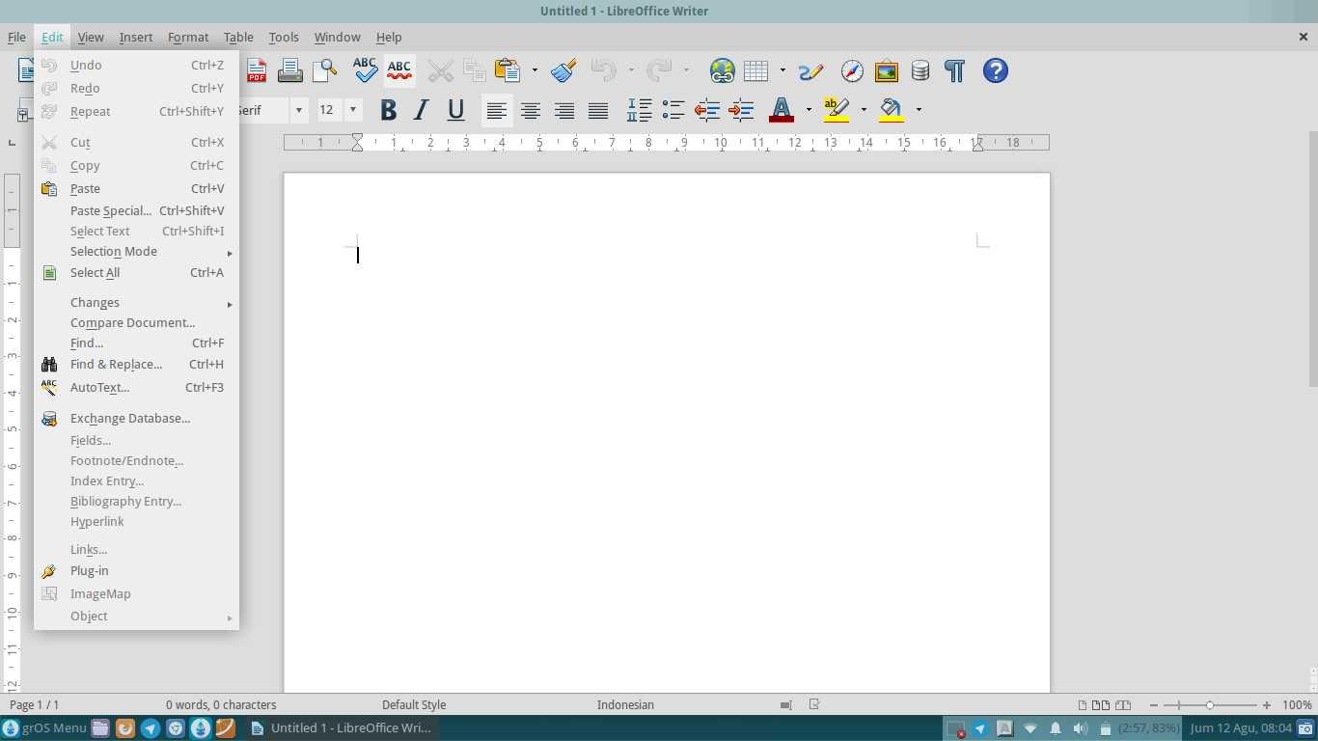
Picture 19: The Edit Menu

Descriptions:
1. | Undo | Undo or step (back to previous command)
2. | Redo | Repeat orders or canceled step (towards the Undo command)
3. | Repeat | Repeat user command
4. | Cut | Cut a piece of writing or object
5. | Copy | Copy writing or objects.
6. | Paste | Attach the post or object that has been copied
7. | Paste Special | Display the results of a copy with additional commands
8. | Select Text | Select writings
9. | Selection Mode | Set the mode selection
10. | Select All | Select the entire writing
11. | Changes | Set the document changes
12. | Compare Document | Compare documents
13. | Find | Find writings
14. | Find & Replace | Find and replace writing
15. | AutoText | Make writing automatically
16. | Exchange Database | Set Exchange database
17. | Fields | Set field
18. | Footnote/Endnote | Provide footnotes or endnotes
19. | Index Entry | Set the index entry
20. | Bibliography Entry | Set Bibliography Entry
21. | Hyperlink | Set hyperlink
22. | Links | Set up/form links (relationships)
23. | Plug-in | Set the plug-in
24. | ImageMap | View/manage image maps
25. | Object | Set the object that has been inserted

Each Sub Menu in the Edit Menu, and has Sub Sub Menu or options respectively. The following is a function of the options/Sub-Sub menus on the Sub Menu in the File Menu.

Sub-Sub Menu Selection Mode
Sub's menu selection mode serves to set the mode selection. For example, you want to change a sentence with another sentence. You can use the feature Selection Mode to select the sentence, and then replace them as you want.
Sub's menu selection mode is Standard and Block Area.
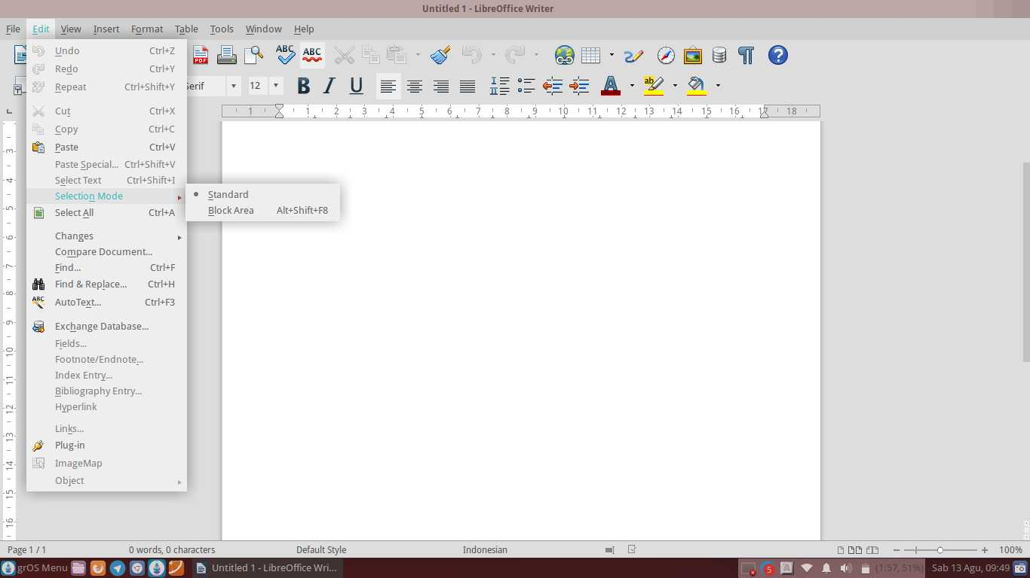
Picture 20: Sub-Sub Menu Selection Mode

Descriptions:
1. | Selection Mode | Select the writing mode selection
2. | Block Area | Choose a writing block area

Sub-Sub Menu Changes
Sub's menu changes serve to set up change document. For example, if you want to comment on a text, you can use the option Comment.
Sub's Menu Changes is: Record, Protect Records, Show, Accept or Reject, Comment, Next Change and Previous Change, Merge Document.
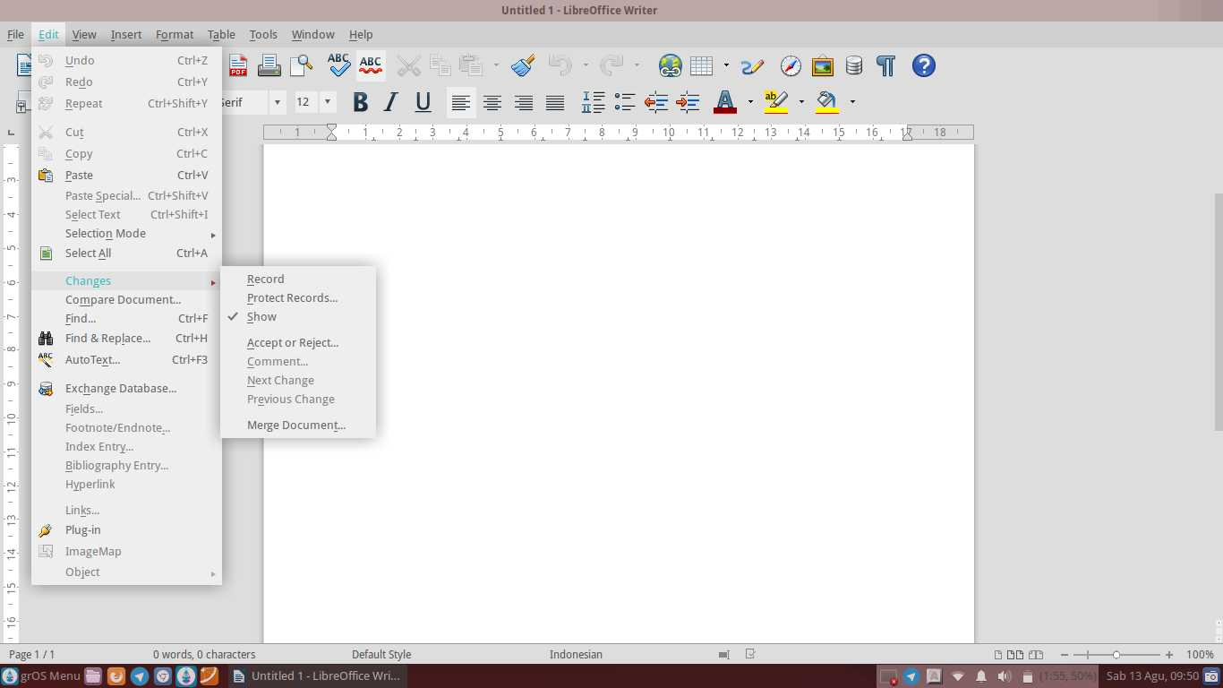
Picture 21: Sub-Sub Menu Changes

Descriptions:
1. | Record | Record changes
2. | Protect Records | Protect recordings by giving your password
3. | Show | Publish your changes
4. | Accept or Reject | Accept or cancel a recording
5. | Comment | Provide comments on the document
6. | Next Change | See further changes
7. | Previous Change | See previous changes
8. | Merge Document | Merge document before and after the edit by more than one person

The View Menu
The view menu is used to display the text boundaries, toolbars, pictures, status bar, rulers, scrollbars, etc. on the document. Sub Menu View: Print Layout, Web Layout, Toolbars, Status bars, Input Method Status, Ruler, Text Boundaries, Field Shadings, Field Names, Non-printing Characters, Hidden Paragraphs, Comments, Data Sources, Navigator, Sidebar, Full Screen and Zoom.
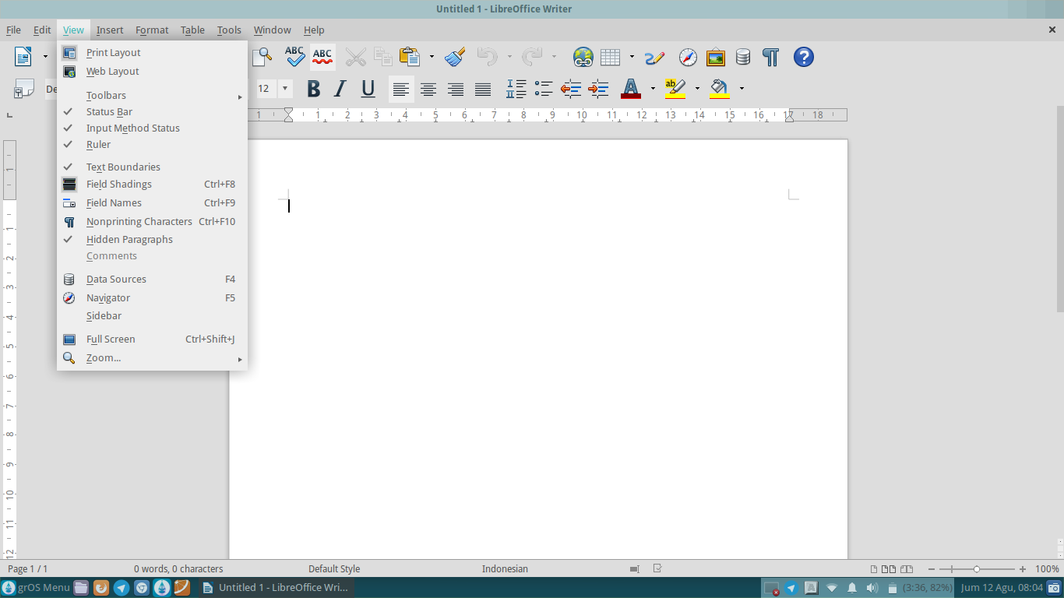
Picture 22: The View Menu

Descriptions:
1. | Print Layout | Display the print layout
2. | Web Layout | Display our document editing when it appears in a web browser
3. | Toolbars | Show or hides the toolbar's
4. | Status Bar | Show or hides the status document
5. | Input Method Status | Track the status of the input method
6. | Ruler | Show or hide the rulers above and to the left of the work area
7. | Text Boundaries | Show or hides margin limits in the work area
8. | Field Shadings | Show or hide the shadow field
9. | Field Names | Show/hide a field name
10. | Nonprinting Characters | Show or hides the characters are not printed
11. | Hidden Paragraphs | Enable or disable hidden paragraph
12. | Comments | Make a comment
13. | Data Sources | Display or hide the data source
14. | Navigator | Show or hide the menu Navigator
15. | Sidebar | Display the toolbar menu Sidebar at the side of the documents/work area
16. | Full Screen | Create a full-screen mode
17. | Zoom | Set the magnification of a document display

Each Sub Menu in the View Menu, has a Sub Sub Menu or options respectively. The following is a function of the options/Sub-Sub menus on the Sub Menu in the View Menu.

Sub-Sub Menu Toolbars
Sub's menu toolbars used to insert text objects, fontwork, table, picture, frame, media playback and so on. The toolbar can be said as a shortcut that aims to make it easy for users in the work. So, the users who work with using LibreOffice Writer can work in comfort.
Sub's Menu Toolbars is 3D Settings, Align Objects, Bullets and Numbering, Changes, Drawing, Drawing Object Properties, Find, Fontwork, Form, Form Design, Control the Form Navigation, Formating, Frame, Insert, Media Playback, Navigation,
OLE-Object, Picture, Standard, Standard (Viewing Mode), Table, Text objects, Tools, Customize formulas, and Reset.
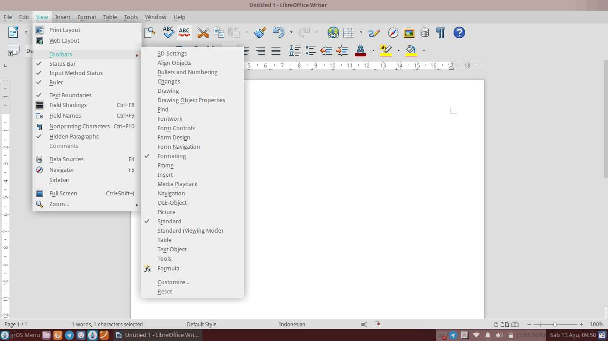
Picture 23: Sub-Sub Menu Toolbars

Descriptions:
1. | 3D Settings | 3D Settings toolbar
2. | Align Objects | Setting the direction of the object toolbar
3. | Bullets and Numbering | Bullet and numbering Settings toolbar
4. | Changes | Toolbar settings change documents
5. | Drawing | Drawing toolbar
6. | Drawing Object Properties | Toolbar settings
7. | Find | Toolbar search writings
8. | Fontwork | Graphic writing toolbar
9. | Form Controls | Forms toolbar controls/settings
10. | Form Design | Form Design toolbar
11. | Form Navigation | Forms toolbar Navigation
12. | Formatting | Toolbar to edit the document
13. | Frame | Insert a picture into a worksheet
14. | Insert | insert mode toolbar into the toolbar
15. | Media Playback | Media player toolbar
16. | Navigation | Sidebar navigation toolbar
17. | OLE-Object | Toolbar settings object as a link or embedded object
18. | Picture | Toolbar settings picture
19. | Standard | Normal mode is the standard toolbar
20. | Standard (Viewing Mode) | The standard toolbar mode view
21. | Table | Toolbar settings table
22. | Text Object | Toolbar text objects
23. | Formula | Toolbar to insert mathematical formulas
24. | Tools | Toolbar to insert tool's needed
25. | Customize | Customize icons on the toolbar
26. | Reset | Return the entire toolbar settings to its original form

Sub-Sub Menu Zoom
Sub's menu zoom is used to set the display size of the document. Suppose you want to enlarge the screen display of your documents. You can choose the Zoom Sub Menu option and choose the desired display magnification.
Sub's menu zoom is Entire Page, Page Width, Optimal view, 50%, 75%, 100%, 150%, 200% and Zoom.
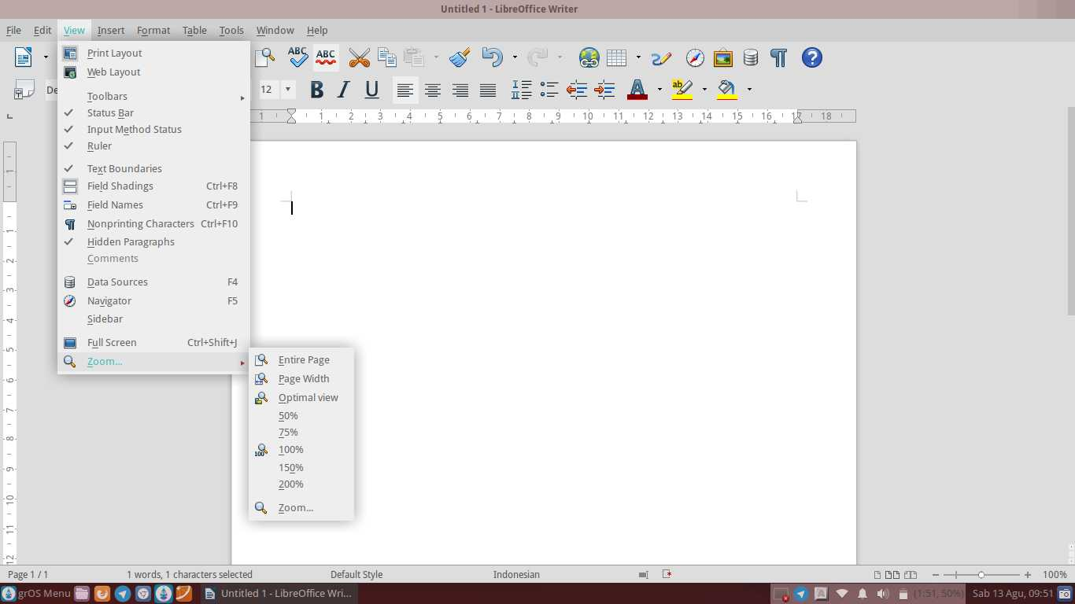
Picture 24: Sub-Sub Menu Zoom

Descriptions:
1. | Entire Page | See entire page worksheets in one screen
2. | Page Width | Look at the size of the worksheet pages as wide screen
3. | Optimal view | See page worksheets are ideally set
4. | 50% | See the pages worksheet with 50% zoom
5. | 75% | See worksheet page with magnification of 75%
6. | 100% | See worksheet page with magnification 100%
7. | 150% | See page worksheets with 150% zoom
8. | 200% | See the pages worksheet with 200% magnification
9. | Zoom | See worksheet page with zoom mode

The Insert Menu
The Insert menu use to insert an image, header, footnote and endnote, feet, objects, diagrams, special characters, hyperlinks, tables, scripts, caption, bookmarks and etc.
Sub Menu Insert is: Manual Break, Fields, Special Character, Formating Mark, Section, Hyperlink, Header, Footer, Footnote/Endnote, Caption, Bookmark, Cross-reference, Comment, Script, Indexes and Tables, Envelope, Frame, Table, Image, Movie and Sound, Object, Floating Frame and File.
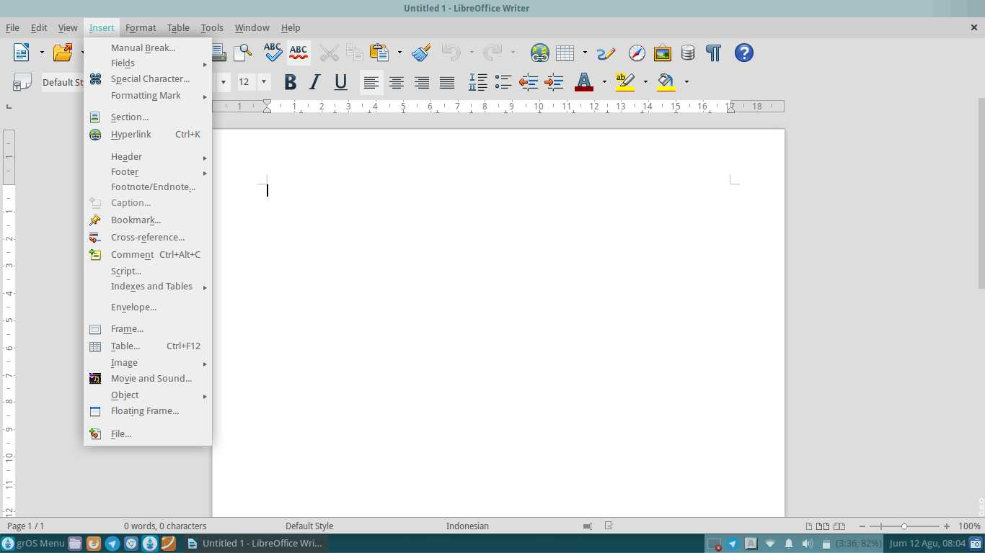
Picture 25: The Insert Menu

Description:
1. | Manual Break | Provide a manual break at work page
2. | Fields | Insert data that is changed in the document sheets
3. | Special Character | Insert special characters
4. | Formatting Mark | Paste formatting mark into a worksheet
5. | Section | Add section
6. | Hyperlink | Providing hyperlinks
7. | Header | Provide a heading on a worksheet
8. | Footer | Give Away on a worksheet
9. | Footnote/Endnote | Provide footnotes and endnotes
10. | Caption | Provide a caption on a worksheet
11. | Bookmark | Marking an important part
12. | Cross-reference | Provide cross-reference
13. | Comment | Provide comments on a worksheet
14. | Script | Give the script on a worksheet
15. | Indexes and Tables | Provides index and tables
16. | Envelope | Add envelope
17. | Frame | Make layouts one or more columns of text and objects
18. | Table | Insert a table into a worksheet
19. | Image | Insert a picture into a worksheet
20. | Movie and Sound | Providing sound and image
21. | Object | Insert object into the worksheet
22. | Floating Frame | Insert a floating frame (used in HTML documents-shaped) to display the contents of another file
23. | File | Insert a file into a worksheet

Each Sub Menu in the Insert Menu, has a Sub Sub Menu or options respectively. The following is a function of the options/Sub-Sub Sub Menu in the Menu on the Insert Menu.

Sub-Sub Menu Fields
Sub's menu fields used to insert data that is changed, for example is a page number, date and so on. For example, if you enter the page numbering manually then you should edit it multiple times and this will cause not efficiency time. You can use this option to efficiency the time.
Sub's menu fields is: Date, Time, Page Number, Page Count, Subject, Title, Author and Other.
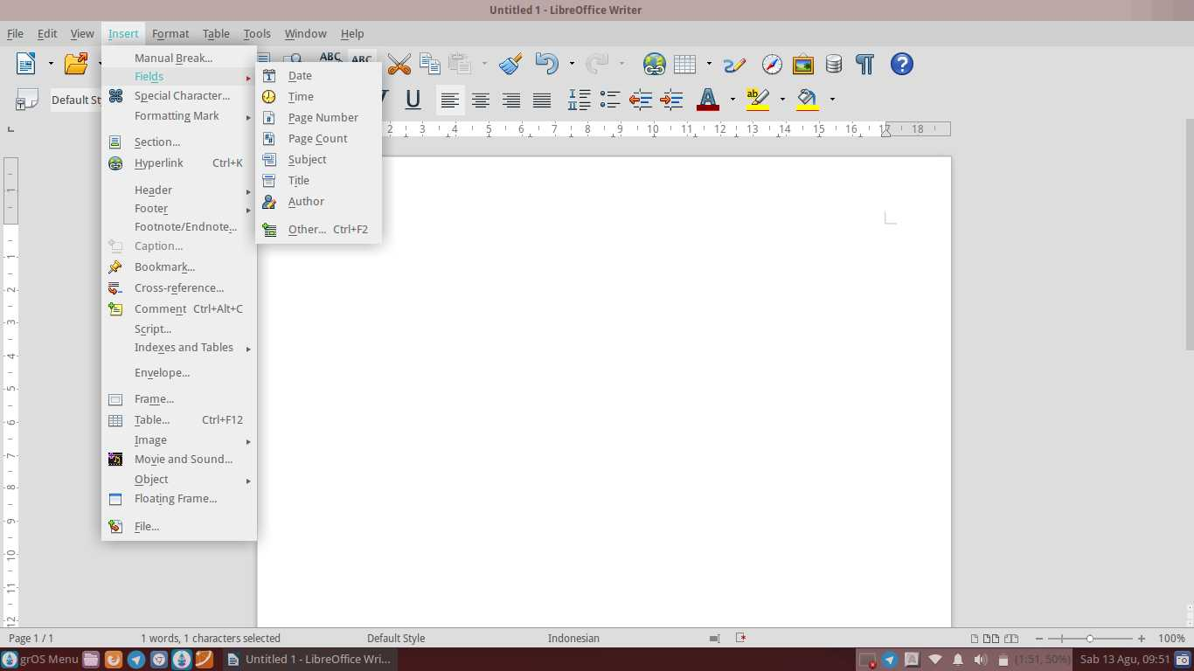
Picture 26: Sub-Sub Menu Fields

Descriptions:
1. | Date | Provides information on a worksheet
2. | Time | Provide a description of a time on a worksheet
3. | Page Number | Give the page numbers on a worksheet
4. | Page Count | Inserts a large number of pages on a worksheet
5. | Subject | Inserts a subject on a worksheet
6. | Title | Provide a title on a worksheet
7. | Author | Insert description document on a worksheet maker
8. | Other | Insert another document as a field

Sub-Sub Menu Formatting Mark
This Sub menu is used to set mark formatting using hyphen space or hyphen. Suppose you write and you want to separate the two words, you can use the separator distance with a space or hyphen (-).
Sub's menu formatting mark is: Non-breaking space, Non-breaking hyphen and Optional hyphen.
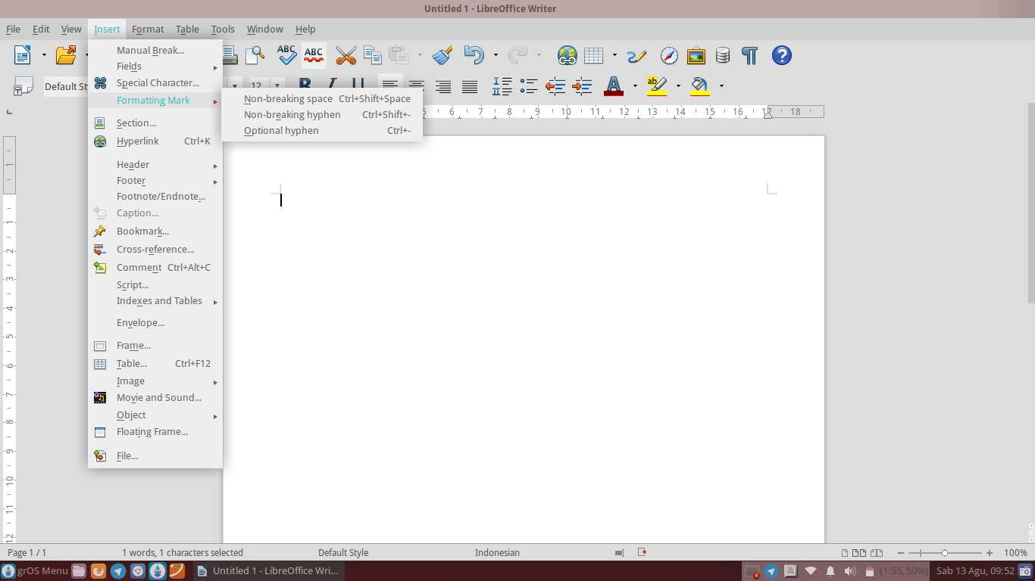
Picture 27: Sub-Sub Menu Formatting Mark

Descriptions:
1. | Non-breaking Space | Two or more words separated by spaces
2. | Non-breaking Hyphen | Separate two or more words with a dash
3. | Optional Hyphen | Separate two or more words fit the desired options

Sub-Sub Menu Header
Sub's header menu is used to make header/head. Suppose you want to create a header/head on your document, then you can choose to make the header header/head on your document. If you use a heading in your document, then the header will be automatically active on your next document sheet page.
Sub menu header is Default Style.
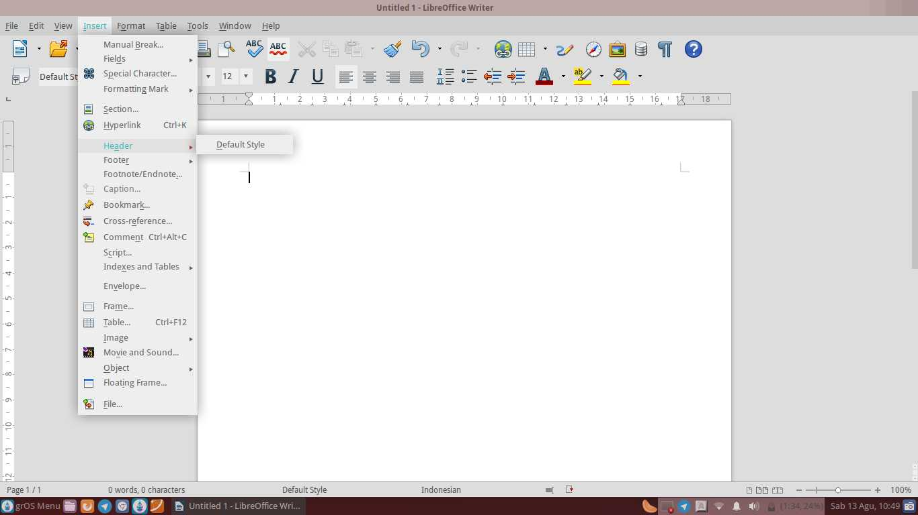
Picture 28: Sub-Sub Menu Header

Descriptions:
Default Style | Choose header/default-style header/default

Sub-Sub Menu Footer
Sub's footer menu is used to make the footer/feet. For example, you want to make a note at the bottom of each page of your document, you can then enable the footer. If you use the footer on your document, then the entry will be automatically active on your next document sheet page.
Sub menu footer is default style.
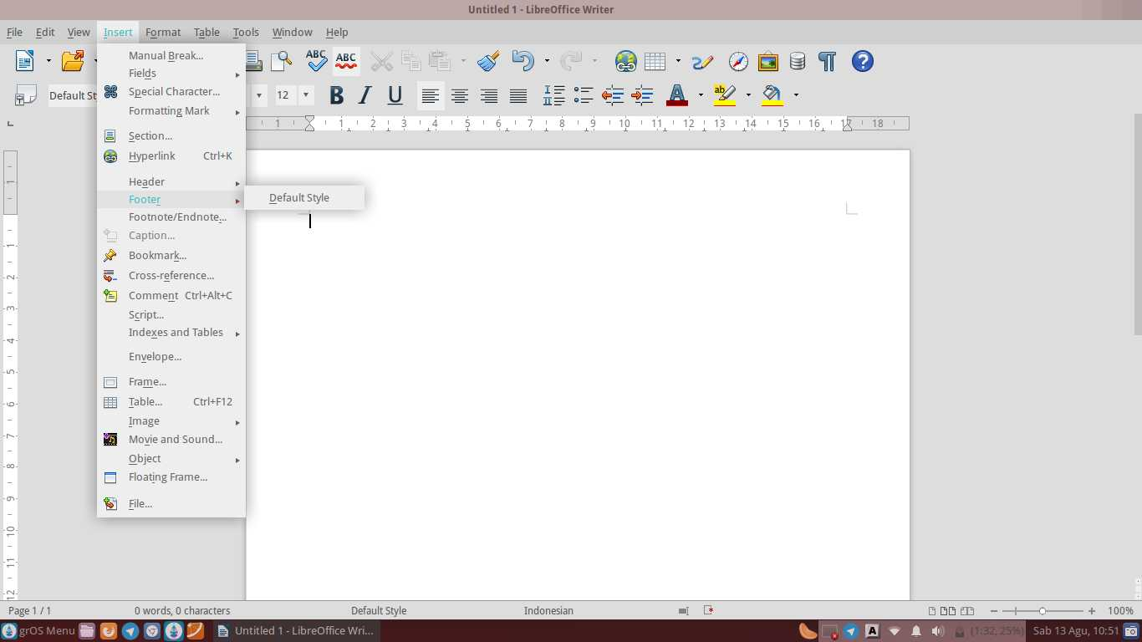
Picture 29: Sub-Sub Menu Footer

Descriptions:
Default Style | Choose footer default style/feet/default

Sub-Sub Menu Indexes and Tables
Sub's menu indexes and tables used to include references and tables and indexes. Suppose you want to create a bibliography, you do not need to create your own format. LibreOffice has been providing its format to facilitate your work.
Sub's menu on indexes and tables is: Entry, Indexes and Tables and Bibliography Entry.
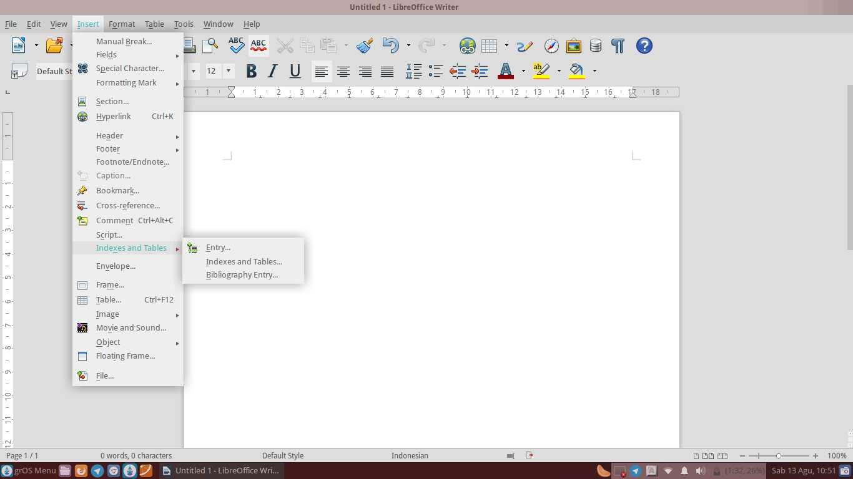
Picture 30: Sub-Sub Menu Indexes and Tables

Descriptions:
1. | Entry | Inserts index entries
2. | Indexes and Tables | Insert index and table
3. | Bibliography Entry | Insert bibliography

Sub-Sub Menu Image
Sub's menu image used to insert images into a worksheet. Suppose you want to insert a picture into your document, you can easily paste it because LibreOffice Writer has prepared for you.
Sub's menu image is: From File, Scan and Fontwork Gallery.
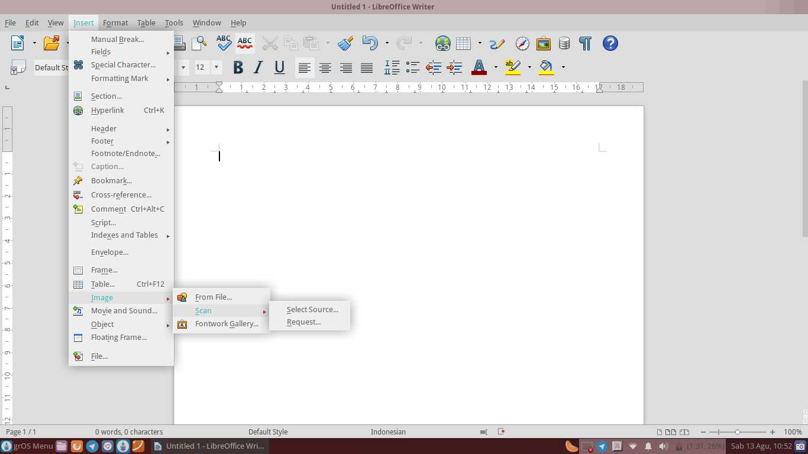
Picture 31: Sub-Sub Menu Image

Descriptions:
1. | From File | Insert a picture from a file that has been provided previously
2. | Scan | Insert a picture from a scanned
3. | Fontwork Gallery | Insert an image via the Gallery fontwork

Sub-Sub Menu Object
Sub's menu object is used to insert object into the worksheet. For example, you want to make the diagram and insert it into your document. You can use the Chart option in the Sub Menu Object.
Sub's Menu Object is: OLE-Object,Plug-In, Formula and Chart.
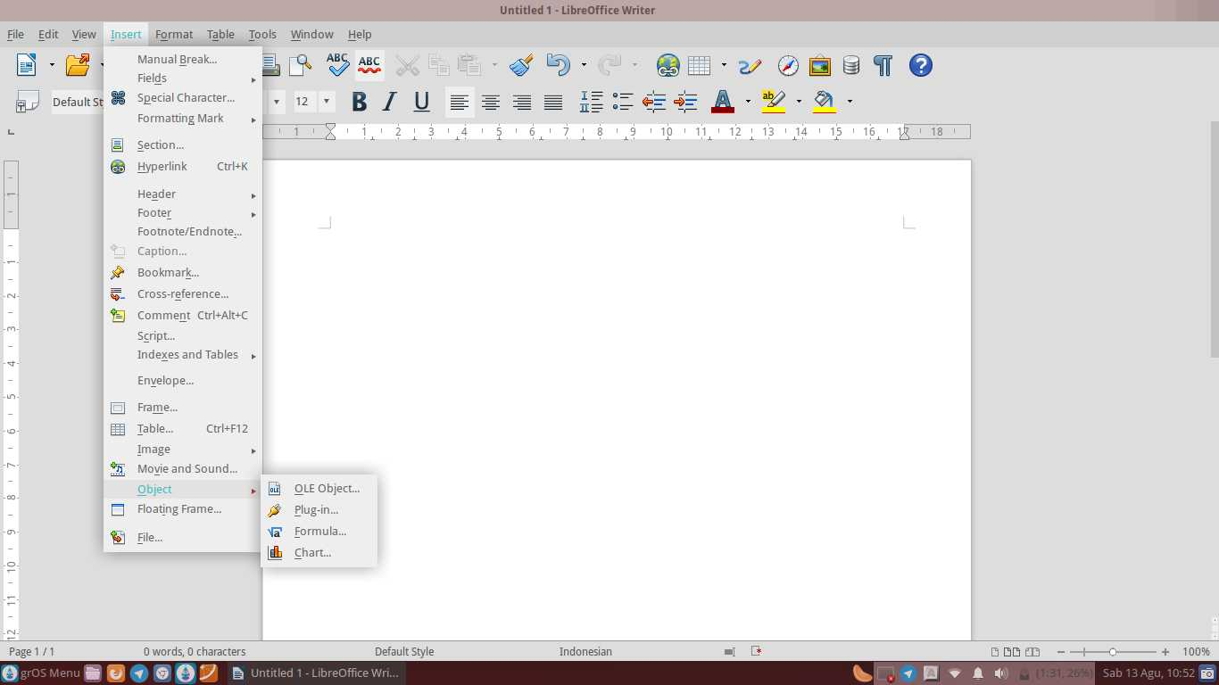
Picture 32: Sub-Sub Menu Object

Descriptions:
1. | OLE-Object | Paste the object as a link or an object
2. | Plug-In | Insert plug-in
3. | Formula | Insert a mathematical formula into a document
4. | Chart | Insert a chart into a document

The Menu Format
The menu format function to set up the worksheet page, paragraph, insert a bullet and numbering, enable keyboard guide Phonetic Asia, insert columns, page titles and characters into a worksheet.
Sub menu format is: Clear Direct Formating, Character, Paragraph, Bullets and Numbering, Page, Title Page, Change Case, Asian Phonetic Guide, Columns, Sections, Styles and Formating, AutoCorrect, Anchor, Wrap, Alignment, Arrange, Flip, Rotate, Group, Object, Frame/Object and Image.
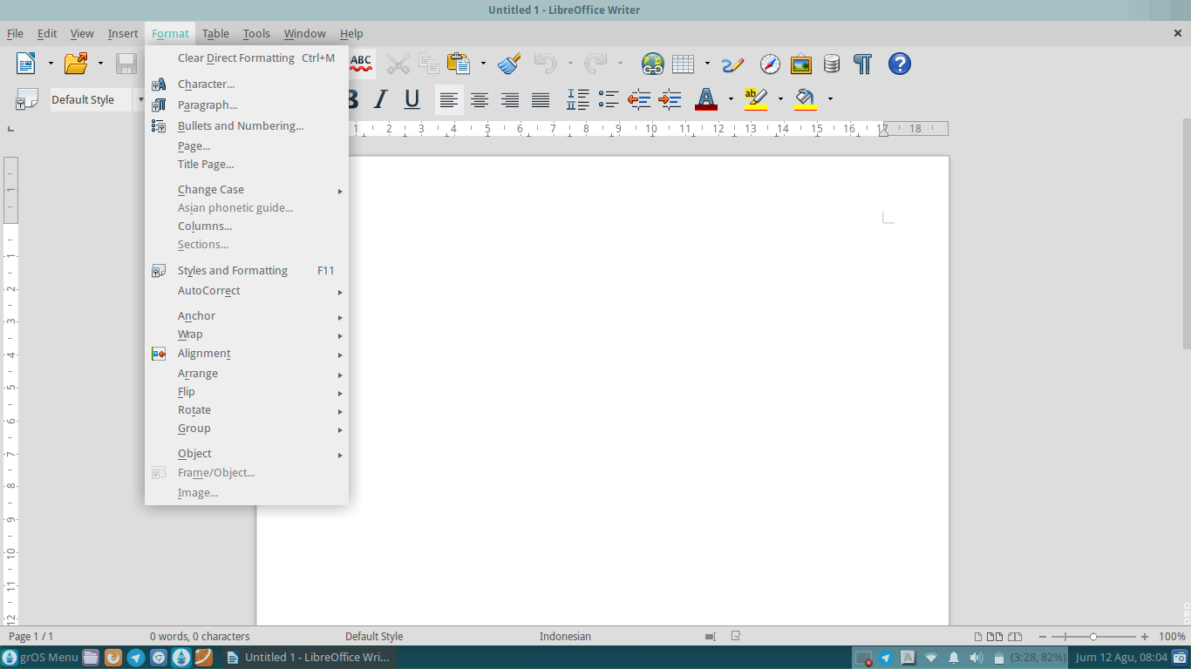
Picture 33: The Menu Format

Descriptions:
1. | Clear Direct Formatting | Remove the direct formatting
2. | Character | Insert the character into a worksheet
3. | Paragraph | Set paragraphs in the document
4. | Bullets and Numbering | Insert a bullet and numbering
5. | Page | Set up a worksheet page
6. | Title Page | Insert page title
7. | Change Case | Change the shape of the case, example: Uppercase and Lowercase
8. | Asian Phonetic Guide | Asian Phonetic keyboard Guide
9. | Columns | Insert a column into a worksheet
10. | Sections | Insert a section into a worksheet
11. | Styles and Formatting | Insert styles and formatting
12. | AutoCorrect | Enable word justification automatically on document
13. | Anchor | Set the anchor to selected objects
14. | Wrap | Enable wrap on a worksheet
15. | Alignment | To set the alignment of the text in the document
16. | Arrange | To set up the placement position objects on a worksheet, for example: above or behind text
17. | Flip | Reverse the position of the object, for example: vertical or horizontal
18. | Rotate | Rotate the position of the object
19. | Group | Combine several objects into one
20. | Object | Set the position and size of the objects in a worksheet
21. | Frame/Object | Insert an object/frame into a worksheet
22. | Image | Insert a picture into a worksheet

Each Sub Menu in Menu Format, has a Sub Sub Menu or options respectively. The following is a function of the options/Sub-Sub menus on the Sub Menu in the Menu Format.

Sub-Sub Menu Change Case
Sub's menu change case used to change the shape of the case. For example, you type a few sentences and you want the first letter of each sentence is capitalized, you can select options to Capitalize every word in the Sub Menu Change Case.
Sub's Menu Change Case is: Sentence Case, Lowercase, Uppercase, Capitalize Every Word, Toggle Case, Half Width, Full Width, Hiragana and Katakana.
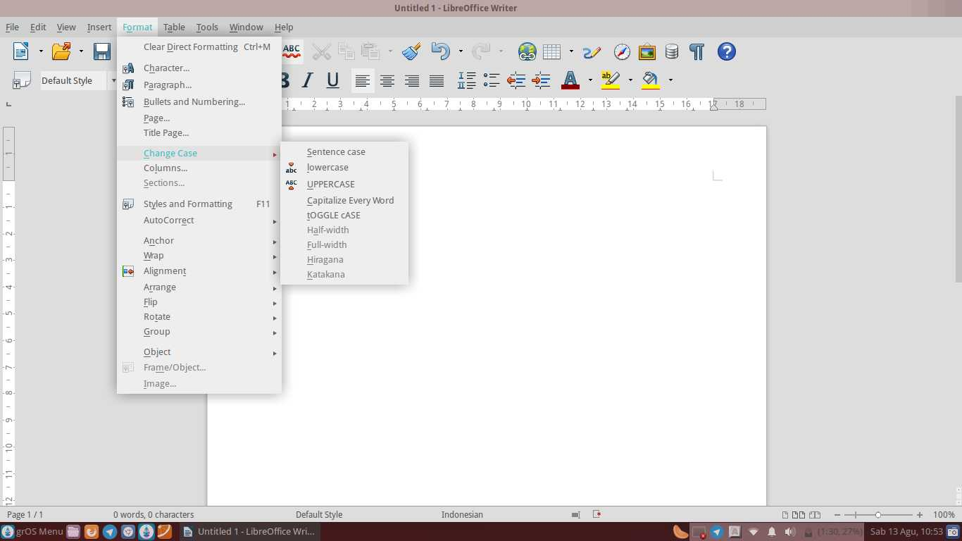
Picture 34: Sub-Sub Menu Change Case
Descriptions:
1. | Sentence Case | Change the characters into the beginning of each sentence capitalized
2. | Lowercase | Change capital letters into small letters on the document
3. | Uppercase | Change lowercase letters into uppercase in the document
4. | Capitalize Every Word | Change the character be capitalized at the beginning of each word
5. | Toggle Case | Change characters into toggle case
6. | Half Width | Change the selected Asian characters to half width characters
7. | Full Width | Change the selected Asian characters to full width characters
8. | Hiragana | Changing font Asian characters into Hiragana on a worksheet
9. | Katakana | Changing font Asian characters into Katakana on a worksheet

Sub-Sub Menu Autocorrect
Sub's menu autocorrect word justification used to activate automatically in the document. Suppose you're typing in the worksheet, but you momentarily led astray and typing the wrong sentence. For example the word ' I am ', to ' I a '. You can take advantage of this option is that it can reduce the occurrence of a typo.
Sub's menu autocorrect is: While Typing, Apply, Apply and Edit Changes and AutoCorrect Options.
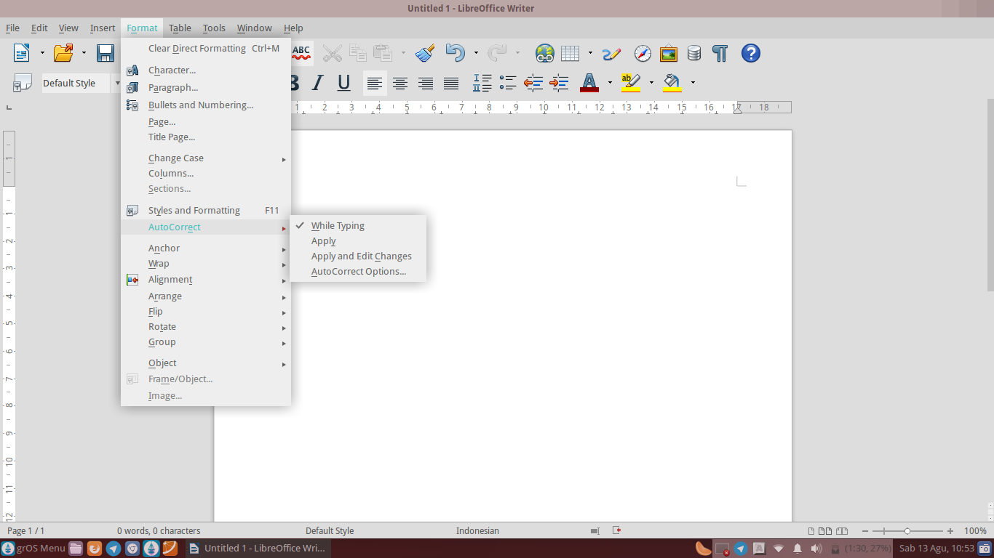
Picture 35: Sub-Sub Menu Autocorrect

Descriptions:
1. | While Typing | Apply auto correct at the writing
2. | Apply | Apply auto correct lineal
3. | Apply and Edit Changes | Apply and optional set auto correct

Sub-Sub Menu Anchor
Sub's menu anchor serves to set the anchor to the selected object. Suppose you insert a picture into your worksheets and you want to put it into the Page (To Page), you can choose the option To Sub Menu Page in the Anchor.
Sub's Menu Anchor is: To Page, To Paragraph, To Character, As Character and to Frame.
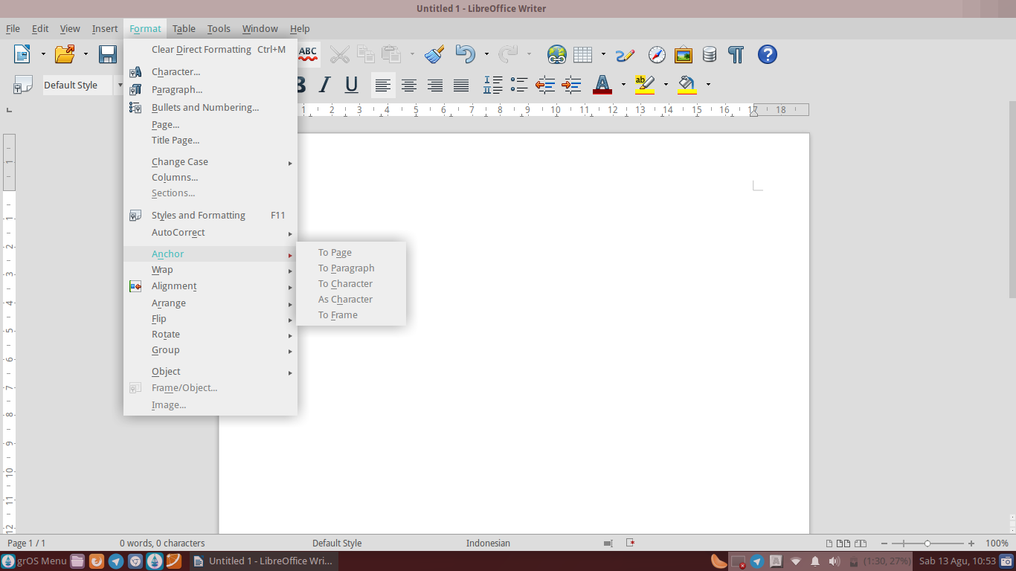
Picture 36: Sub-Sub Menu Anchor

Descriptions:
1. | To Page | Put the anchor object into the page/pages
2. | In Paragraph | Put the anchor object into paragraphs
3. | To Character | Put the anchor object into characters
4. | As Character | Put the anchor object as a character
5. | To Frame | Put the anchor on the frame object

Sub-Sub Menu Wrap
Sub's menu wrap used to lay or set the position of the object (usually an image) on a worksheet. Suppose you want to put an image behind text or overwrite the text, you can use it easily due to LibreOffice Writer already provide it for you.
Sub's Menu Wrap is: Wrap Off, Page Wrap, Optimal Page Wrap, Wrap Through, In Background
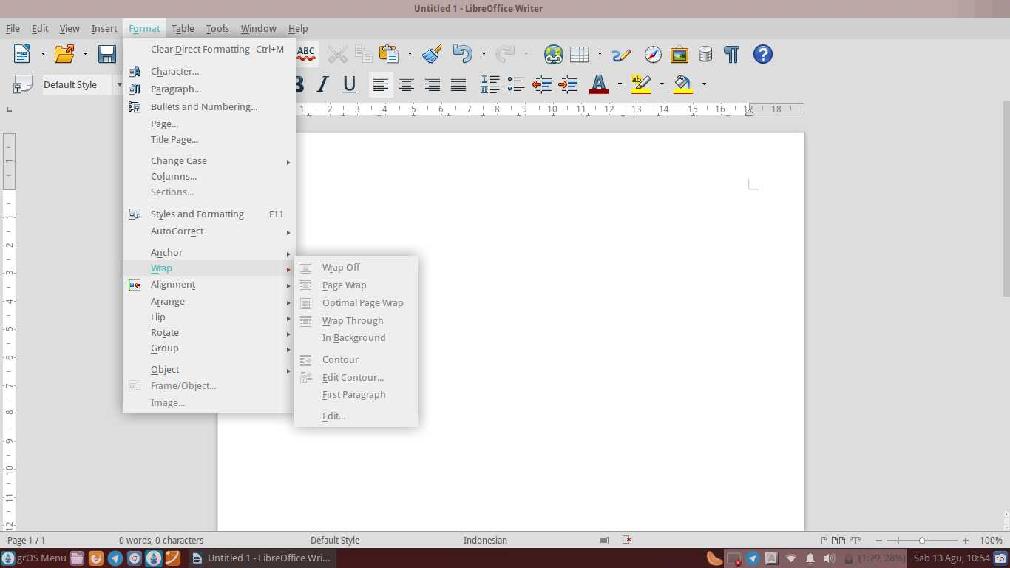
Picture 37: Sub-Sub Menu Wrap

Descriptions:
1. | Wrap Off | Me-off-right wrap on document
2. | Page Wrap | Positioning objects with Wrap to Page mode
3. | Optimal Page Wrap | Positioning objects with Optimal mode Page Wrap
4. | Wrap Through | Positioning objects with the Wrap mode Through
5. | In Background | Position of the object to the background
6. | Contour | Position of the object to the contours
7. | Edit Contour | Edit the settings of the contours on the document
8. | First Paragraph | Positioning objects on the first paragraph
9. | Edit | Changing font Asian characters into Katakana on a worksheet

Sub-Sub Menu Alignment
Sub's menu alignment is used to set the alignment of the text in the document. For example, you want the text to be left-align. You can select Align Left. You can also set text align right become align (Align Right), middle (Centered) and the mean left-right (Justified).
Sub's Menu Alignment is: Left, Right, Centered, Justified, Top, Center and Bottom.
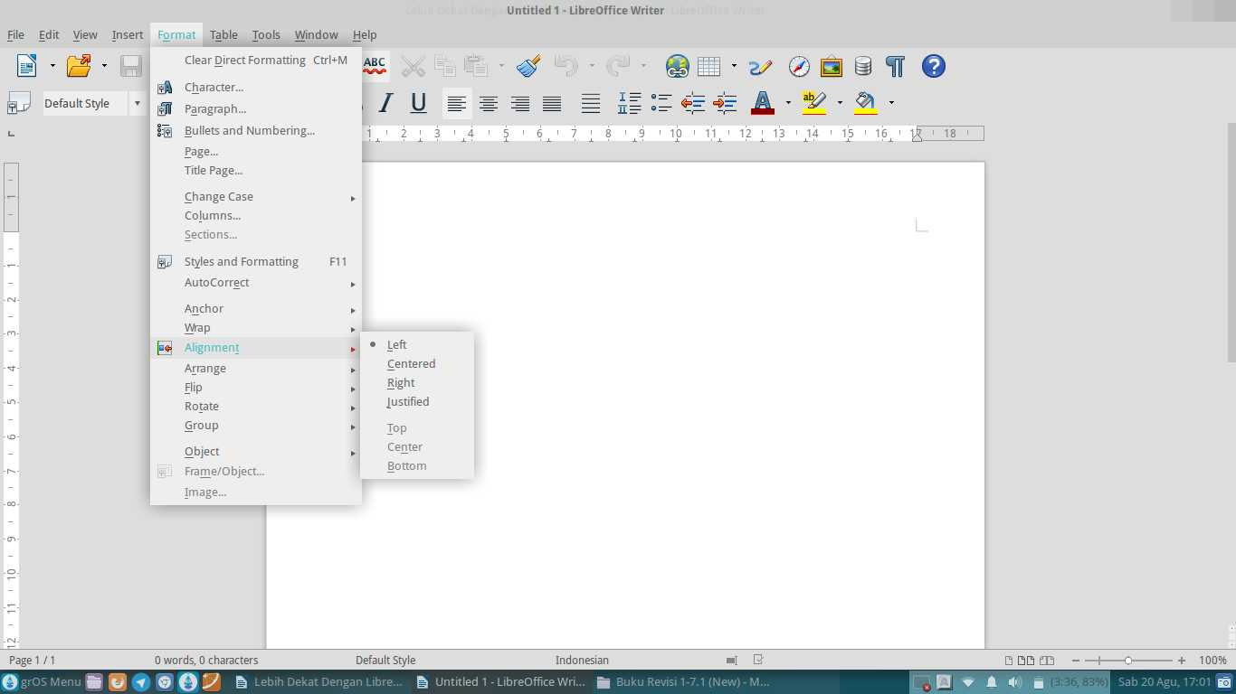
Picture 38: Sub-Sub Menu Alignment

Descriptions:
1. | Left | Make the text align left
2. | Centered | Make text centering
3. | Right | Make the text align right
4. | Justified | Make the text align left-right
5. | Top | Align text at the top of the selected objects
6. | Center | Align the text in the middle of the selected objects
7. | Bottom | Align the text at the bottom of selected objects

Sub-Sub Menu Arrange
Sub's menu arrange used to put the position of the object on a worksheet, for example: above or behind. For example, you want to put the pictures are in the rear position, you may select the option Send to Back on the Sub Menu Arrange. You can also put the object in front with select Bring to Front.
Sub's Menu Arrange is: Bring to Front, Forward One, Back One, Send to Back, To Foreground and To Background.
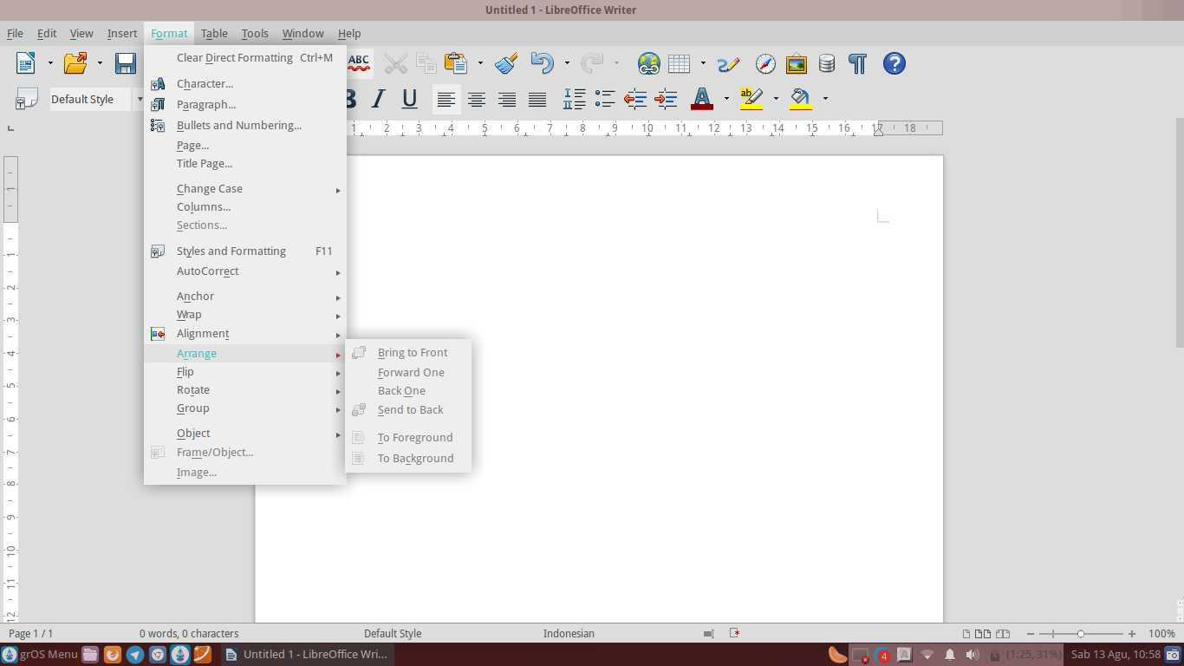
Picture 39: Sub-Sub Menu Arrange

Descriptions:
1. | Bring to Front | Change the order of the selected object to the front
2. | Forward One | Change the order of the selected objects is forwarded to the next
3. | Back One | Change the order of the selected objects is forwarded to the back
4. | Send to Back | Change the order of the selected object to the back
5. | To Foreground | Change the order of the selected objects into the foreground
6. | To Background | Change the order of the selected objects into the background

Sub-Sub Menu Flip
Sub's menu flip used to reverse the position of the object, for example: vertical or horizontal. Suppose you want to reverse the position of the picture from the horizontal into vertical. You can rotate it easily by selecting the option to Flip.
Sub Menu Flip is: Flip Vertically and Flip Horizontally.
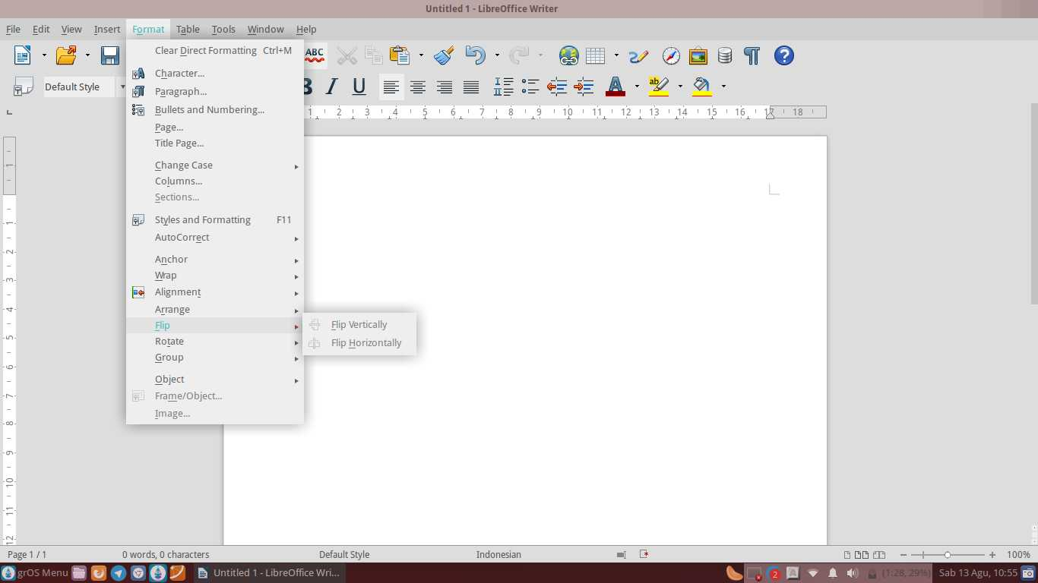
Picture 40: Sub-Sub Menu Flip

Descriptions:
1. | Flip Vertically | Reverse the object vertically
2. | Flip Horizontally | Reverse the objects horizontally

Sub-Sub Menu Rotate
Sub menus Rotate is used to rotate the object. Suppose you want to rotate the image of 90^{O}-from the horizontal position becomes vertical. You can easily rotate it by using the Sub menus Rotate.
Sub's Menu Rotate is: Rotate 90^{O} Left and Rotate 90^{O} Right.
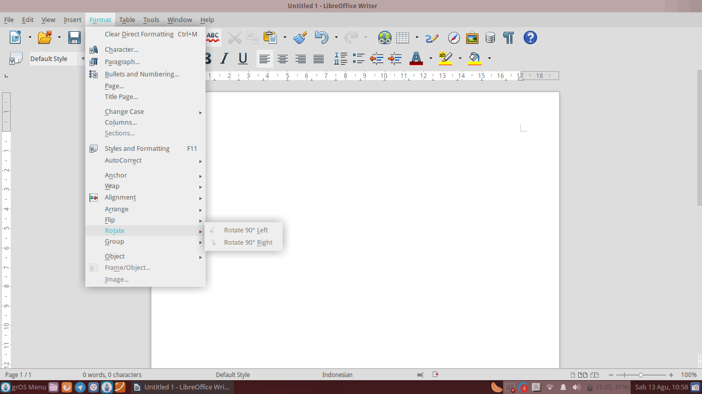
Picture 41: Sub-Sub Menu Rotate

Descriptions:
1. | Rotate 90^{O} Left | Rotate the object to the left direction of 90^{O}
2. | Rotate 90^{O} Right | Rotate the object to the right direction of 90^{O}

Sub-Sub Menu Group
Sub's menu group is used to combine several objects into one. Suppose you want to joins two separate images, you can easily combine it with select Rotate.
Sub's menu group is: Group, Ungroup, Enter Group and Exit Group.
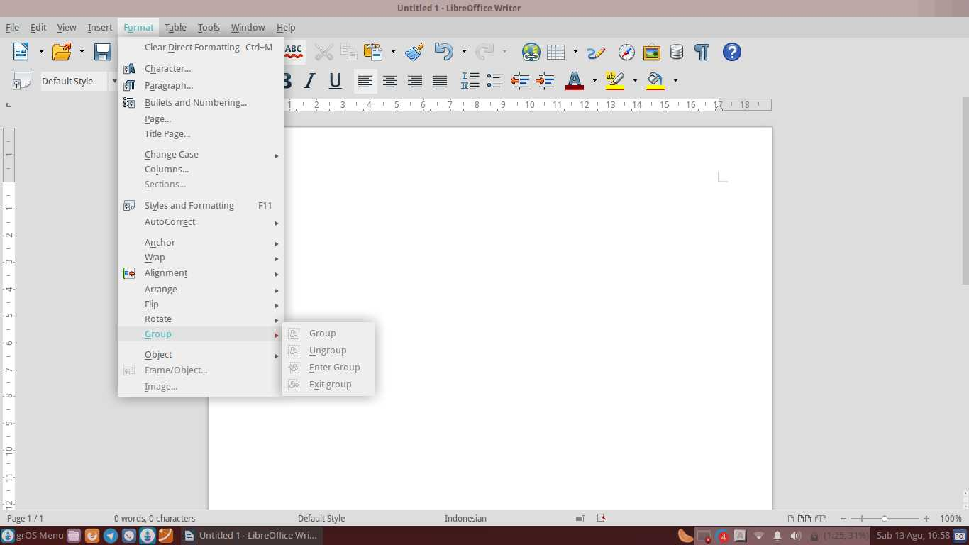
Picture 42: Sub-Sub Menu Group

Descriptions:
1. | Group | Combine several objects into one
2. | Ungroup | Undo Group
3. | Enter Group | Opens the selected group, so you can edit the individual objects
4. | Exit Group | Close the Group chosen, so that you cannot edit individual objects in a long time

Sub-Sub Menu Object
Sub Menu Object functions to set the position and size of the object into a worksheet. Suppose you want to edit the position and size of a picture that has been placed in a worksheet, you can easily set them up by selecting the option Position and Size.
Sub's Menu Object is: Position and Size, Line, Area, Text Attributes, Fontwork, Descriptions and Name.
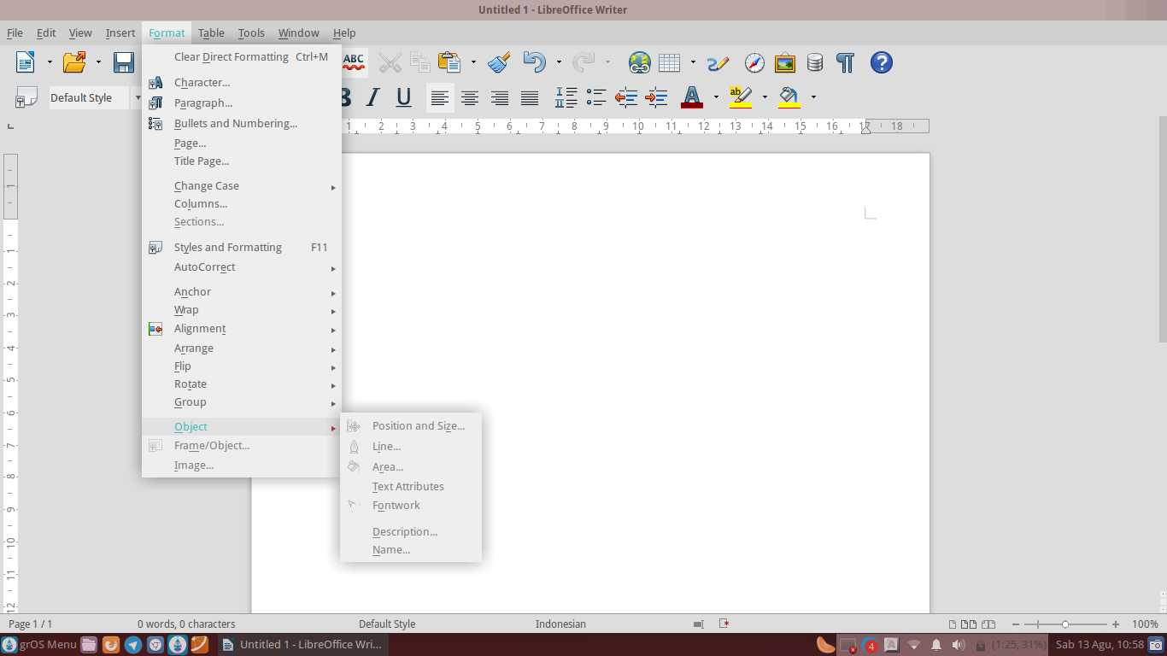
Picture 43: Sub-Sub Menu Object

Descriptions:
1. | Position and Size | Set the position and size of the selected object
2. | Line | Insert lines into documents
3. | Area | Edit the object in your document area
4. | Text Attributes | Inserts text into an object attribute
5. | Fontwork | Fontwork insert into worksheets
6. | Descriptions | Give a description on the object
7. | Name | Naming objects

The Menu Table
Menu Table is used to create the chart, combining table, delete table, adding tables and inserts the formula (formula). Sub Menu Table: Insert, Delete, Select, Merge Cells, Split Cells, Protect Cells, Merge, Split Table, Table AutoFormat, AutoFit, Heading Rows Repeat, Convert, Sort, Formula, Number Format, the Table Boundaries and Table Properties.
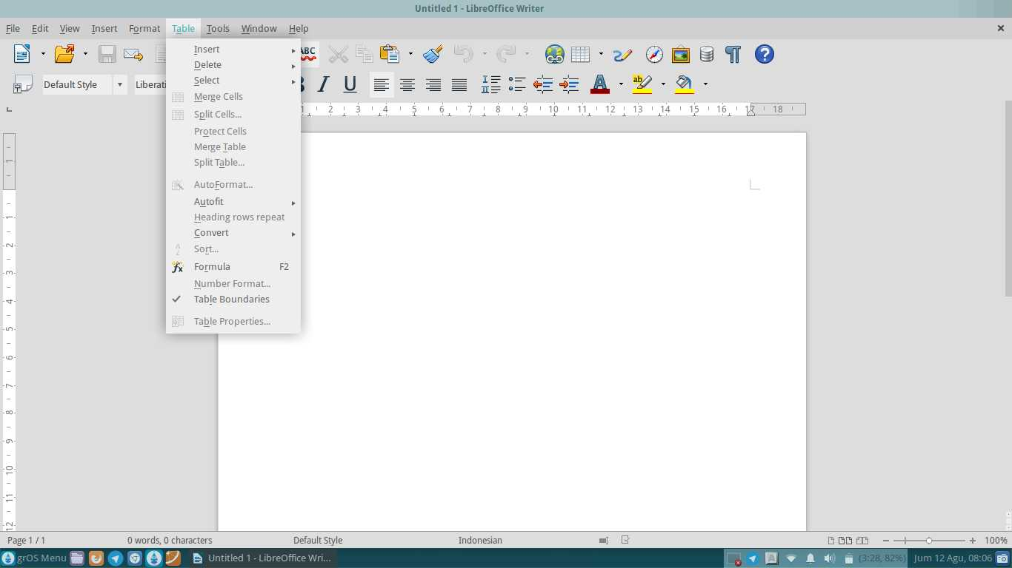
Picture 44: The Menu Table

Descriptions:
1. | Insert | Insert a table in a document
2. | Delete | Delete a table in a document
3. | Select | Select the table in the document
4. | Merge Cells | Merge the cells in the document
5. | Split Cells | Separating the cells in the document
6. | Protect Cells | Protect documents
7. | Merge Table | Combining tables in documents
8. | Split Table | Separate tables in documents
9. | AutoFormat | Turn autoformat on the table
10. | AutoFit | Turn autofit on the table
11. | Heading Rows Repeat | Repeat row Headings from the table
12. | Convert | Converting from text to a table or vice versa
13. | Sort | Sort the contents of a table
14. | Formula | Insert Formula (formula)
15. | Number Format | Set aside the option selected from the formatting
16. | Table Boundaries | Enable Table Boundaries
17. | Table Properties | Enable Table Properties

Each Sub menu on the Table Menu, has a Sub Sub Menu or options respectively. The following is a function of the options/Sub-Sub Menu Sub Menu in the Menu on the Table.

Sub-Sub Menu Insert
Sub's menu insert is used to insert a chart into a spreadsheet/document Instance that you want to insert a table into the document, you can select the Insert option. Sub Sub Menu Insert, namely: Table Rows and Columns.
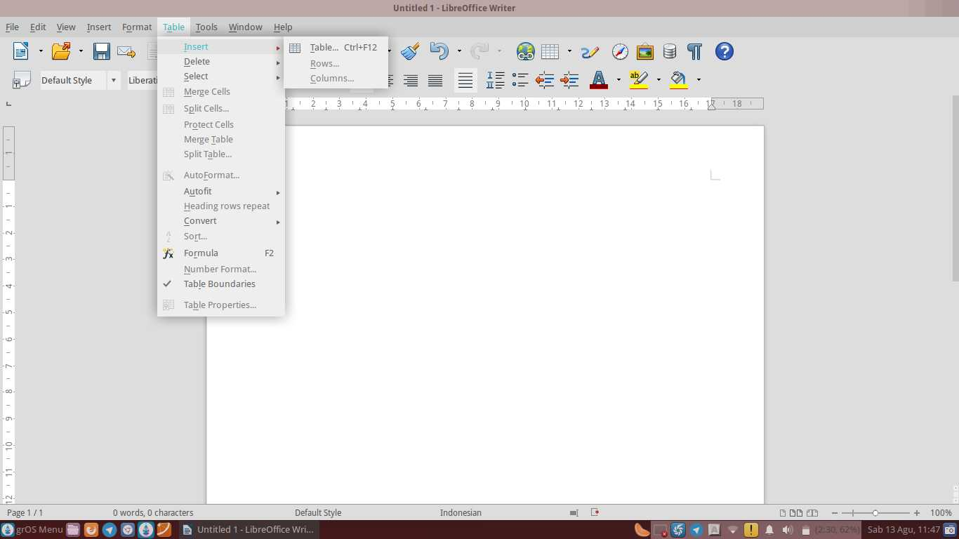
Picture 45: Sub-Sub Menu Insert
Descriptions:
1. | Table | Insert a table into the document
2. | Rows | Insert lines into documents
3. | Columns | Insert a column into the document

Sub-Sub Menu Delete
Sub's menu delete used to delete tables, rows and columns in your document. You can use this feature to delete tables, rows and columns in your document with ease.
Sub's Menu Delete is : Table, Rows and Columns.
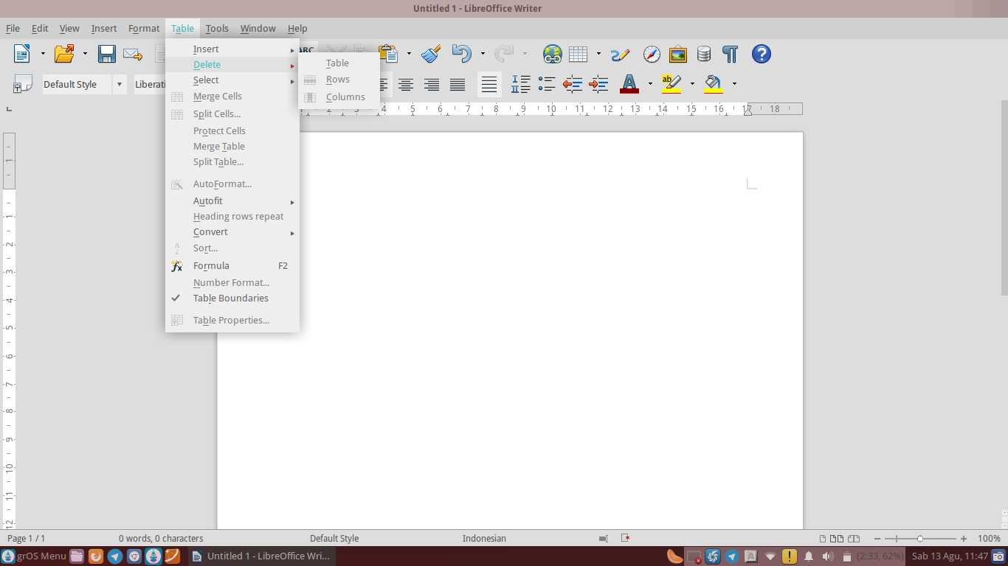
Picture 46 Sub-Sub Menu Delete

Descriptions:
1. | Table | Delete a table in a document
2. | Rows | Delete rows in the document
3. | Columns | Remove the columns in a document

Sub-Sub Menu Select
Sub's menu select function to select a table, cell, row and column. For example, You want to choose a table, you can select the Table option on the Select Sub Menu.
Sub's Menu Select is: Table, Rows, Columns and Cells.
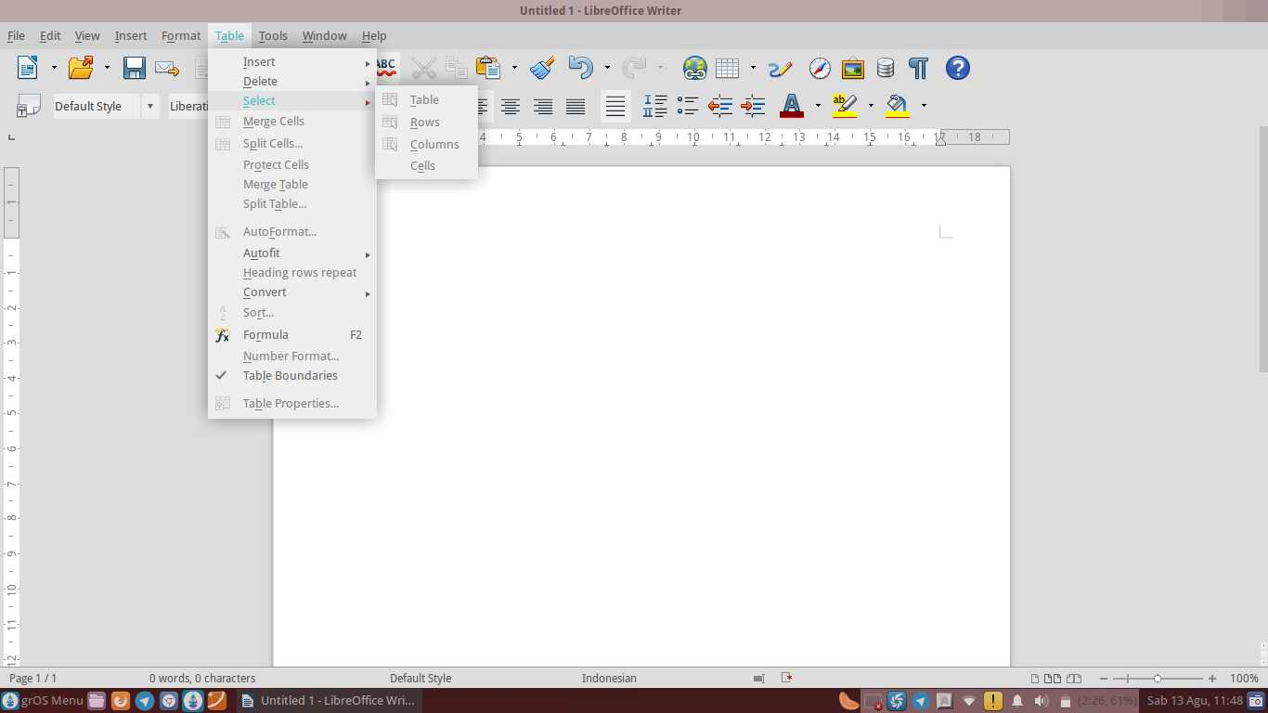
Picture 47: Sub-Sub Menu Select

Descriptions:
1. | Table | Selecting a table
2. | Rows | Selecting rows
3. | Columns | Selecting columns
4. | Cells | Selecting cells

Sub-Sub Menu AutoFit
Sub's menu autofit mode is used for the document. Suppose you want to set the column widths optimally, you can select the optimum mode of the Column Width.
Sub's menu autofit is: Column Width, Optimal Columns Width, Distribute Column Evenly, Row Height, Optimal Row Height, Distribute Row Evenly and Allow Row to Break Accross Pages and Columns.
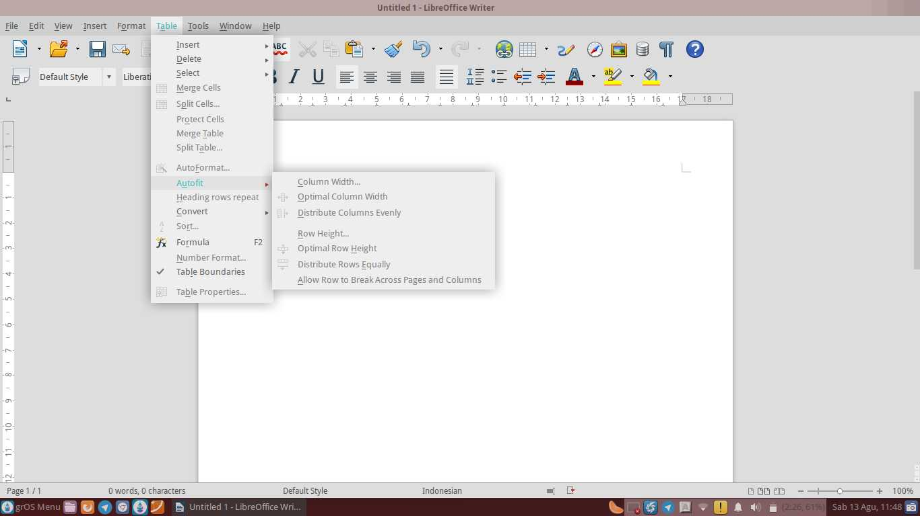
Picture 48: Sub-Sub Menu AutoFit

Descriptions:
1. | Column Width | Set the width of a column
2. | Optimal Columns Width | Set the width of the columns so that the optimal
3. | Distribute Column Evenly | Set the columns evenly
4. | Row Height | Set the height of row
5. | Optimal Row Height | Set the height of the rows so that the optimal
6. | Distribute Row Evenly | Set the height of the columns evenly
7. | Allow Row to Break Across Pages and Columns | Allow the line to split between pages and columns

Sub-Sub Menu Convert
Sub's menu convert is used to change/convert text into a table or table into the text. With this option, you do not need to be complicated to change/convert the table into which you want.
Sub's Menu Convert is: Text to Table and Table to Text.
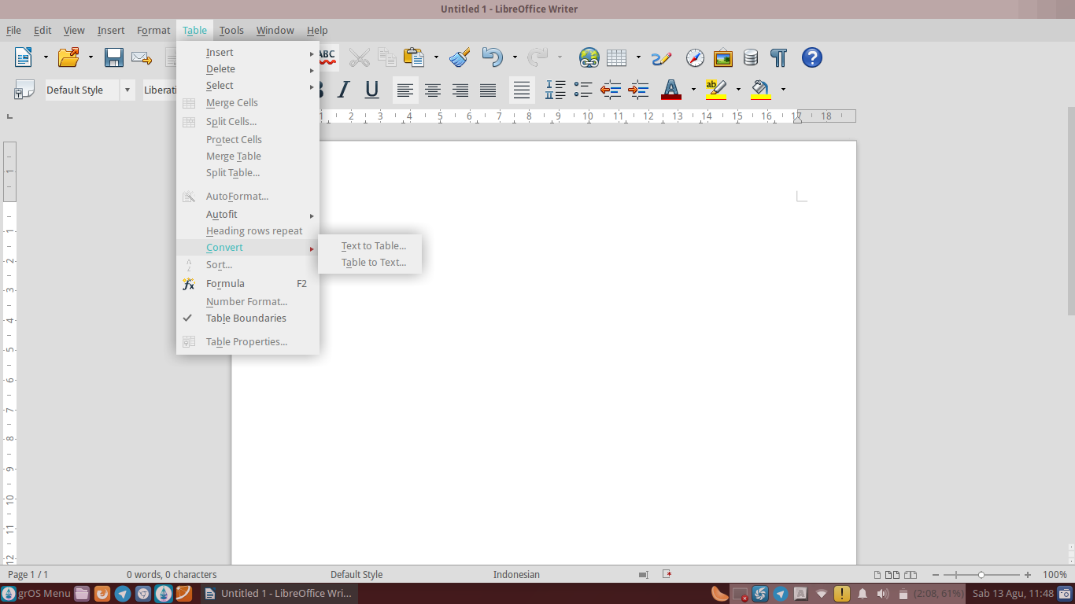
Picture 49:Sub-Sub Menu Convert

Descriptions:
1. | Text to Table | Convert text into a table
2. | Table to Text | Convert table to text

The Tools Menu
The tools menu serves to check spelling and grammar, count the number of words, insert a bibliography, mail merge, sorting, macro, auto correct, extension manager, customization and setting surrounding the LibreOffice Writer LibreOffice Writer.
Sub Menu Tools is: Spelling and Grammar, Language, Word Count, Outline Numbering, Line Numbering, Footnotes/Endnotes, Gallery, Bibliography Database, Address Book Source, Mail Merge Wizard, Sort, Calculate, Update, Macros, Extension Manager, XML Filter Settings, AutoCorrect Options, Customize and Options.
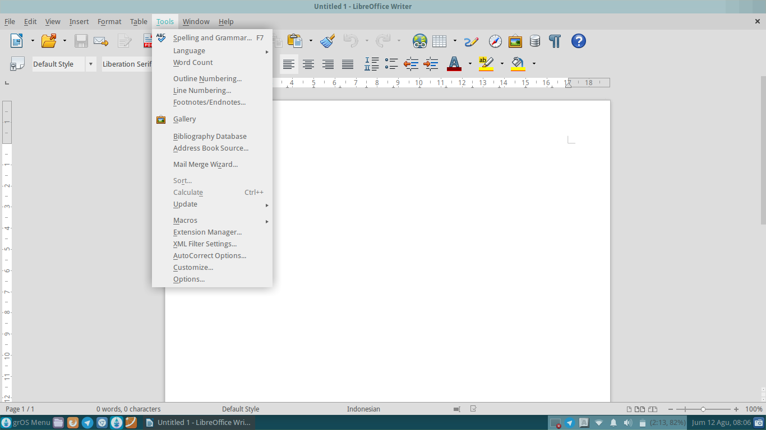
Picture 50: The Tools Menu

Descriptions:
1. | Spelling and Grammar | Check spelling and grammar
2. | Language | Select the default language to be used
3. | Word Count | Count the number of words
4. | Outline Numbering | Set the numbering on the worksheet
5. | Line Numbering | Set line numbering on a worksheet
6. | Footnotes/Endnotes | Insert a footnote.
7. | Gallery | Insert logos and symbols on the worksheet
8. | Bibliography Database | Insert a bibliography on a worksheet
9. | Address Book Source | Insert the source address book
10. | Mail Merge Wizard | Inserts a mail merge
11. | Sort | Set the order on documents alphabetically or numerically
12. | Calculate | Describe the setting calculation for numeric processing program
13. | Update | Update documents from previous changes
14. | Macros | Enable macro function
15. | Extension Manager | Manage extensions
16. | XML Filter Settings | Set the XML filter
17. | AutoCorrect Options | Set the AutoCorrect settings
18. | Customize | For customization LibreOffice Writer
19. | Options | Set the settings surrounding the LibreOffice Writer

Each Sub Menu in the Tools menu, has a Sub Sub Menu or options respectively. The following is a function of the options/Sub-Sub menus on the Sub Menu in the Tools Menu.

Sub-Sub Menu Language
Sub's menu language function to select the default language to use. The existence of this facility, the authors do not need to worry about the difficulty of the default language will be used. Because the LibreOffice Writer has been providing this option to facilitate the users.
Sub's Menu Language is: For Selection, For Paragraph, For All Text, Thesaurus, Hyphenation and More Dictionaries Online.
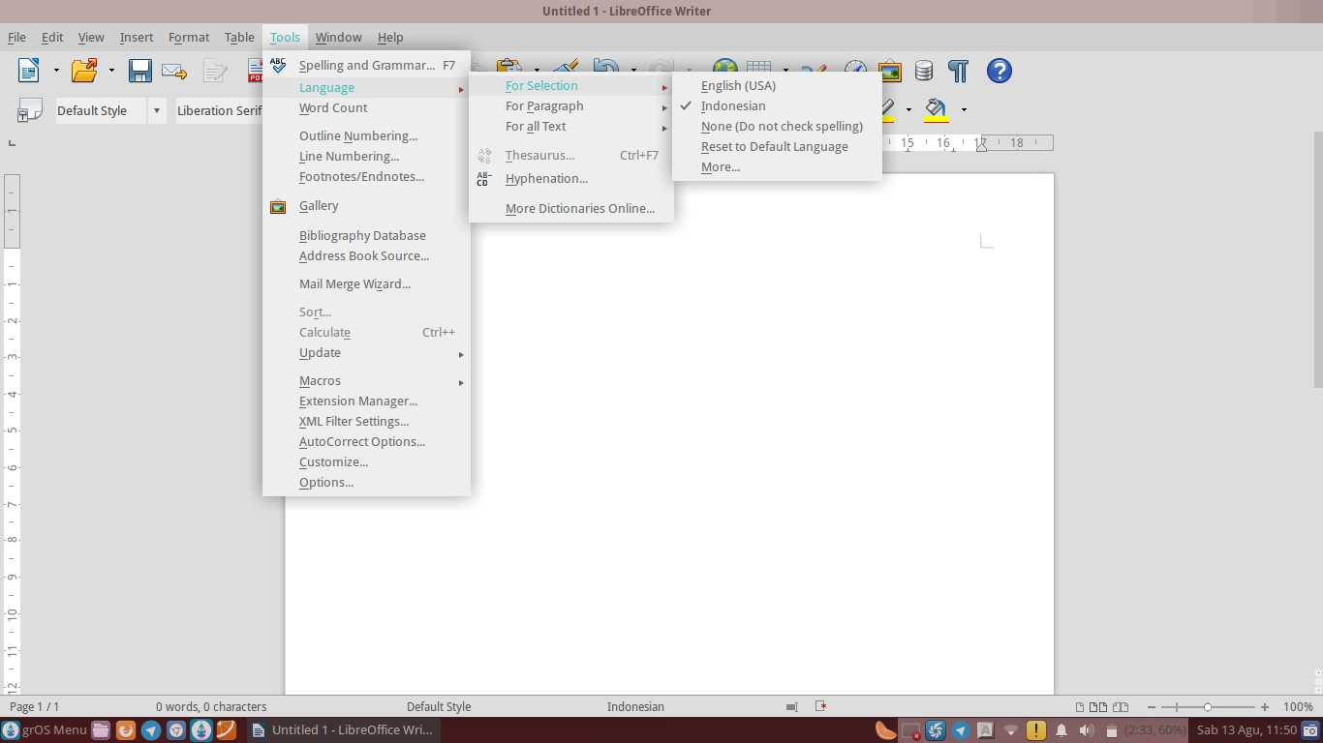
Picture 51: Sub-Sub Menu Language (For Selection)

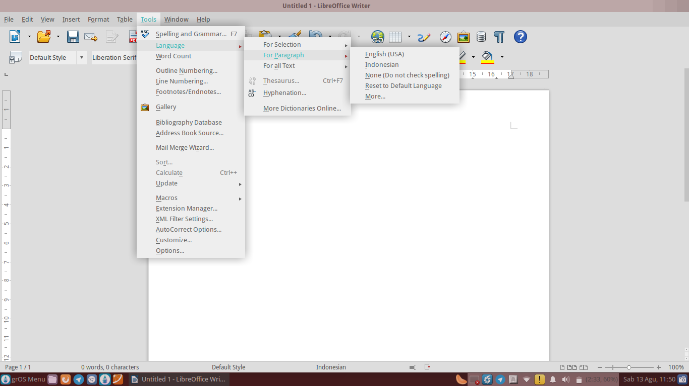
Picture 52: Sub-Sub Menu Language (For Paragraph)

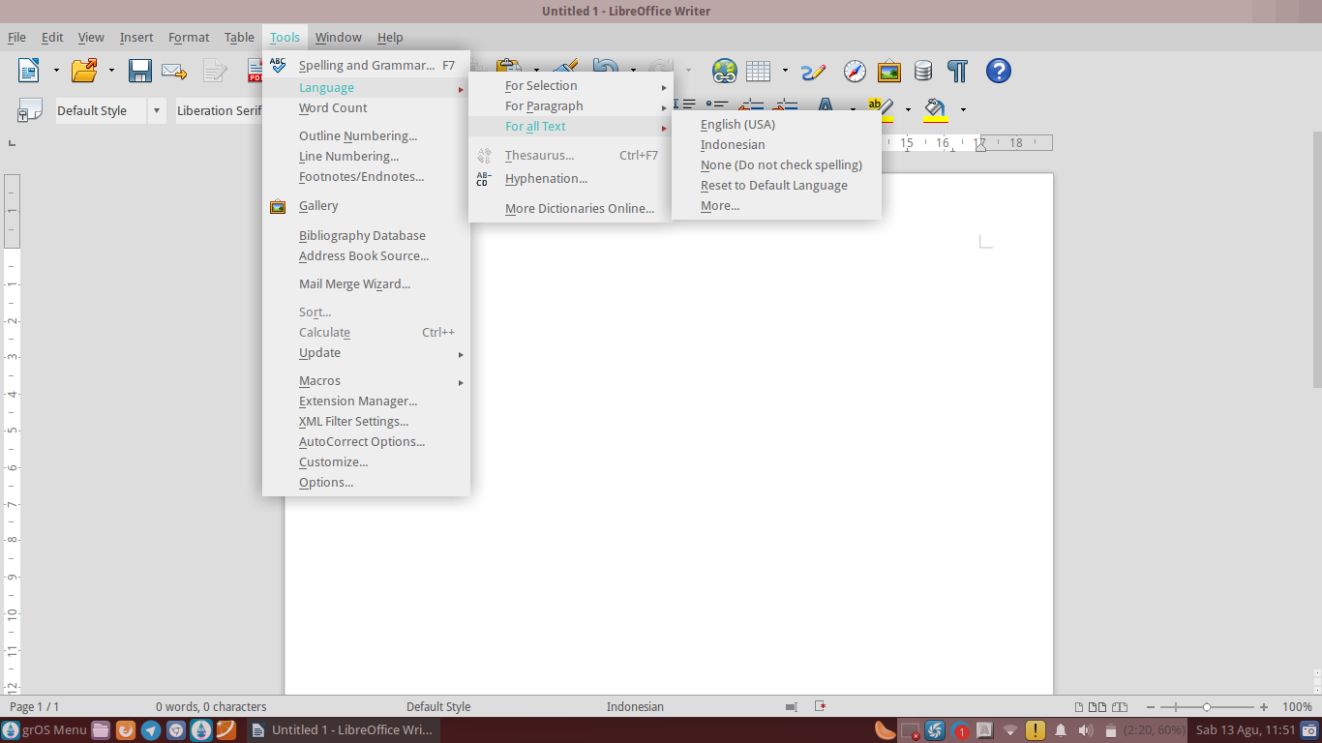
Picture 53: Sub-Sub Menu Language (For All Text)

Descriptions:
1. | For Selection | Select the default language for selection
2. | For Paragraph | Select the default language for paragraphs
3. | For All Text | Select the default language for the entire text
4. | Thesaurus | Check each word with Dictionary Thesaurus
5. | Hyphenation | Separate the words with symbol separated.
6. | More Dictionaries Online | Check each word with another online dictionary

Sub-Sub Menu Update
Sub's menu update functions to update documents from previous changes. Suppose you want to update all documents or fields only. You can easily update it by choosing the option to Update All or Fields.
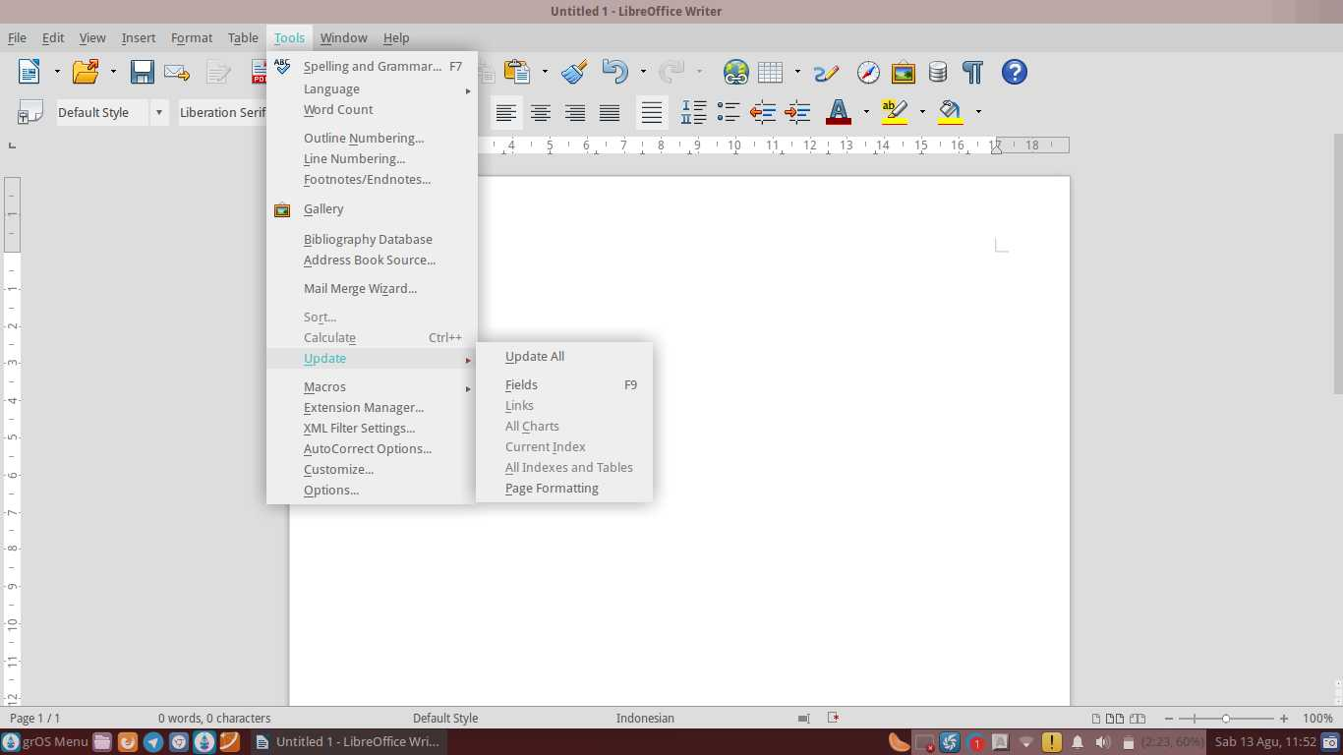
Sub's Menu Update is: Update All, Fields, Link, All Charts, Current Index, All Indexes and Tables and Page Formatting.
Picture 54: Sub-Sub Menu Update

Descriptions:
1. | Update All | Update the contents of the entire document
2. | Fields | Update the contents of a field
3. | Link | Update the link to the document
4. | All Charts | Update the entire diagram
5. | Current Index | To update a specific index
6. | All Indexes and Tables | Update the entire table and index
7. | Page Formatting | Update the settings page

Sub-Sub Menu Macros
The menu macros function to activate a function on LibreOffice Writer. Suppose you want to record the macro to do format, then any document you run the macro, the document will be formatted automatically according to your will. However, the average macro more utilized in LibreOffice Calc.
Sub's Menu Calc is: Record Macro, Run Macro, Organize Macros, Digital Signatures and Organize Dialogs.
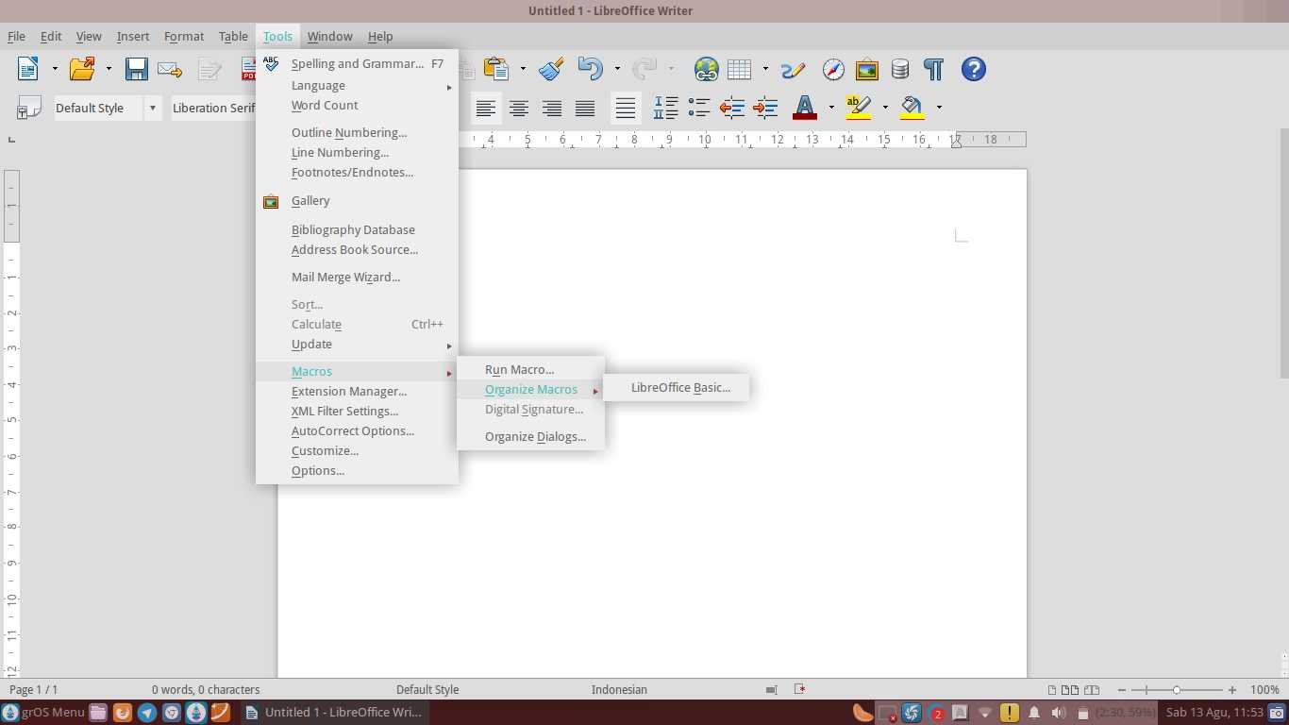
Picture 55: Sub-Sub Menu Macros

Descriptions:
1. | Record Macro | To record the activity into a macro
2. | Run Macro | To run the macro in the document function
3. | Organize Macros | To manage macro-macro on Writer
4. | Digital Signatures | Enable digital signatures
5. | Organize Dialogs | Manage Dialog Writer

By default, the Sub Menu Record Macros are not shown unless we turn on in advance via Menu Tools Option >, then select Advanced > LibreOffice. Select the Enable macro recording (may be limited)
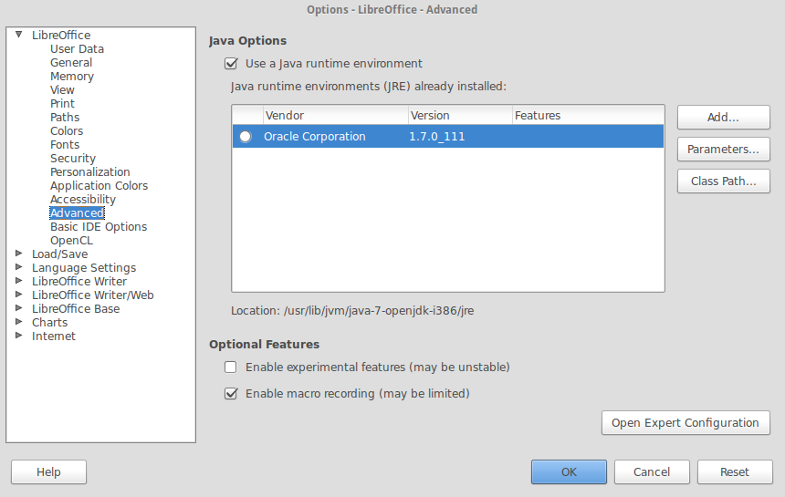
Picture 56: Activate Record Macro

Menu Window
Menu windows is used to open the same document and being active, close the active document and know the name of the document that is being worked on/off. Sub Menu Window IE: New Window and Close the Window.
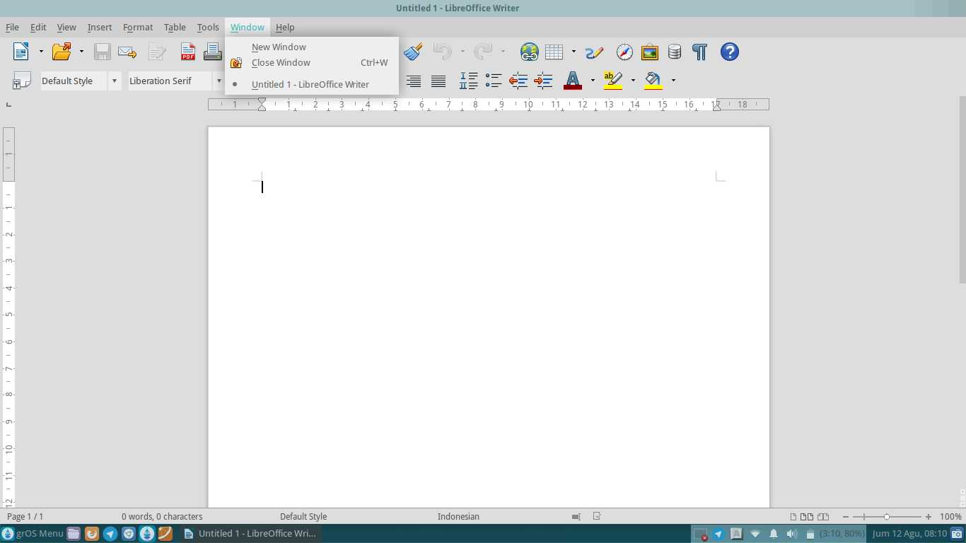
Picture 57: Menu Window
Descriptions:
1. | New Window | Open the document that is active
2. | Close Window | Close the active document

Menu Help
Menu help is used to ask for help about LibreOffice, send feedback, knowing information about license and LibreOffice. Sub Help Menu are: LibreOffice Help, what's This, Send Feedback, License Information and About LibreOffice.
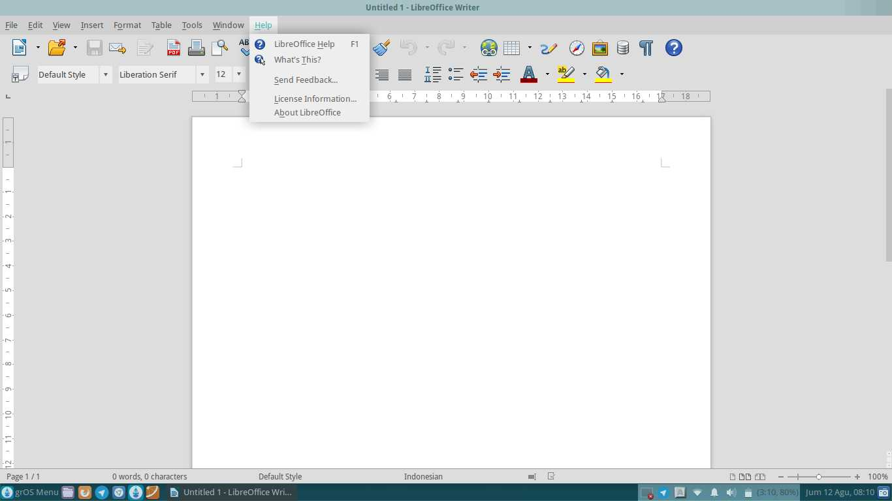
Picture 58: Menu Help

Descriptions:
1. | LibreOffice Help | Find out information, functions and how to use tools-tools that exist on the LibreOffice
2. | What’s This | So users know the meaning one by one the icons and menus that are on the LibreOffice Writer
3. | Send Feedback | Send feedback to libreoffice.org
4. | License Information | To find out information from license LibreOffice
5. | Organize Dialogs About LibreOffice | To find out information about LibreOffice, version LibreOffice used, credit to libreoffice.org and website of LibreOffice

CHAPTER 6 HEADING
BAB 6
HEADING

Copyright © 2016 Ade Malsasa Akbar < teknoloid@gmail.com >
Translated by Ilham Akbar <ilhamsahil05@gmail.com>

Heading
This chapter explains about how to compose the content in well structured arrangement, so that each component could be fully managed by the writer. A well structured arrangement could be achieved by applying a feature named heading (or called Paragraph Style) on the title, subtitles, and the sub of a writing subtitle. Benefits of using heading are so many, some of those are a full control of the whole article, the ease of arranging the index automatically and navigating (changing position) in a lengthy and complex article.

Applying Heading
Heading is commonly applied on the title, chapter title, subtitle, sub of a subtitle, etc. By applying heading, LibreOffice will record each heading as “one point” and it will fully map the document content into Navigator dialogue (F5).
- The way how to apply heading on title is by locating the cursor on the text > click combo box Default Style > select Heading 1.
- The way how to apply heading on subtitles is by locating cursor on the text > click combo box Default Style > select Heading 2.
- The way how to apply heading on the sub of a subtitle is by locating cursor on the text > click combo box Default Style > select Heading 3.
- Applying heading on a sub of sub is by doing the same step with a higher number. The deeper it is, the higher its number.

Quick Way: Shortcut for heading 1 is Ctrl+1. Shortcut for heading 2 is Ctrl+2. Shortcut for heading 3 is Ctrl+3. The next heading only need the correct number.

Appearance of The Writing
The following figure is a simple document of which already have such a heading arrangement. Take a look on how the headings being applied, also take a look on the Navigator panel on the right side. The content of a document which already have heading will be mapped onto Navigator. Please compare with a document which has no heading at all (for example, just having bold).
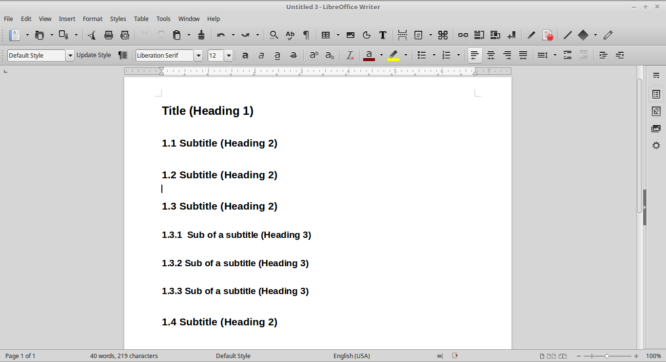
Picture 59: Heading Application

Appearance of Automatic Index
The following is the same document with an automatically created index. The result is tidy and consistent with the headings of which applied in advance/previous
and surely matches with the map on the Navigator. In the other hand, the way how to create index lies on its specialized chapter.
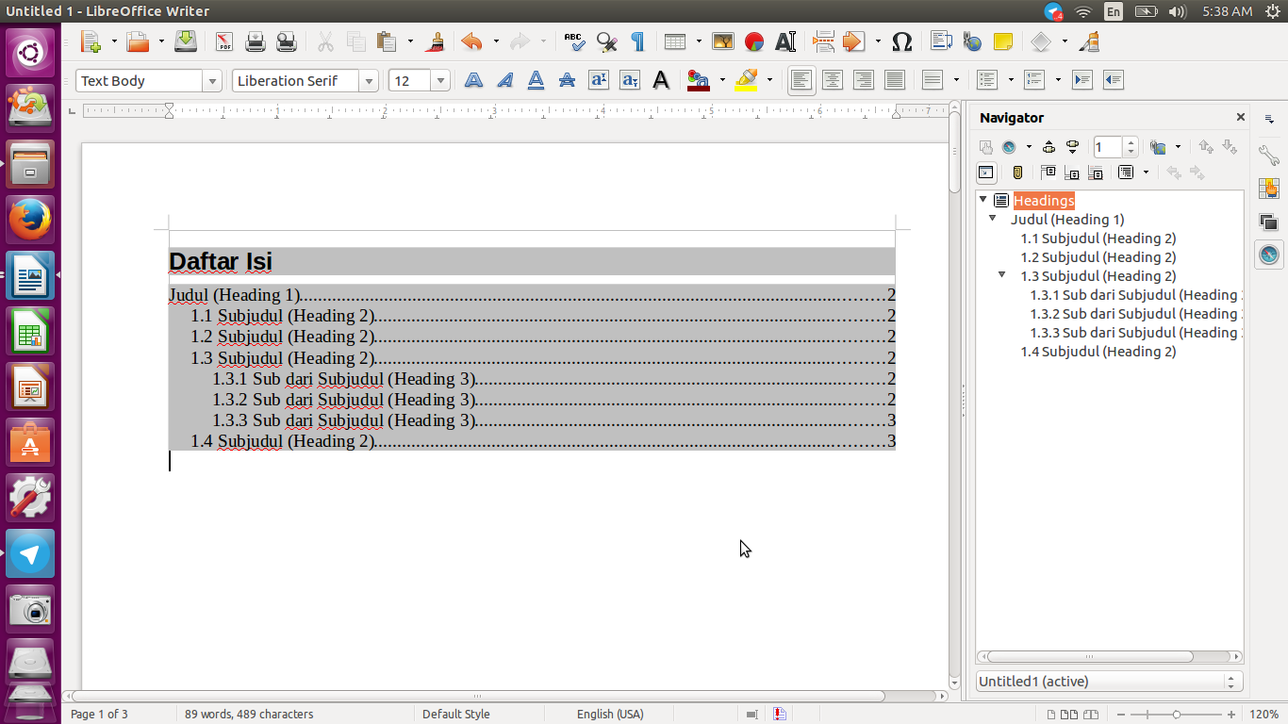
Picture 60: Appearance of Automatic Index

Appearance of PDF
The following figure is the appearance of the same document of which already saved as PDF file and shown on Evince document viewer application. That PDF file will have the same outline as it appears on a professional PDF file level. Of course its outline matches the heading arrangement of which already created, as match as in the Navigator, and matches the previous automatic index. Look onto the following Evince side-panel. In the other hand, the way how to create a PDF file lies on its specialized chapter.
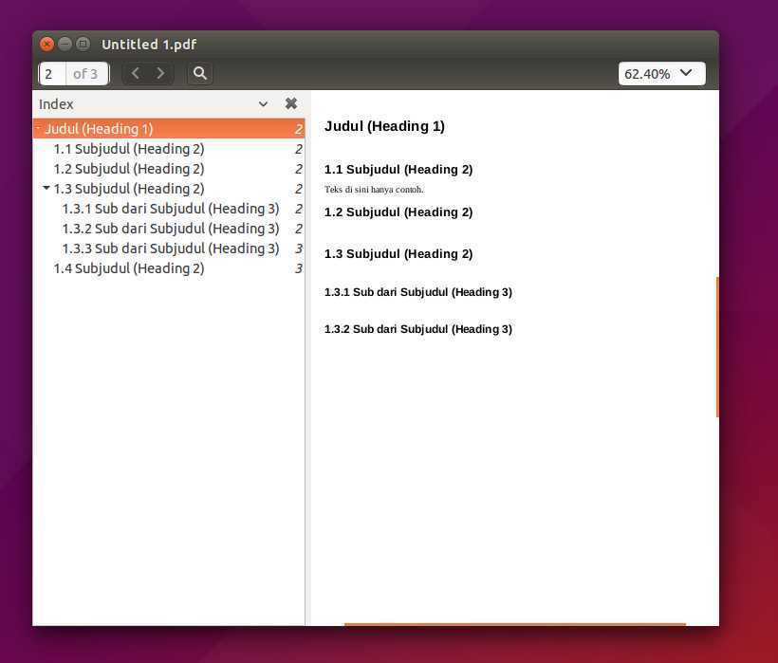
Picture 61: Appearance of PDF

CHAPTER 7 SHORTCUTS ON LIBREOFFICE WRITER
CHAPTER 7
SHORTCUTS ON LIBREOFFICE WRITER

Copyright © 2016 Ade Malsasa Akbar <teknoloid@gmail.com>
Translated by Ilham Akbar <ilhamsahil05@gmail.com>

This chapter explains a number of commonly used shortcut keys for LibreOffice.

Shortcut | Function
Ctrl+A | To select the entire content of a document
Ctrl+O | To open a document of which already being saved once
Ctrl+S | To save the document
Ctrl+Shift+S | To save an active document with a different name of file
Ctrl+Alt+C | To create side comment box
Ctrl+F | To find a text or word
Ctrl+H | To find and replace a text or word
Ctrl+Z | To undo/cancel the previous command
Ctrl+Y | To redo the last canceled command
Ctrl+1 | To apply heading 1
Ctrl+2 | To apply heading 2
Ctrl+3 | To apply heading 3
Ctrl+n | To apply heading n
Ctrl+N | To create a new document
Ctrl+W | To close a currently active document
Ctrl+C | To copy any selected object
Ctrl+V | To paste an already copied object into a document
Ctrl+Q | To close a currently active worksheet
Ctrl+E | Center text
Ctrl+R | Right align text
Ctrl+L | Left align text
Ctrl+J | Justify text
Ctrl+F2 | To show Fields dialog box
Ctrl+F3 | To show AutoText dialog box
Ctrl+F4 | To close a currently active document/to save a document
Ctrl+F7 | To show the Thesaurus tool
Ctrl+F10 | To show Non-Printing Character
Ctrl+F11 | To apply Paragraph Style
F1 | To show LibreOffice Help center
F2 | To show the toolbar of Formula
F5 | To show Navigator
F7 | To show Spelling management tool
F11 | To show Styles and Formatting tool
F12 | To apply numbering feature

Table 12: Shortcuts on LibreOffice Writer

CHAPTER 8 COMPATIBILITY
CHAPTER 8
COMPATIBILITY

Copyright © 2016 Mochammad Nur Afandi <muh.afandi.fandi@gmail.com>
Translated by Mochammad Nur Afandi <localanu@gmail.com>

As we know, LibreOffice users in Indonesia are a bit and Mostly, computer users are using Microsoft Office for their Office Suite. It is difficult for beginner of LibreOffice while using LibreOffice. We have solutions for this problem mentioned in the list below:

LibreOffice Writer
- Using Nimbus Roman No.9 L for replacing Times New Roman font
- Using Nimbus Sans L for replacement of Arial font
- Saving document using pdf format or doc (Microsoft Office Document 2003) for reducing broken style in Microsoft Office Word

LibreOffice Calc
Saving document using xls format for avoiding compatibility issue on Microsoft Office Excel

LibreOffice Impress
Saving document using ppt format for avoiding compatibility issue on Microsoft Office PowerPoint. The best solution for this problem is using LibreOffice portable version from the portable devices and you can download it from https://www.libreoffice.org/download/portable-versions/.

CHAPTER 9 HOW TO WRITE ARABIC IN LIBREOFFICE WRITER
CHAPTER 9
HOW TO WRITE ARABIC IN LIBREOFFICE WRITER

Copyright © 2016 Mukafi <kakafi30@gmail.com >
Translated by Raymon Rahmadhani <raymon.rahmadhani@gmail.com>

In the past, due to the limited sources, people got difficulties to write Arabic alphabet (Hijaiyah) using their computer. People used to write it manually If they want to do so. Nowadays, the need of using this kind of language is getting higher. Now, writing Arabic alphabet can be easily done in LibreOffice writer. Fortunately, LibreOffice facilitates tons of language writing types.
Therefore, the steps to type Arabic alphabet in LibreOffice Writer are as follows:
- First, Make sure that you have added your keyboard characters.

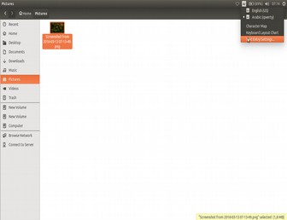

Picture 62: Adding keyboard character
- Then, add Arabic keyboard as shown in the following picture.
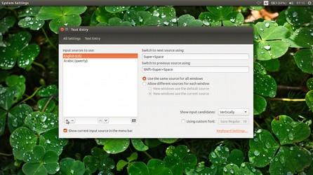

Picture 63: Adding Arabic type keyboard

- Afterwards, Open your LibreOffice Writer application.
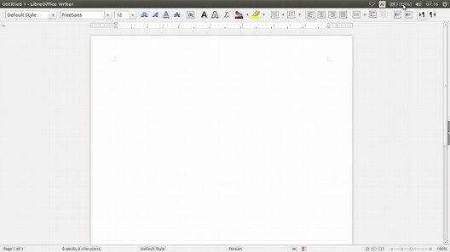
Picture 64: Default view of LibreOffice Writer
- Click “right to left” menu on your LibreOffice writer.
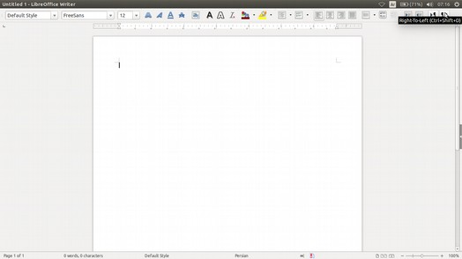
Picture 65: Choosing Right to Left Menu

By this way, Arabic alphabet can be typed in your LibreOffice. Furthermore, in order to type Arabic number, you may do the following steps:

- Click the Tools menu. Then, choose Options.
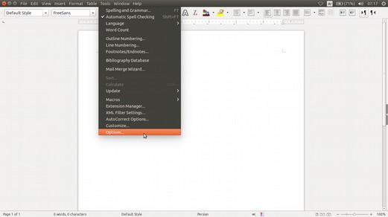
Picture 66: Choosing option in Tools menu

- Then, go to Language settings and click Complex Text Layout. And then, go to General Options and change Numerals into Hindi as described in the following picture.
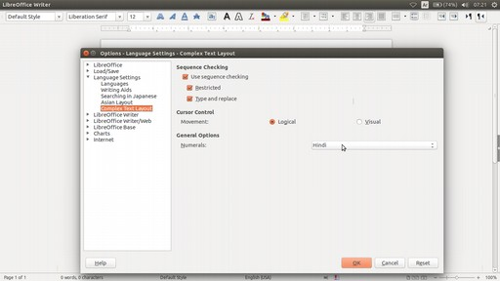
Picture 67: Changing Numerals’ point to Hindi

- The picture is the screenshot result.
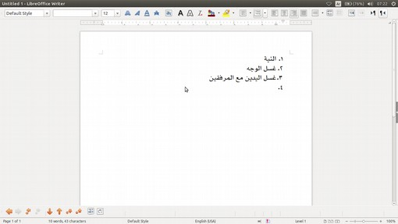
Picture 68: A screen
shoot of Writing Arabic in LibreOffice Writer

CHAPTER 10 CREATING AN AUTOMATIC TABLE OF CONTENT
CHAPTER 10
CREATING AN AUTOMATIC TABLE OF CONTENT

Copyright © 2016 Taufik Hidayat <yumtaufik1997@gmail.com >
Translated by Raymon Rahmadhani <raymon.rahmadhani@gmail.com>

Table of content is important part that should be written in every paper, thesis, journal, etc. Therefore, it needs certain method to create it proper and neat. The following will be explained the steps that appropriate with LibreOffice Writer method to create it.
- Firstly, the following picture is as the example.
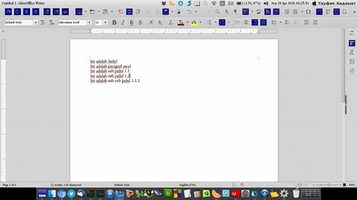

Picture 69: Step 1 Creating an Automatic Table of Contents

- Create a page for every sentence. Place the cursor at the beginning of the sentence, then press Ctrl + Enter. Pay attention to the following picture that describes how it goes.
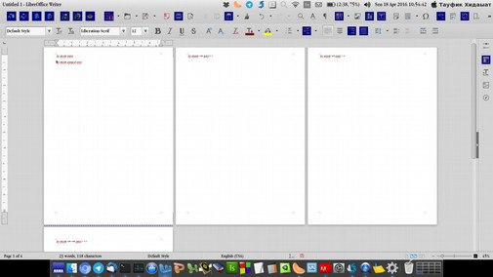
Picture 70: Step 2 Creating an Automatic Table of Contents

- Apply heading to the selected sentence in every created page that later on will help you to create the automatic Table of Contents. Apply level 1 heading (Heading 1) for the title, level 2 heading (Heading 2) for sub-title, and level 3 heading (Heading 3) for sub sub-title. As consideration, you have to apply it properly. Do not change the default font size given, changing the font size may cause the sentence does not emerge. Pay attention to the following picture.

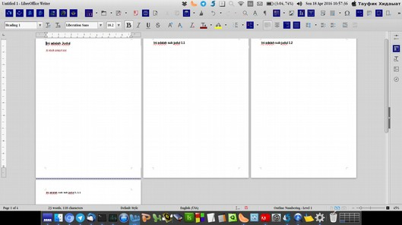
Picture 71: Step 3 Creating an Automatic Table of Contents

- After applying the heading, create a new page which is placed before the title page you have created. It is prepared for Table of Contains page as described in the following picture.
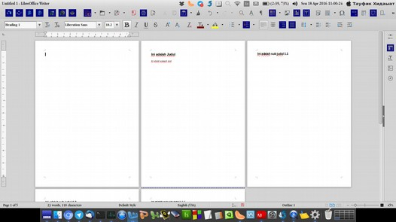
Picture 72: Step 4 Creating an Automatic Table of Contents
- If all is ready, we can start creating the Table of Contents based on the following steps, those are clicking Insert at the tab menu for the first. Next, choose Table of Contains and Index, then choose Table of Contents, Index or Bibliography. Therefore, there will be a window as it’s shown in the following picture.
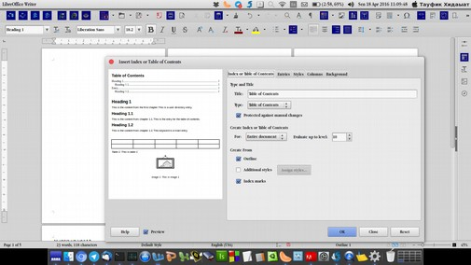
Picture 73: Step 5 Creating an Automatic Table of Contents

- Leave empty or delete the sentence in Title column at Type and Title option as explained in the picture below.
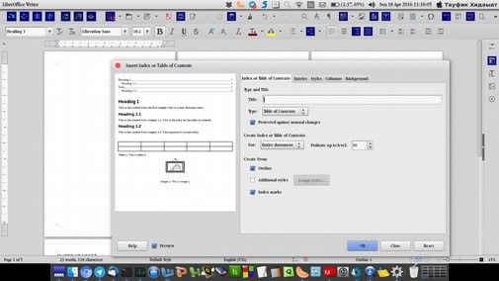
Picture 74: Step 6 Creating an Automatic Table of Contents
- The following step is click OK. As the result, it will show as the following picture.
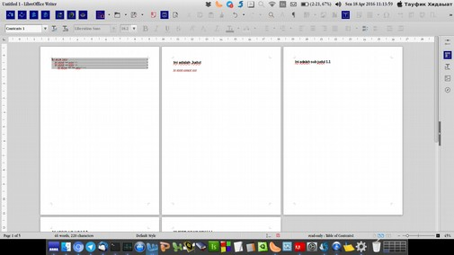
Picture 75: Step 7 Creating an Automatic Table of Contents

- Finally, the steps of creating the automatic table of contents is complete. Additionally, as shown in the following picture, you may add a title above the table of contents and set the text position properly.
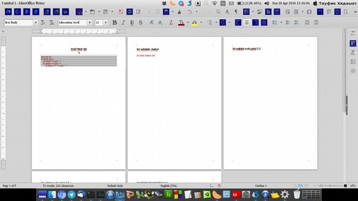
Picture 76: Step 8 Creating an Automatic Table of Contents

CHAPTER 11 PAGE FORMATTING
CHAPTER 11
PAGE FORMATTING

Copyright © 2016 Anto Samalona <ansamsoftdev@gmail.com>
Translated by kucingsebelah <meongpus@hi2.in>

Setting Margins
In this Section, we will learn how to set Margins (edge of paper) in LibreOffice Writer, it is very simple

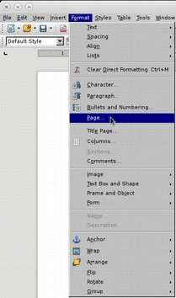
- First at Menu Bar choose Format menu then select Page

Picture 77: Setting Margins using Format Menu

- Window Page Style menu will show up.
- Choose Paper Format (A4, Letter, Legal or Longbond etc) then set the Margins size (Left, Right, Top, Bottom) and click OK button if you finish it.
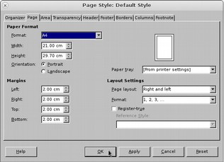
Picture 78: Page Style window

Advanced methods in setting up the Margins will explained in separate chapter.

Setting the Line Spacing
Line spacing is often used in reports, papers, report etc. Unfamiliar user may have difficulty to set the Line spacing. You can follow simple step as below:
- First at Menu Bar choose Format Menu then Paragraph.
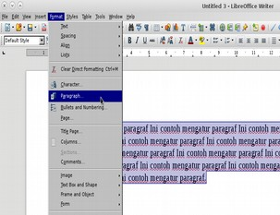
Picture 79: First step to setting Line Spacing

- Paragraph window will show up.
- At Line Spacing menu, choose spacing as you want (Single, 1.5 Lines, Double etc) then click OK button.

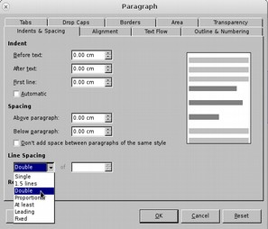

Picture 80 : Paragraph Window

In this tutorial, we implement Double spaces as example. Here's an illustration to simplify you getting the difference.

Before :
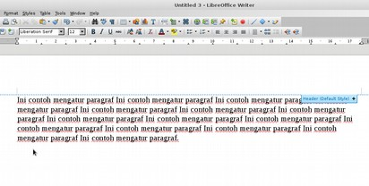
Picture 81: A Paragraph before using Double spaces
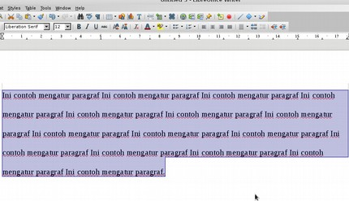
After :
Picture 82: A Paragraph after using Double spaces

Advanced methods to setting up the Line Spacing will explained in separated chapter.

Page Numbers
Page Numbers are very important part from a document, it simplify reader to search chapter or subsection. In Writer, a page number is a field that you can insert into your text.
To set up Page Numbers you can follow step as described below :
- Choose Insert menu at Menu Bar.
- Then choose Header and Footer, choose Footer sub-menu, then click Default Style.

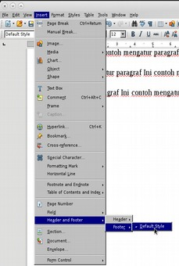

Picture 83: how to set Page Numbers

- A display will appear as below
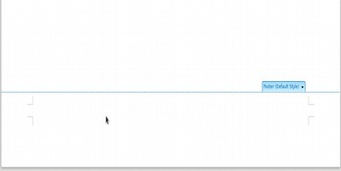
Picture 84: Default Style from Sub Menu Footer

- Enter the page number by selecting Insert menu → Field → Page Number. Automatically LibreOffice Writer will give the page number according to your page. By default, LibreOffice Writer will place the page number according to the documented alignment settings (left / align left / Ctrl + L). To make it at the right, you can use the right align right (Ctrl + R) command.
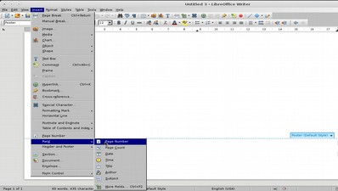
Picture 85: Page Number Menu

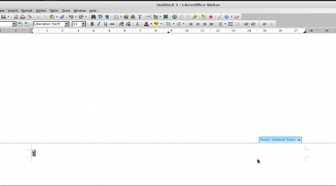
Picture 86: final result of Page Number

CHAPTER 12 INSERTING PICTURE ON LIBREOFFICE WRITER
CHAPTER 12
INSERTING PICTURE
ON LIBREOFFICE WRITER

Copyright © 2016 Taufik Hidayat <yumtaufik1997@gmail.com >
Translated by Thoriq Kemal <thoriqcemal@gmail.com>

An Article will feels lack and bad if we can’t find some picture inside of that. Explanation of some articles will be understood easily if we found some picture available. Therefore, reader will easily understand information from Article.
LibreOffice Writer has provided facilities to Insert Picture to the document since first release. Step by steps to Insert Picture on LibreOffice as below :

- First Open your LibreOffice Applications.
- Choose Menu Insert on Menu Bar.
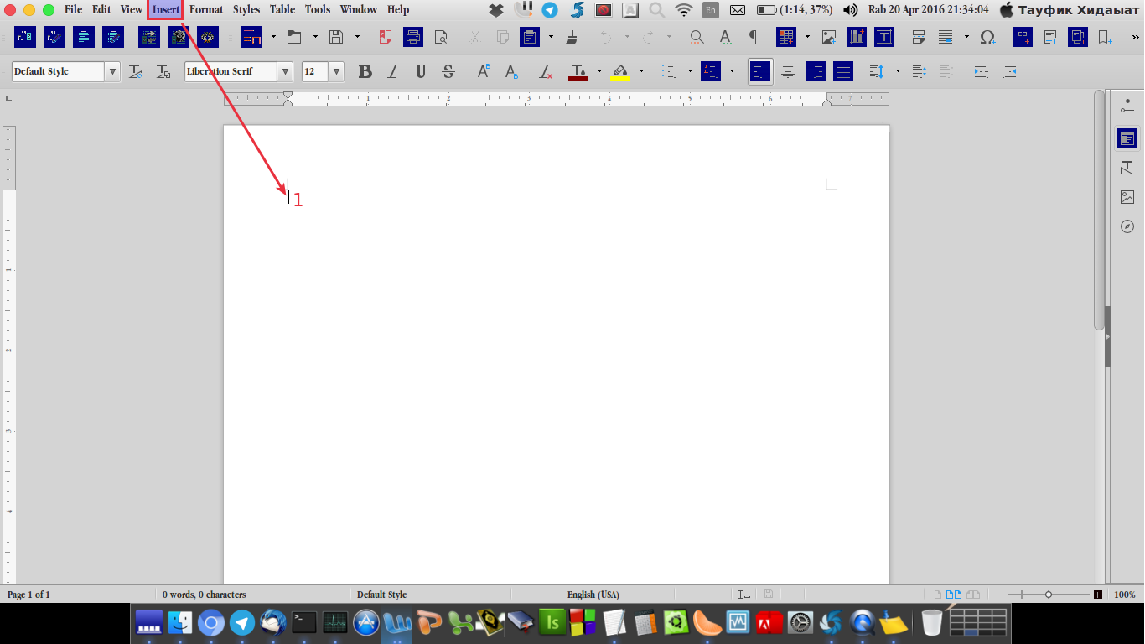
Picture 87: Choose Insert Menu
- Choose Sub Menu Image.
- Then, there will be a dialog box like figure below.
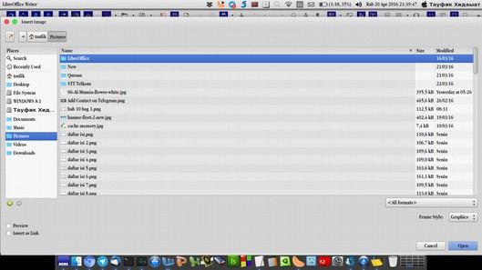
Picture 88: Choose Picture

- Choose Picture which you will insert to document.
- For Example of Picture which inserted to document, Look at figure below.
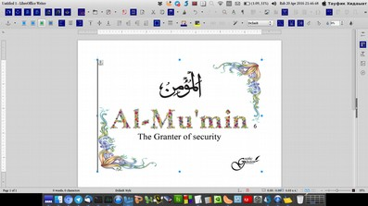
Picture 89: Picture which inserted to document

CHAPTER 13 CREATING TABLE ON LIBREOFFICE WRITER
CHAPTER 13
CREATING TABLE ON LIBREOFFICE WRITER

Copyright © 2016 Taufik Hidayat <yumtaufik1997@gmail.com >
Translated by Thoriq Kemal <thoriqcemal@gmail.com>

We often find some articles or information which is excessive and complicated. This can make us bored before we finish to read it. By using Table, some explanations and illustration can be summarized to data arrangement. The figure below is an example of Table we quoted from the internet.
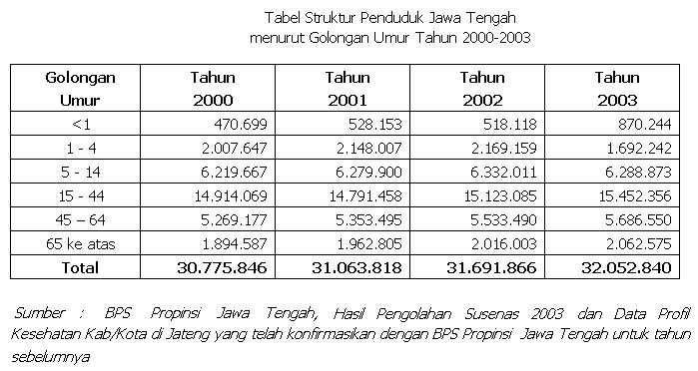
Picture 90: Example Table

Step by step to create Table:
- First Open your LibreOffice Application.
- Further, on Menu Bar Click Table, Look at figure below.
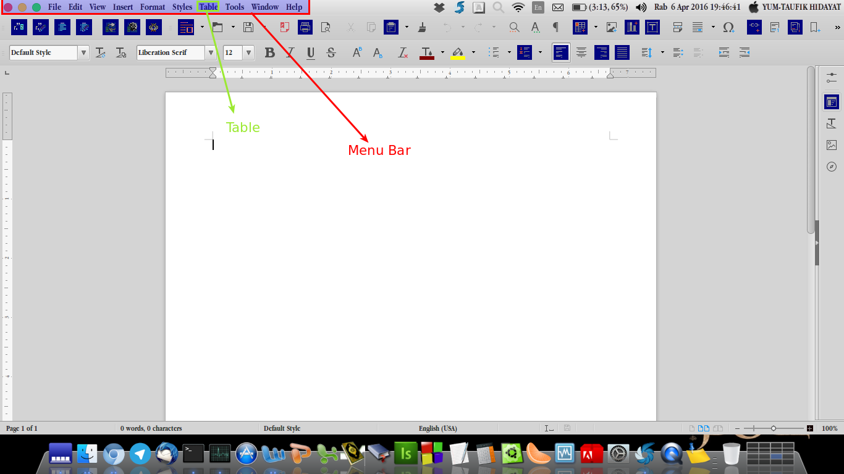
Picture 91: Choose Table on Menu Bar

- Choose Insert Table or keyboard shortcut Ctrl+F12.
- Insert Table Name, Columns and Rows. Look at the figure below.

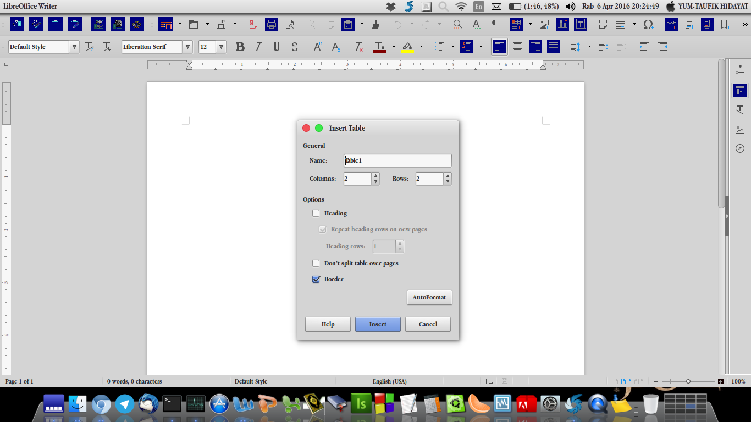
Picture 92: Insert Table Name, Columns and Rows

- Click Insert to Insert Table.
- Then will display like figure below.
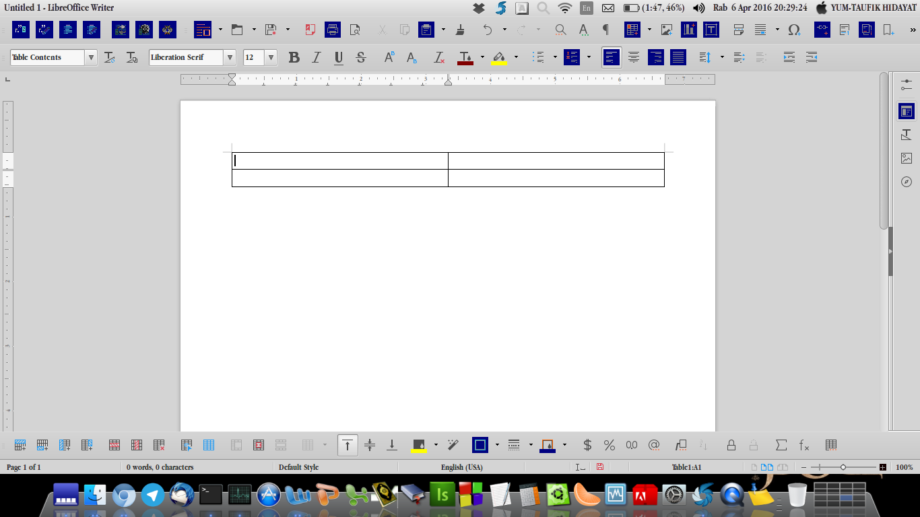
Picture 93: Results from Insert Table

Notes:
You can add, edit or delete table accordance with your needs.

CHAPTER 14 SAVING THE DOCUMENT AS A PDF FILE
CHAPTER 14
SAVING THE DOCUMENT AS A PDF FILE

Copyright © 2016 Taufik Hidayat <yumtaufik1997@gmail.com >
Translated by Ilham Akbar <ilhamsahil05@gmail.com>

We often use a document of which formatted as PDF file (.pdf). A document which is formatted as PDF is more secure from virus attack and cannot be edited so easily without permission from the owner of the data.
To save a document as PDF file on LibreOffice Writer is trivial, because the procedure is similar with the step of saving a document. The difference is the choice of document saving format.
There are two different methods to save a document into PDF format.
Method 1:
- First, prepare the document.
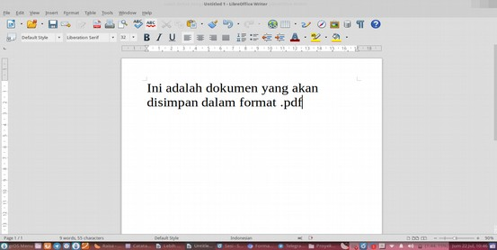
Picture 94: A Sample of Document Which Will be Saved Into PDF Format

- Click File on the Menu Bar.
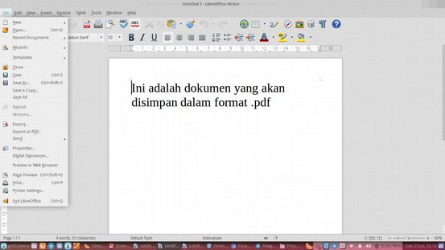
Picture 95: Select File Menu on The Menu Bar

- Select its sub-menu named ‘Export as PDF’.
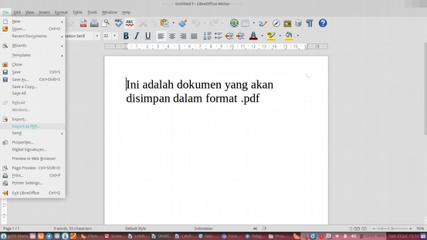
Picture 96: A sub-menu named ‘Export as PDF’
- After that, a PDF Options window will appear. We can set how the appearance of our PDF file will be. Click Export button to start export process.
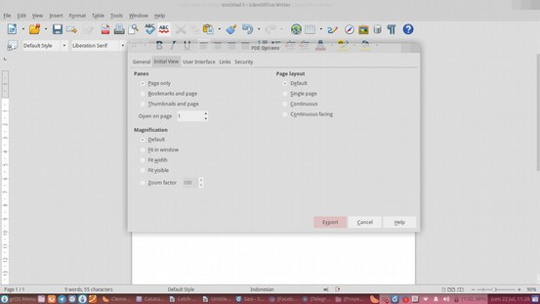
Picture 97: A sub-menu named ‘Export as PDF’

- On the Export window, input the document name and set the purpose of saving the document. Click Save to finish.
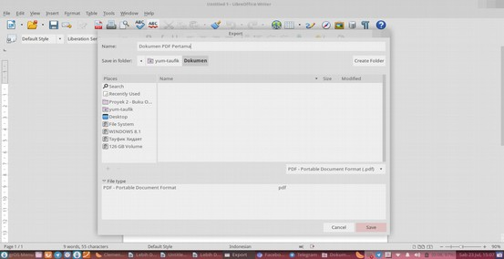
Picture 98: Export Window Appearance
- The following image is the result of the document of which saved into PDF format.
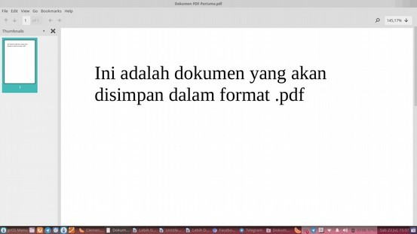
Picture 99: PDF Viewer Software Showing The Document

Method 2:
- Prepare the document of which will be saved into PDF format.
Picture 100: A Sample of The Document of which Will be Saved Into PDF Format.

- Next, click the icon of 'Export Directly as PDF' on the toolbar.
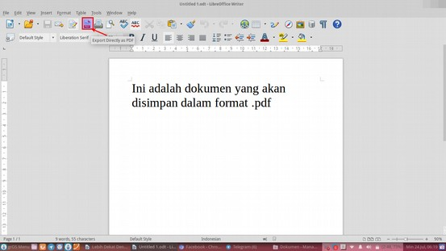
Picture 101: Logo Export Directly as PDF shown by pointing cursor

- The Export window will appear. Input the document name and select where will the document be saved.
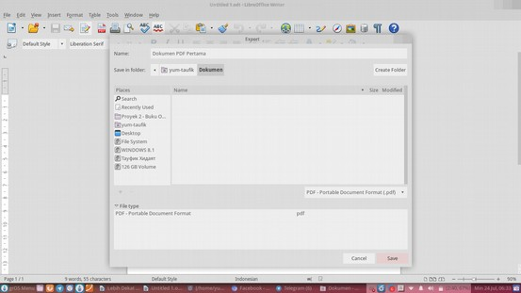
Picture 102: Export Window Appearance

- Finally, this is the document which is saved into PDF format
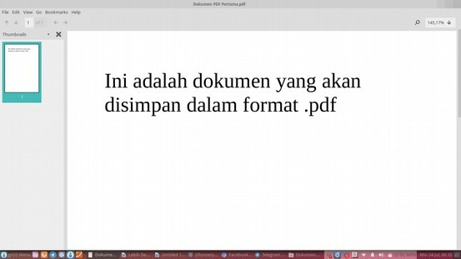
Picture 103: The PDF Document Opened with PDF Viewer

CHAPTER 15 INSERTING HEADER AND FOOTER IN LIBREOFFICE WRITER
CHAPTER 15
INSERTING HEADER AND FOOTER
IN LIBREOFFICE WRITER

Copyright © 2016 Sasongko Bawono <sasongko262@gmail.com>
Translated by Faiq Aminuddin <dampuawang@gmail.com>

Inserting Header
Usually, there is a header in the top of letter, book etc. There are three ways to add the header to the document;

First Way:
- First, click above the top of the text area above margin.
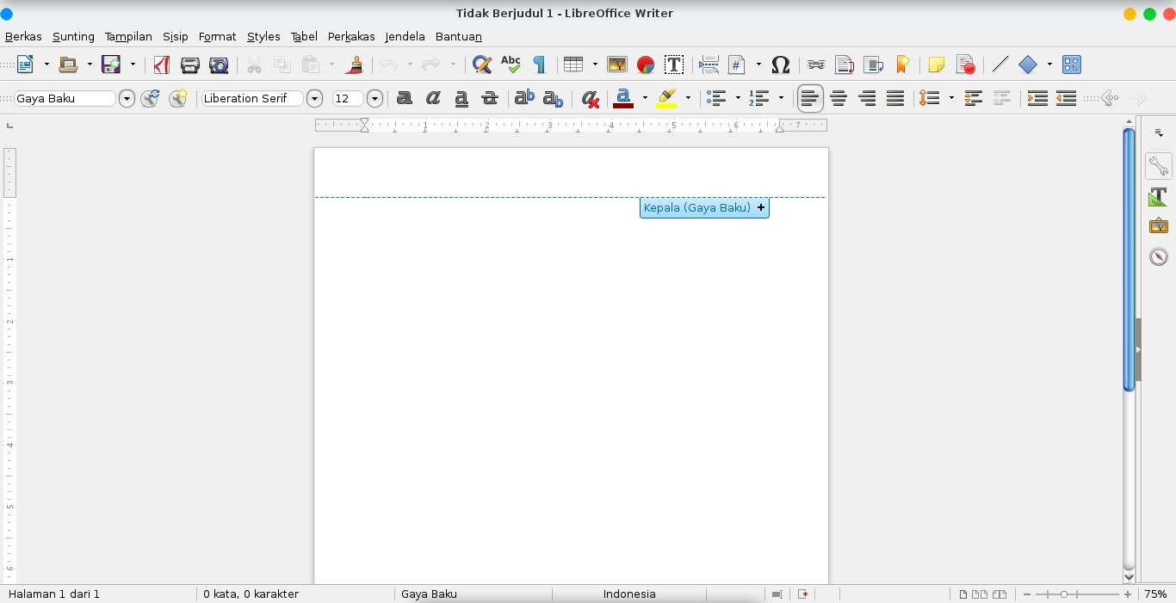
Picture 104: Step 1 Inserting Header
- Next, click Header (Default Style).
Picture 105: Step 2 Inserting Header

- If the cursor have moved to the Header area, add a sentence or words as a header.
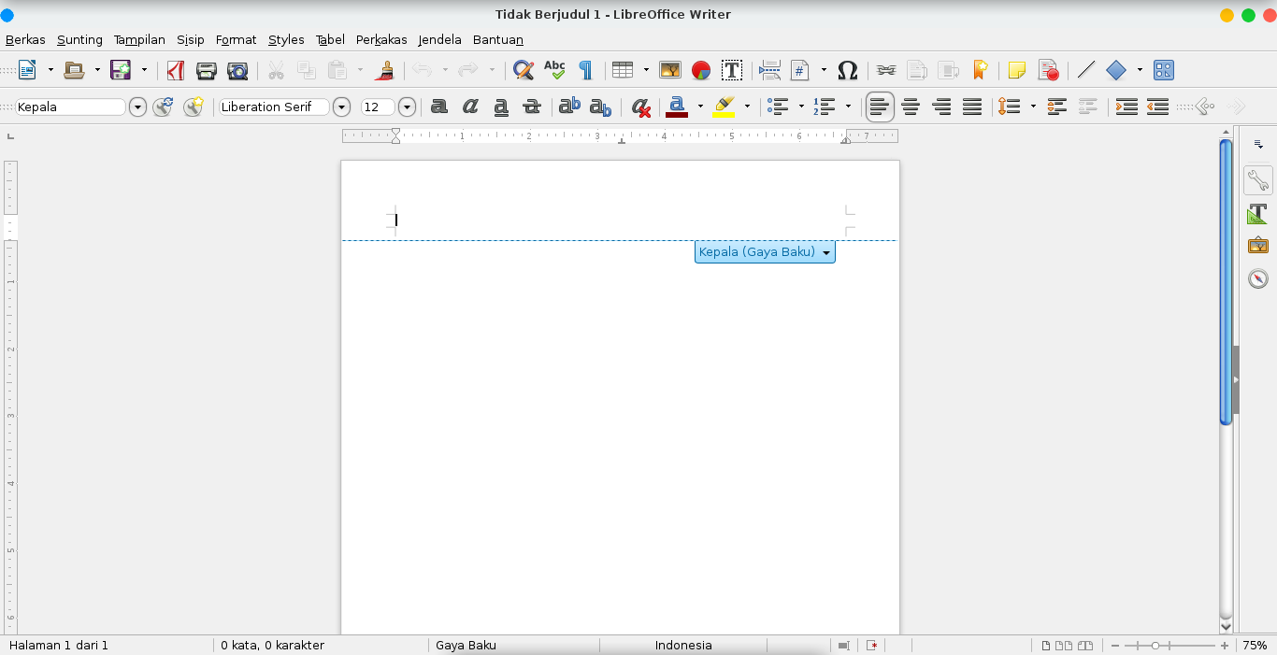
Picture 106: Step 3 Inserting Header

Second Way:
- First, click Insert menu on Menu Bar
- Next, select Header menu and choose Default Style.
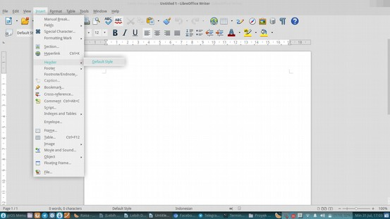
Picture 107: Step 1 and 2 for Inserting Header

- If the cursor have moved to the header area, you can write a sentence or words as the header.
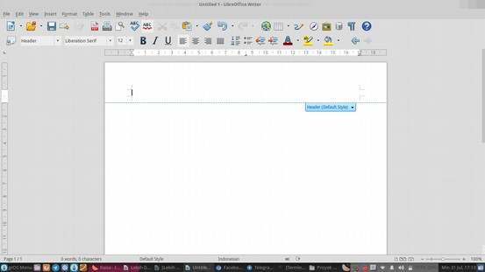
Picture 108: Step 3 Inserting Header

Third Way:
- First, click Format menu on Bar Menu.
- Next, click Page Menu.
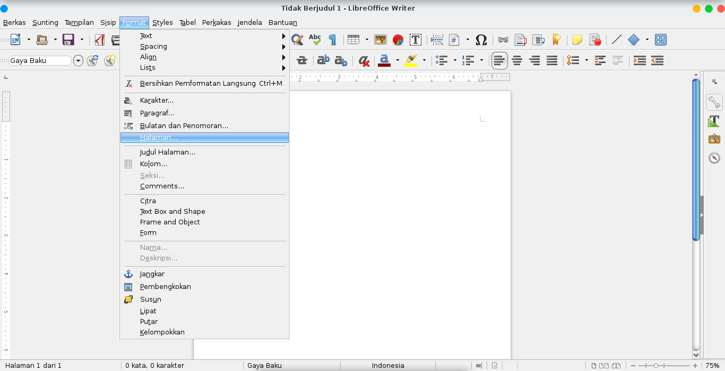
Picture 109: Step 1 and 2 for Inserting Header

- On Page Style window, click Header tab, then click check box on Header on, then click Apply button.
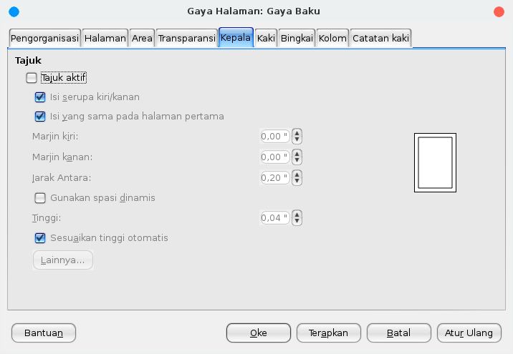
Picture 110: Step 3 Inserting Header

- Click on top part of document area, then add the header.
Picture 111: Step 3 Inserting Header

Removing Header
A header can be removed easily. We can remove the header directly or from the menu bar. There are two ways to removing header from document page. The ways are;
First Way:
- First, click the header directly.
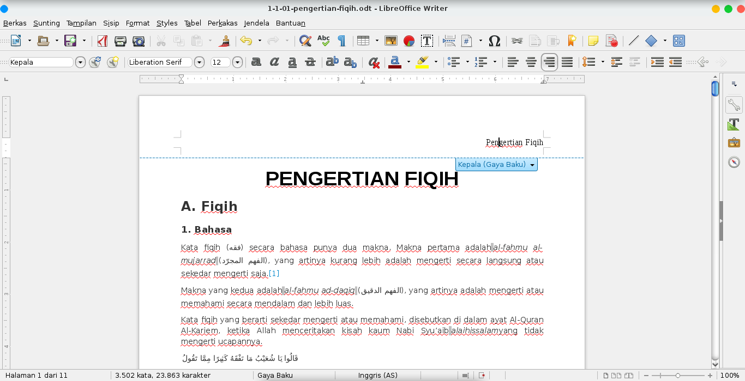
Picture 112: Step 1 Removing header
- Next, click the Header (Default Style), then click Delete Header.
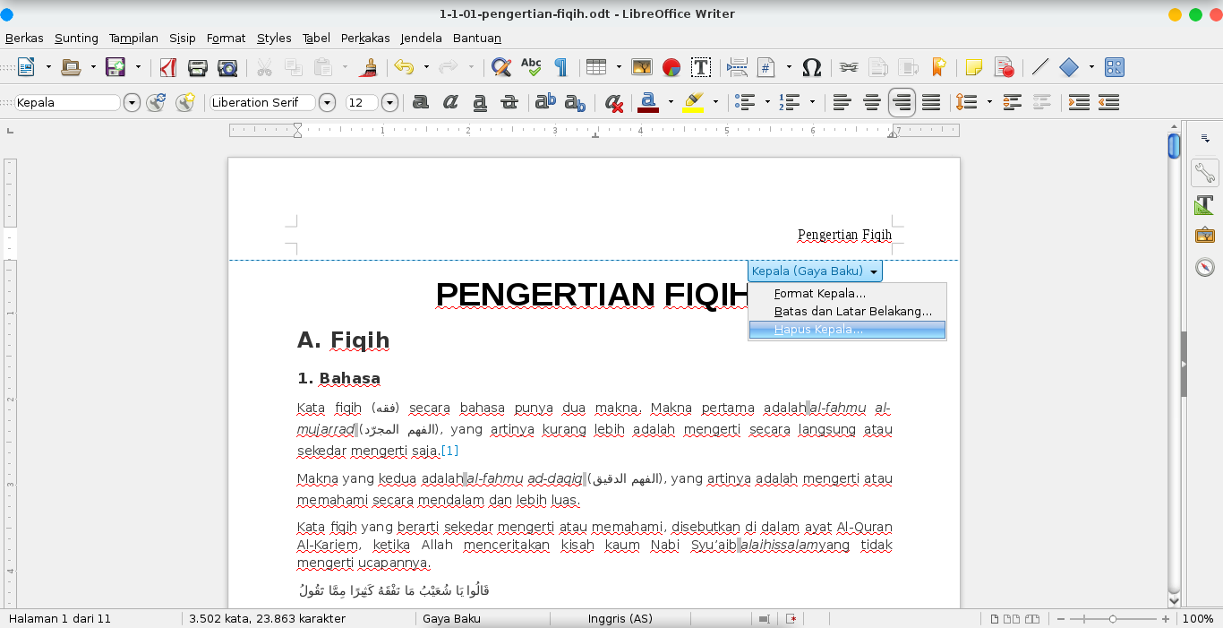
Picture 113: Step 2 and 3 Removing Header

- Finally, when confirmation window appear, click Yes.
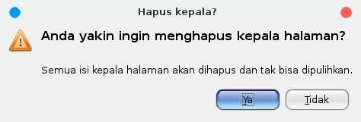Picture 114: Confirmation window for removing header

Second Way:
- First, click Format on Menu Bar.
- Next, click Page.
Picture 115: Step 1 and 2 Removing Header

- Next, when Page Style window appear, click Header tab for removing the header.
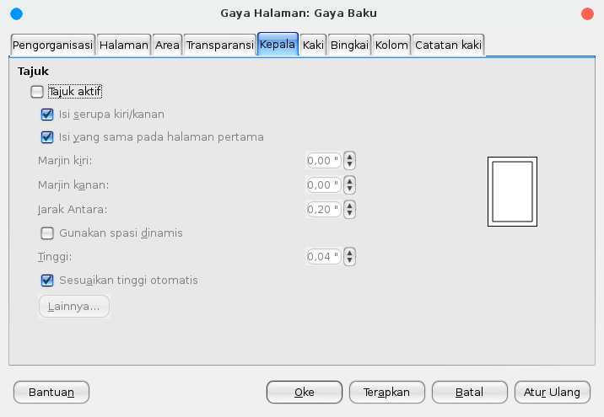Picture 116: Step 3 Removing Header

- Click the Header on check box for removing the check sign.
- 5. Finally, click OK.

Inserting Footer
A footer is a text as a page number which always appear on bottom part of document. A footer is similar to a header. The difference between footer and header is its place. The header is on top part of document, while the footer is on bottom part of document.
Similar to inserting header, there are three ways in inserting footer;
Firs Way:
- First, click on bottom part of document.
- Next, click Footer (Default Style) +.
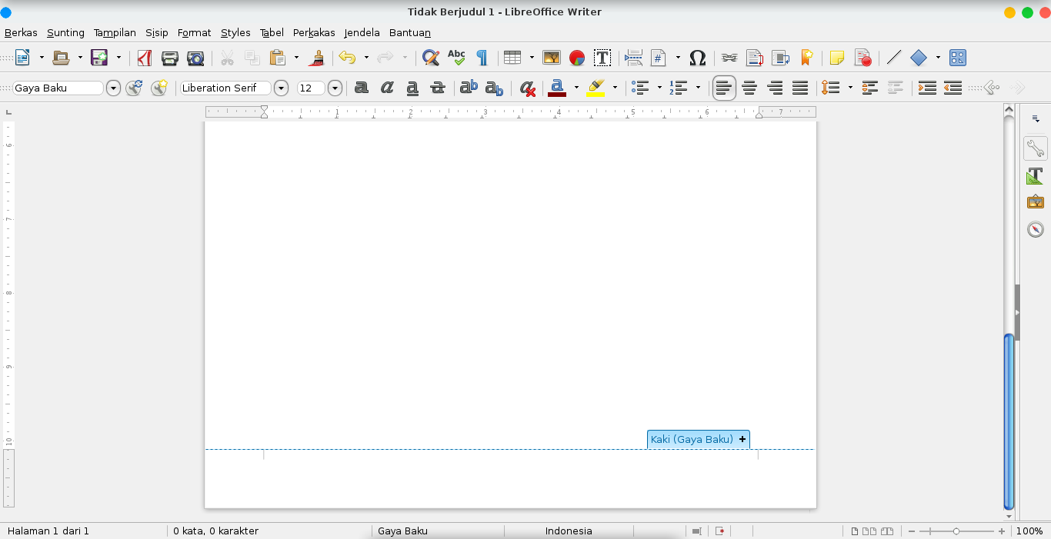
Picture 117: Step 1 and 2 Inserting Footer

- Then, look at the cursor that moved. It indicate that the footer is active. Next, write a word or a sentence as a footer of your document.
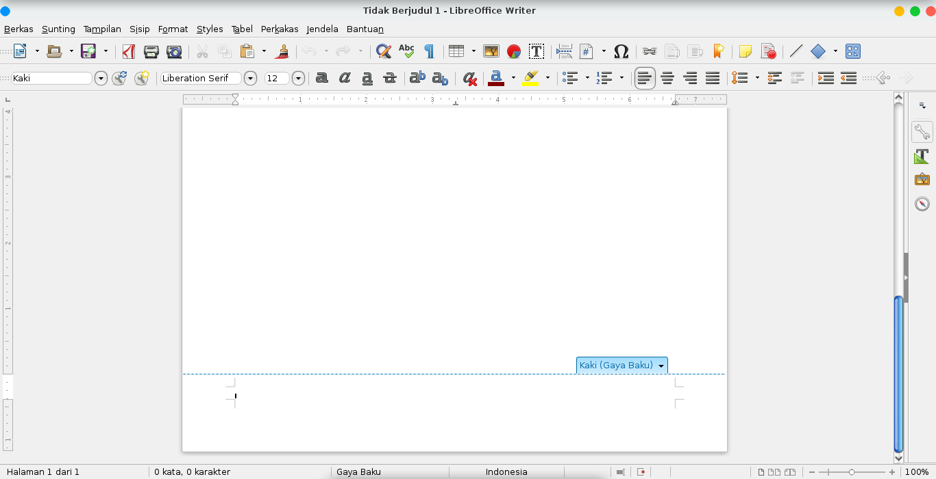
Picture 118: Step 3 Inserting Footer

Second way:
- First, click Format on the Menu Bar.
- click Page.
Picture 119: Step 1 and 2 Inserting Footer

- Click footer tab, then click the Footer on check box. Click Apply to apply the footer. Klik tab Kaki/Footer.
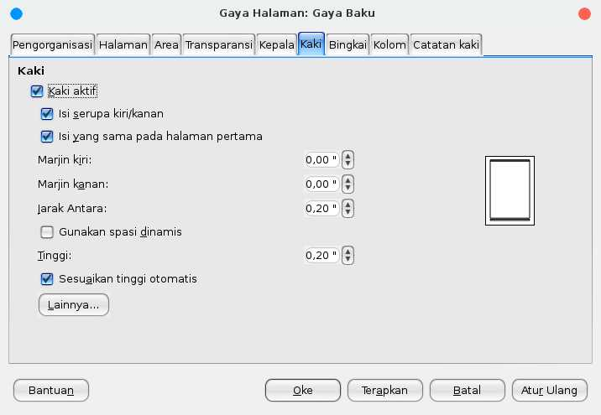
Picture 120: Step 3 Inserting Footer

- Finally, click button OK.

Removing Footer
A Footer can be removed easily. There are two ways for removing footer;

- First, click the footer
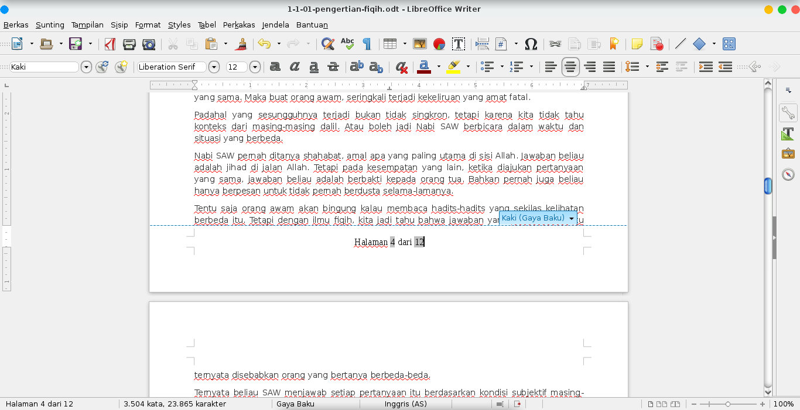
Picture 121: Step 1 Removing Footer

- Next, click Footer (Default Style).
- Click Delete Footer.
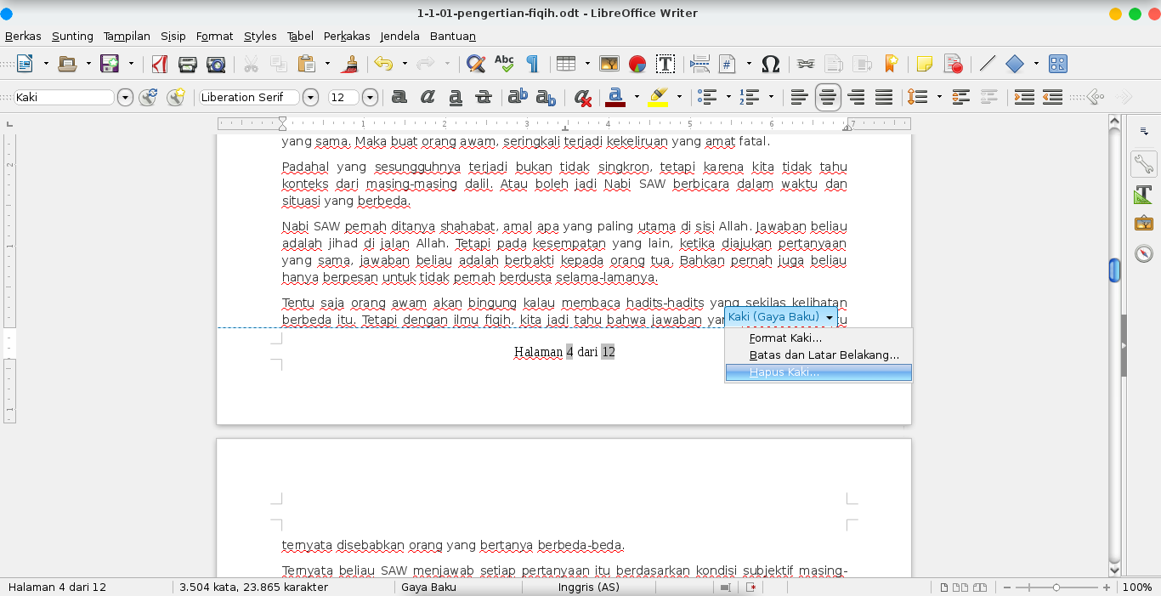
Picture 122: Step 2 and 3 Removing Footer

- Then, when confirmation window is appearing, click Yes for removing the footer.
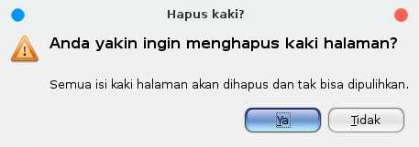
Picture 123: Step 4 and 5 Removing Footer

Second Way:
- First, click Format on Menu Bar. Then, click Page.
Picture 124: Step 1 Removing Footer

- click footer tab.
Picture 125: Step 2 Removing Footer

- Then, click Footer on check box. So, the check is gone. Click OK.
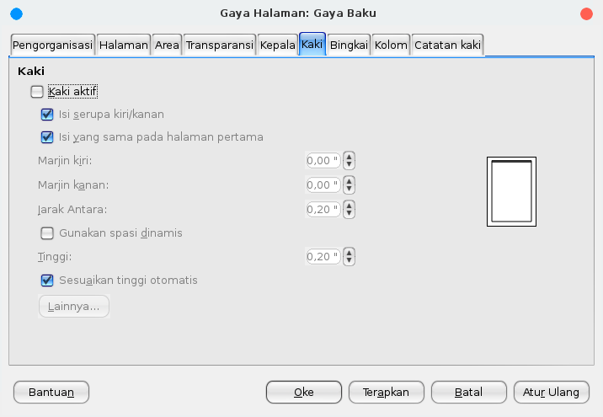
Picture 126: Step 3 Removing Footer

CHAPTER 16 SAVING DOCUMENT
CHAPTER 16
SAVING DOCUMENT

Copyright © 2016 Sasongko Bawono <sasongko262@gmail.com>
Translated by kucingsebelah <meongpus@hi2.in>

After typing a document, we need to save it so we can edit it again. There are two common methods ie. Save and Save As. Save is used to store documents with same name and location while Save As is used to store documents with different name, location or formats.
A. Saving Document Using “Save” and “Save As” from “File” Menu
- First choose “File” menu
- Choose “Save” to store document with the same name and location or choose “Save As” to store document with different name, location or formats. If we choose “Save As” a window menu will appear, fill the name of document, choose new file location or change document format then click “Save”
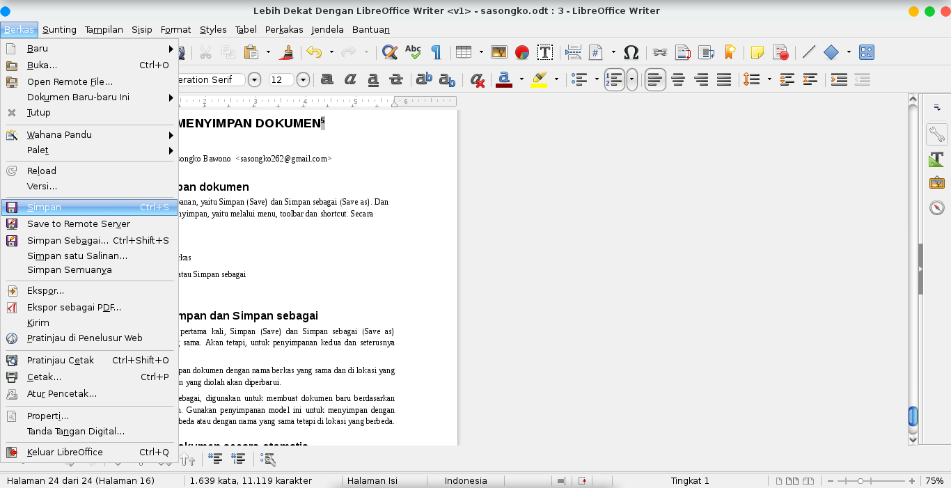
Picture 127: Saving document using “Save”

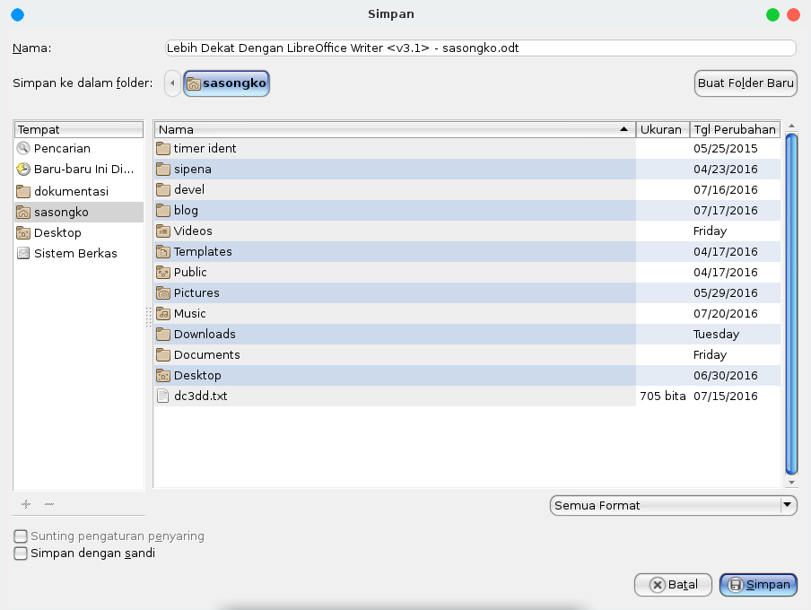
Picture 128: Saving document using “Save As”

B. Saving Document Using Save Button
You can click save button (Floppy Disk logo on left Toolbar) to save document. To Save As, you can click drop down / black triangle logo (right side of Floppy Disk logo) then, choose “Save As”. Window menu will appear, fill the name of document, choose new file location or change document format then click “Save”

C. Saving Document Using Keyboard Shortcut
You can also use keyboard combination key to save the document, by pressing Ctrl + S to save document or press Ctrl + Shift + S to Save As document (a window menu will appear then you can fill new name, location or format).

D. Saving Document Automatically
You can save the document automatically with interval time :
- First, click the “Tools” menu on the Menu Bar.
- Then choose “Options” menu.
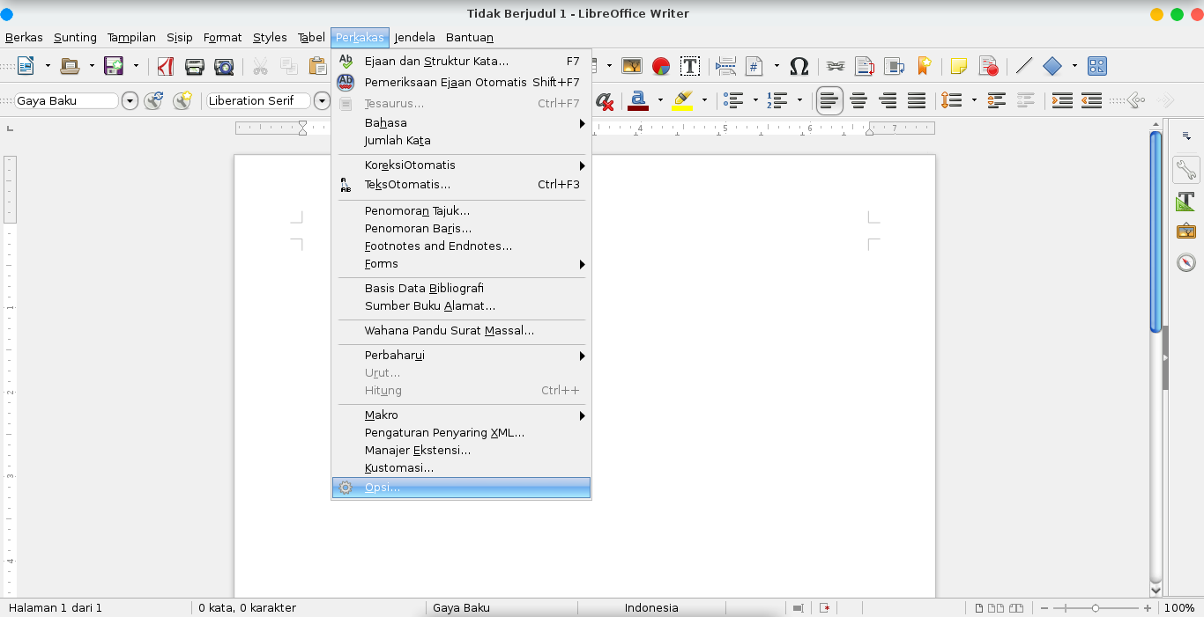
Picture 129: “Tools” and “Option” Menu

- “Options” windows will appear.
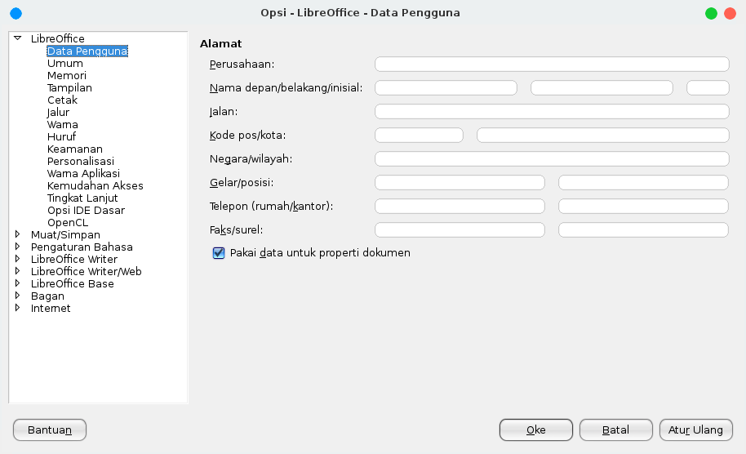
Picture 130: Libre Office “Option” Window

- then choose “Load/Save” sub menu
- choose “General”
- In the “Save” section, check “Save AutoRecovery information every” option then fill the time interval (in minutes) after that, click OK / OK.
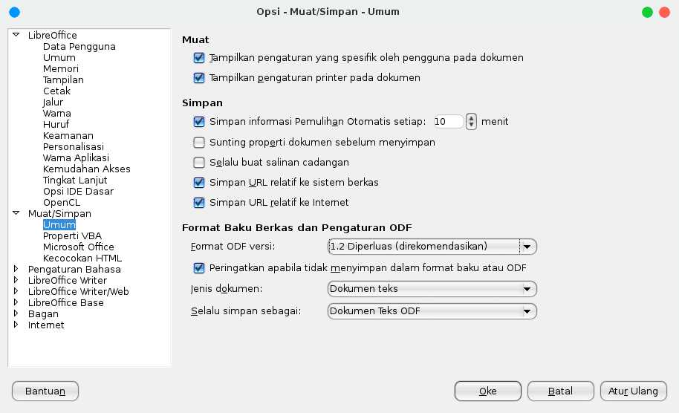
Picture 131: setting automatically saving the document

CHAPTER 17 MAKING LINE SPACING ON LIBREOFFICE WRITER
CHAPTER 17
MAKING LINE SPACING ON LIBREOFFICE
WRITER

Copyright © 2016 Taufik Hidayat <yumtaufik1997@gmail.com >
Translated by Astrida Atni Ayu Mahardini <astriddini7@gmail.com>

Line spacing functions to set the spacing between lines/distance. Line spacing is the distance between the lines of text that are above or below. Generally, line spacing default value is 1 (single). However, we can organize them into a 1,5 or 2 (double). Line spacing is indispensable for the making of: term papers, theses, manuscripts, theses, etc.
Below are the steps to make line spacing on LibreOffice Writer, that is as follows.
Method 1:
- First, create the first paragraph will be given the line spacing.
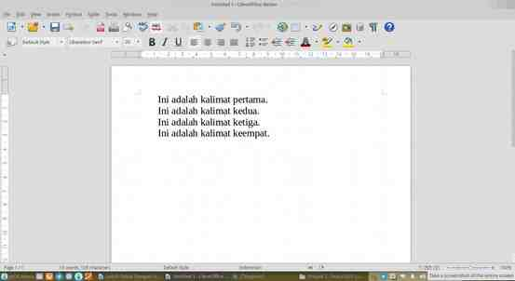
Picture 132: Step 1 Make Line Spacing

- Next, select entire sentence that is already completed.
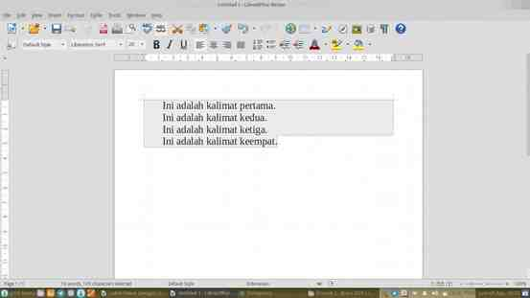
Picture 133: Step 2 Make Line Spacing

- Next, click the Format menu on the Menu Bar and highlight the Paragraphs. It will pop up a window display Paragraphs.
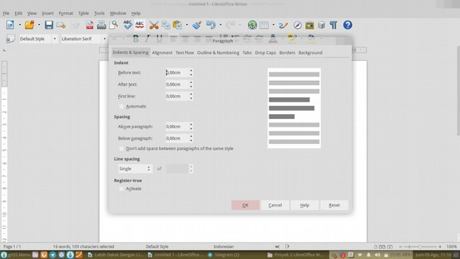
Picture 134: Step 3 Make Line Spacing

- Select the tab Indent & Spacing. On the choice of Line Spacing, please choose the size of the line spacing you want. As for the line spacing is
- provided: Single, 1.5 Lines, Double Proportional, At Least, Leading and Fixed.
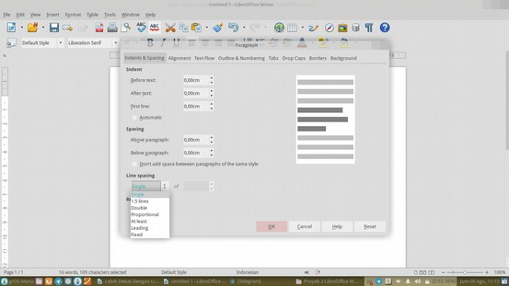
Picture 135: Step 4 Make Line Spacing

- Lastly, this is the result of line spacing. In this case, it uses the line spacing 1.5.
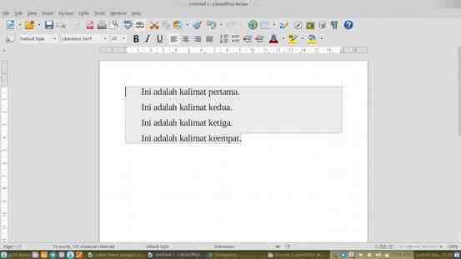
Picture 136: Step 5 Make Line Spacing

CHAPTER 18 FIND AND SMART REPLACE WITH REGULAR EXPRESSION
CHAPTER 18
FIND AND SMART REPLACE WITH
REGULAR EXPRESSION

Copyright © 2016 Ade Malsasa Akbar <teknoloid@gmail.com>
Translated by Astrida Atni Ayu Mahardini <astriddini7@gmail.com>

Find & Replace feature in LibreOffice Writer has been equipped with the capabilities of the regular expression. With these capabilities, search and replace text became very sophisticated without limits. For those of you who are unfamiliar with this feature, regular expression (regex) is a method which is standardized internationally to improve discovery of patterns in text1. The regex has been applied on all types of software; for example in Office suite, in the search engines (including Google), and of course on each of your operating system.. With a regex, you can perform text searches more efficiently. Amazingly enough, the regex is studied in one piece of software then it can be applied in all other software. This chapter will show you two examples of the use of the regex.

How To Enable Regex Capabilities
Open the Find dialog & Replace (Ctrl + H) and then check the options of Regular Expression or by selecting the Edit Menu on the Menu Bar and then highlight the option Find & Replace.
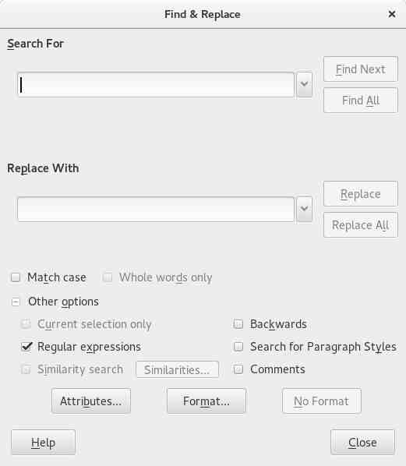
Picture 137: Enable Regex Capabilities

Example 1
You have a text document containing 10,000 rows in the beginning of each row there is a line number. How do You delete only the line number in front of it for 10,000 lines of text? If you delete it manually, it's very tiring and time wastes. If you do it with regular expression, you can delete everything in second

Regular expression:
^[0-9]*[0-9].
Demonstration:
Picture 138: Demonstration Example 1 (Before)
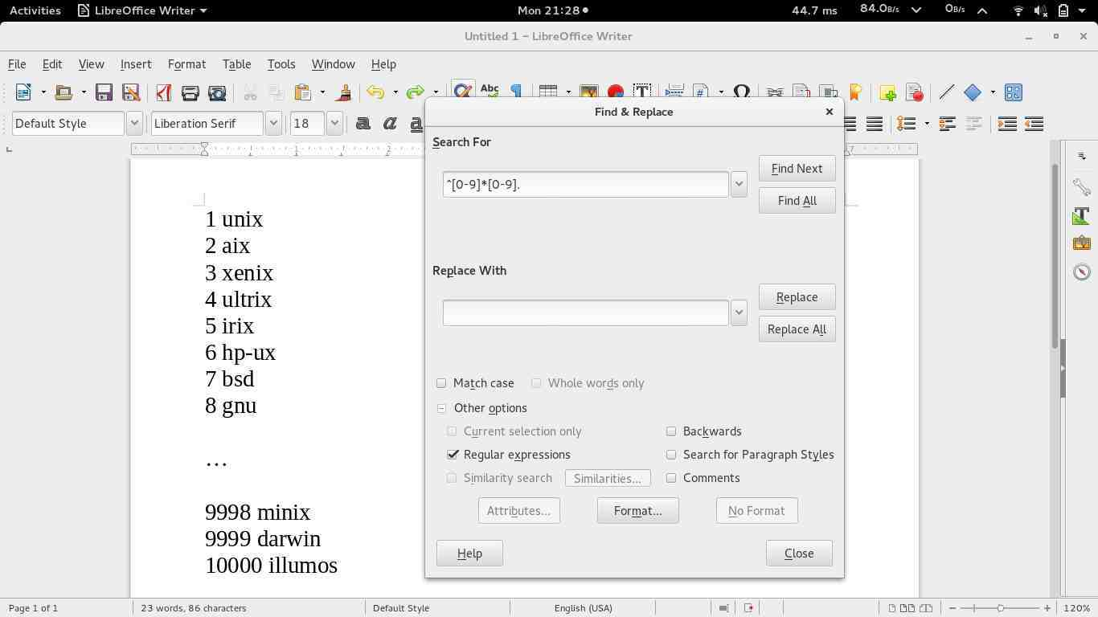

Picture 139: Demonstration Example 1 (After)
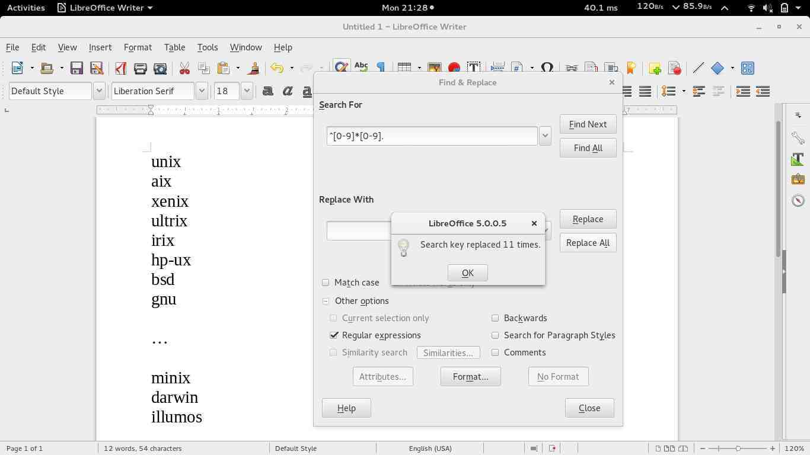

Explanation of example 1:
Regular expression that reads ^ [0-9] * [0-9]. It actually consists of 3 parts:
- The first part is the ' ^ ' (radical written) which meant the beginning of the line. This character searches for the earliest part of the targeting of each row (because the line number to be there).
- The second part is ' [0-9] * [0-9] ' which means any kind of digits, starting with the number [0-9] and end with a number [0-9]. This regular expression will be targeting figures ranging from 0 to 10000, even up to unlimited. As for the character ' * ' in the middle is the cause of this regular expression equates how many digits.
- The third part is a '. ' (a dot character) which means that any one character. In the example of the use of the regular expression, the dot character represents one space between line number and the name of the OS that is always there in every line.
- The workings of the regular expression in the Find/Replace this overall & is focusing the target to the beginning of the line first, then matching the number of how many digits, and then matching one character space, and replacing it with a blank character ( the same as delete), and then repeating it until the end of the document. The result is all line numbers removed.

Example 2
You have a text document that contains 10,000 lines of text that are on the sidelines between one with another line there is one empty line without text. How to remove the entire blank lines so that only the text lines are left? If you do it manually, then this takes very long and tiring. But with regular expression, you can do it in the blink of an eye.

Regular expression:
^$

Demonstration:
Picture 140: Demonstration Example 2 (Before)
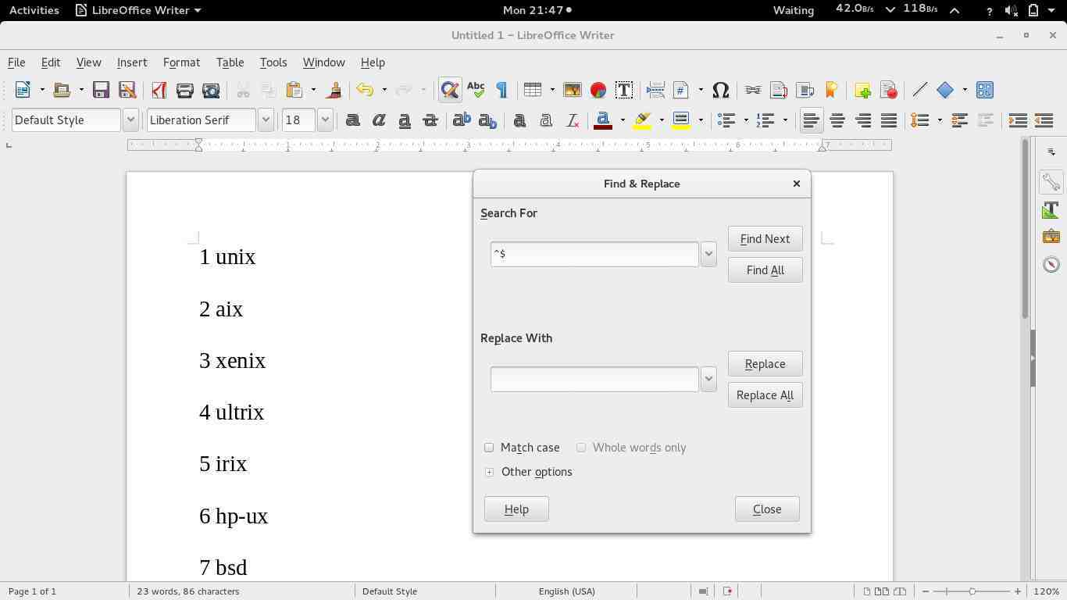

Picture 141: Demonstration Example 2 (After)
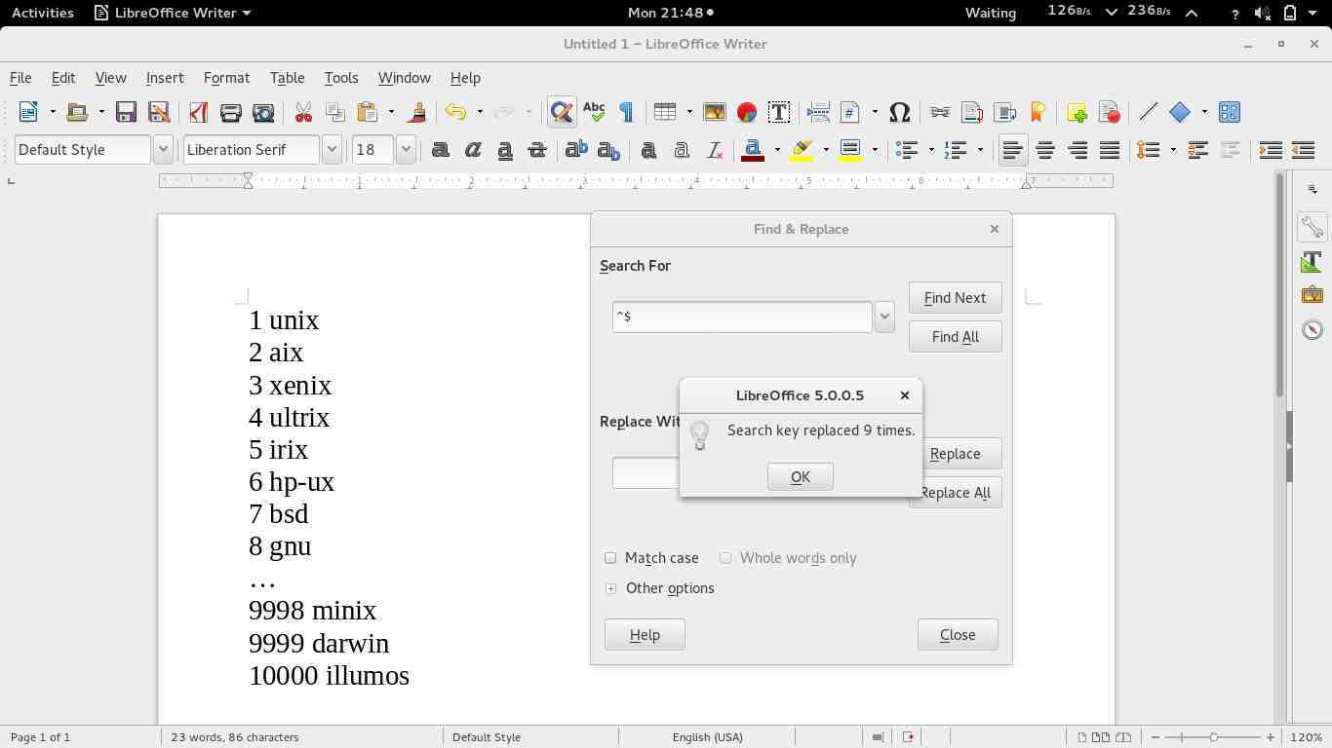

Explanation Example 2 :
Regular expression used here is a `^$`. The first part is the `^` (Caret Character ) which means the beginning of the line. The second part is a `$` (Dollar Character) meaning the end of the line. The combined regular expression `^$` means the beginning of a line, end of line without any text, which is tantamount to an empty row. This Regular expression searches for every blank line. If replacement/replace with was left blank, then replace the activity will delete all blank lines in the text.

Advanced Reference:
See the following references If you want to be more steeped in the regular expression. http://www.regular-expressions.info is website that gives information source regular expression with very good and complete.
- http://www.regular-expressions.info/examples.html presents real examples of regular expression.
- Https://www.wikibooks.org/wiki/Regular_Expressions/POSIX-Extended_Regular_Expressions presents tables code regular expression and its meaning from WikiBooks.

CHAPTER 19 MAIL MERGE IN LIBREOFFICE WRITER
CHAPTER 19
MAIL MERGE IN LIBREOFFICE WRITER

Copyright © 2016 Nur Kholis <khokunsmile@gmail.com>
Translated by Astrida Atni Ayu Mahardini <astriddini7@gmail.com>

Mail merge is a facility to facilitate the making of letters available on the document processing devices. Mail merge is used to specify a list of recipients that are stored on a database created previously in the document we made, so we just need to make a letter as a template and recipients will be listed automatically.
The steps in the mail merge LibreOffice Writer include:
- Prepare the template document and database of recipients.
- Insert the receiver into the database mail.
- Save and print the results of a mail merge.

Preparing the Template Document and Database Receiver
We create a document in LibreOffice Writer (can either be letters, invitations, Charter or certificate, or other), as the following example.
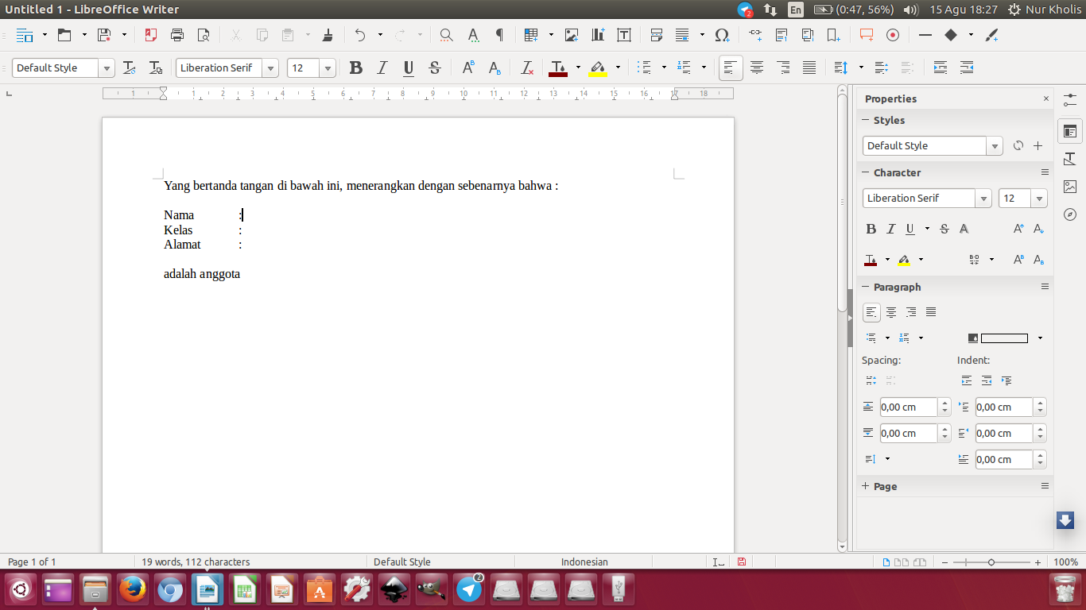
Picture 142: Template Document for Mail Merge

Finished preparing form letters, we create a database of recipients. This receiver can be a database table spreadsheet, text file or database. However, in the discussion of this time, we use the spreadsheet table as the source of its data, because this is the most common way and easy to use.
We make tables of recipients in LibreOffice Calc. We make sure our content stands on the first line of the Header Column, and the list of recipients we put on the second line, like the example below.
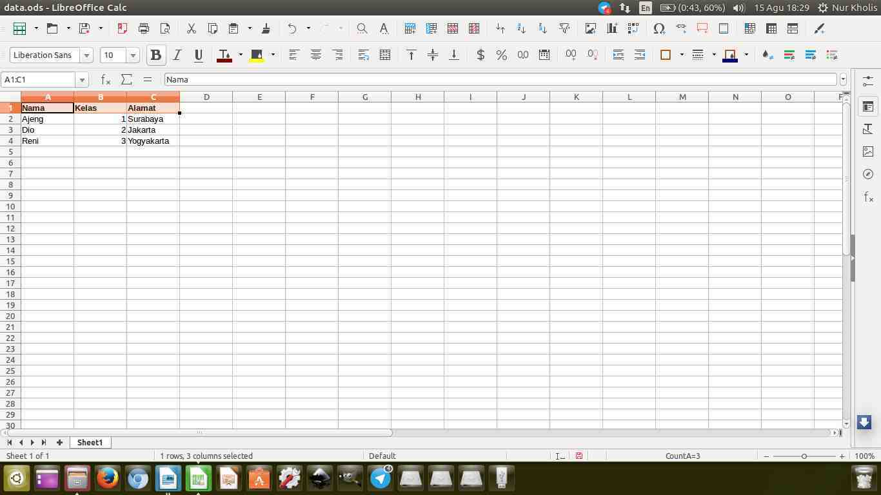
Picture 143: List Of Recipients Using LibreOffice Calc
After that, we save the file. Until this stage, the first step has been completed.

Inserting the receiver into the Mail Database
The next step is we open the file letter we made on LibreOffice Writer above, we then select Edit > Exchange Database... it will pop up a dialog as shown below.
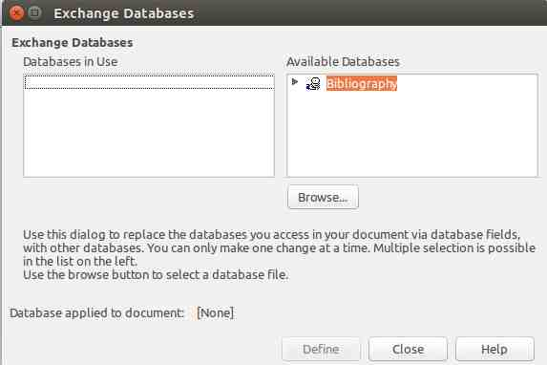
Picture 144: Template Document for Mail Merge Template

Press the Browse button and select the spreadsheet we have made earlier. After that, it will appear a new database from the list of existing databases. Double click the new database we paste, select the sheet that contains the data that we have to prepare, and then click Define like the illustration below.
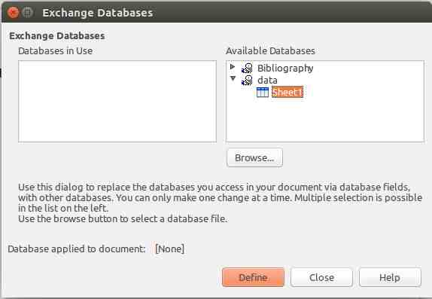
Picture 145: Selecting The Database

Next is click View > Data Sources or press Ctrl+Shift+F4 to display form Data Sources, select the database that we have created above, click Tables, and then select the name of the table that we have to prepare in advance. In General, this table name based on the name of the Sheet in the file that we created.
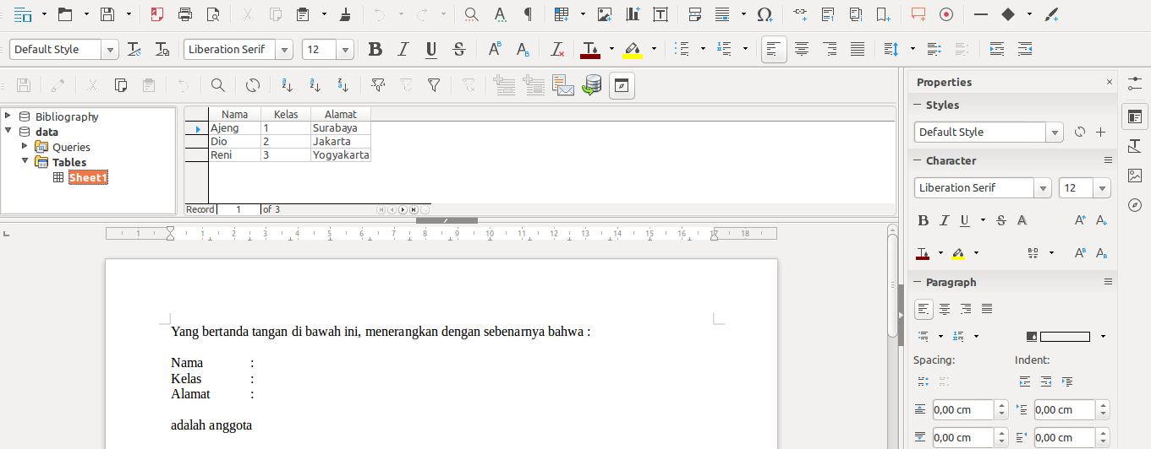
Picture 146: displaying a list receiver of Data Sources

As shown above, after we open the Sheet1 data we have made earlier will appear in the Data Sources. The next step is to connect the database to document
letter by draging and droping on the name of the field. Click the name of the column, hold down and drag up to stuff documents we like the example below.
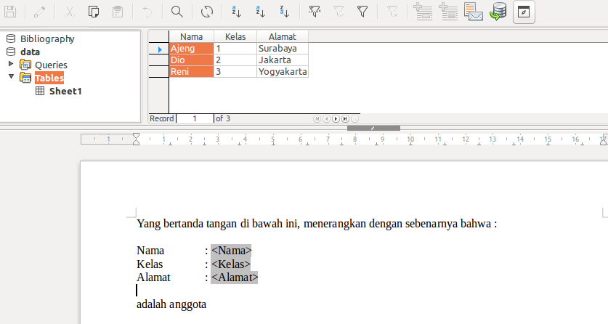
Picture 147: Drag and Drop from the Data Sources into your document

As such, we've finished pasting the list of recipients into the template document.

Saving and Printing the Results of a Mail Merge
The last step is to save and print the results of a mail merge. The trick is to open the mail merge dialog via the Tools menu > Mail merge Wizard... or by clicking the icon in the mail merge Data Source while displaying.
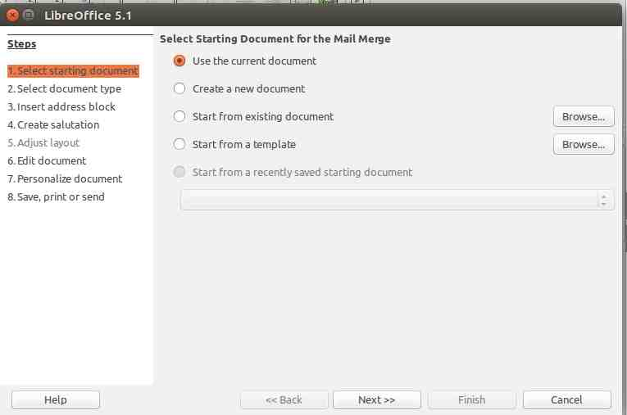
Picture 148: Mail Merge Wizard

To save and print a document the results of the mail merge, we can skip directly to step number 8.
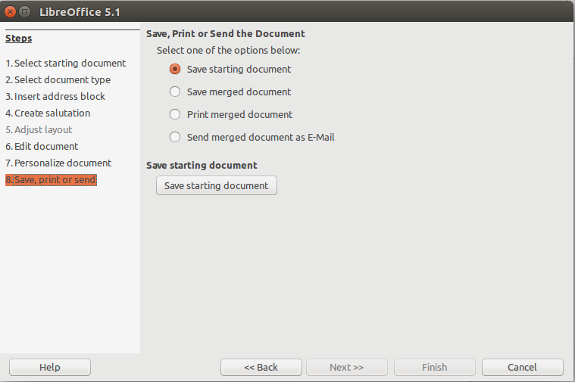
Picture 149: Save, print or send in Mail Merge

So far, it can be adapted to our desires. If we choose the Save starting document, it will be created a new document with the results of the mail merge. If we choose Save merged document, then we are given three options, namely the Save as single document to store all the results of the mail merge into a single file, Save as individual documents to save to multiple files, and From ... To ... to save some of the results of the mail merge to multiple files.
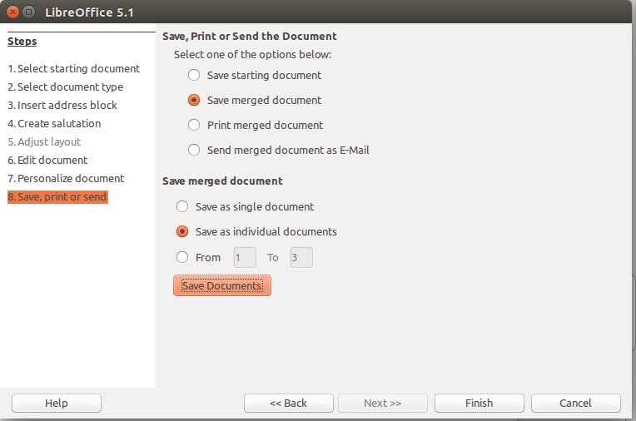
Picture 150: Save Merged Document

To print the results of the mail merge, select the ‘Print merged document’, then it would appear the option Properties for the printer settings, Print all document to print the entire document mail merge, and From ... to ... to print some of the mail merge results.
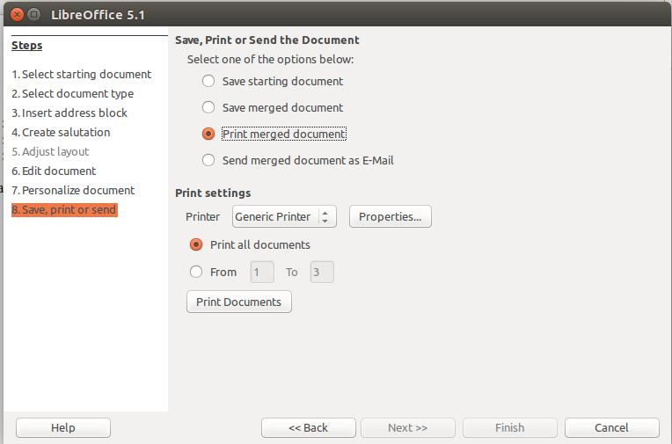
Picture 151: Print merged document

If the recipient list is an email address, we can send you the mail merge results to existing addresses in the recipient list.
Once completed, we click Finish to close the Mail merge Wizard. As such, we've managed to do a mail merge on LibreOffice Writer.

CHAPTER 20 EYE PROTECTION PAPER IN LIBREOFFICE WRITER
CHAPTER 20
EYE PROTECTION PAPER IN
LIBREOFFICE WRITER

Copyright © 2016 Aziz Rahmat Pratama <azis.pratama@gmail.com>
Translated by Azis R. Pratama <azis.pratama@gmail.com>

By default, LibreOffice Writer does not have “Eye Protection Mode” feature, like WPS Office. But don’t worry, with a little trick and creativity, user can still modify the plain white paper into more healthy green color.
The advantage of this little tweak is to reduce eye-strain effect, when the writer must work long hours duration, in front of his/ her monitor screen. This is the end result of “eye protecting paper” after the theme successfully being applied.

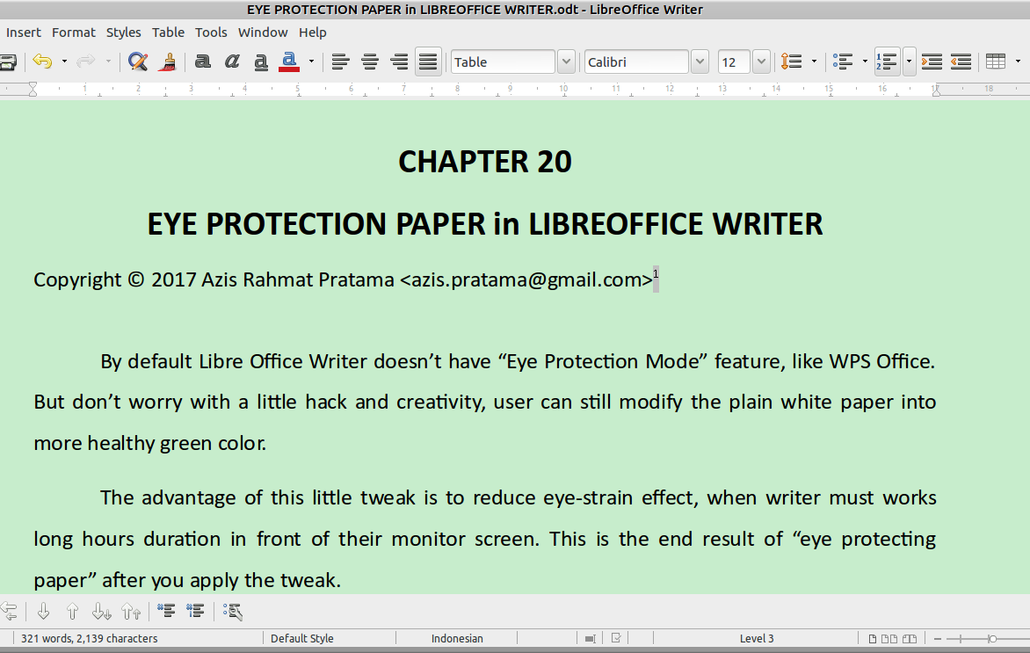

Picture 152: #C7EDCC Eye-Protection Paper in Libre Office Writer.

Don’t worry, this tweak only affect your LibreOffice on your computer, even after apply this configuration, you can still print the hard-file and share the soft-file without being worry about the paper color. So, consider this tweak. It is kind of tweaking your LibreOffice suite. Currently, I'm using LibreOffice version 5.4.0.3
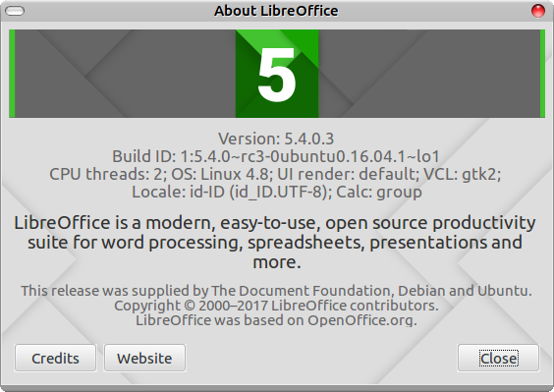Picture 153: LibreOffice 5.4.0.3

Technically, there are some different configuration between the current LibreOffice and the older version. In the older version of LibreOffice, there are some additional steps to define new color scheme. But, it seems in then current version, the color and the application color configuration is merged. Alright, here is the step by step to apply “Document Background” color in LibreOffice 5.4.0.3 or above/ newest version.
- Open Tools menu, and then pick sub menu Option (ALT+F12), for keyboard shortcut.
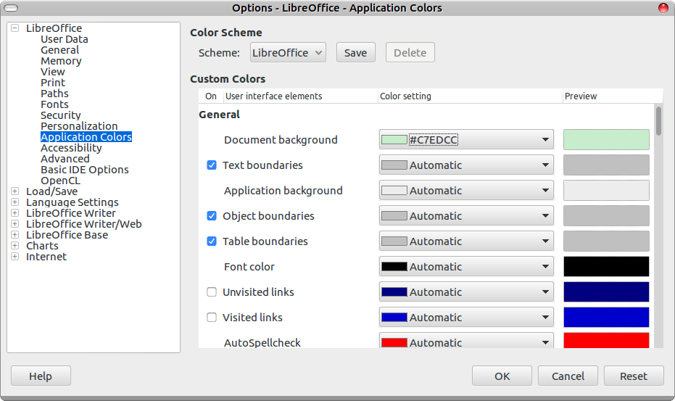

Picture 154: LibreOffice-Aplications Colors window configuration.
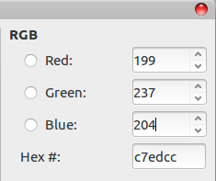Picture 155: RGB Colour Window

- Just click the “Document Background Color Setting”. And then hit add custom color. You will be given new Pick Color Window (see Screen-Shot number 3 below). Give these value on to those configuration.
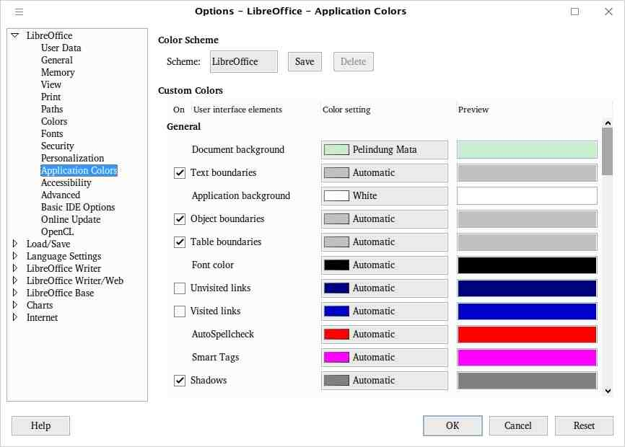

Picture 156: Opsi Application Colors
- Hit OK. Congratulation, you just applied new healthy eye protection paper in LibreOffice.

Bonus: Dracula Theme Configuration for LibreOffice
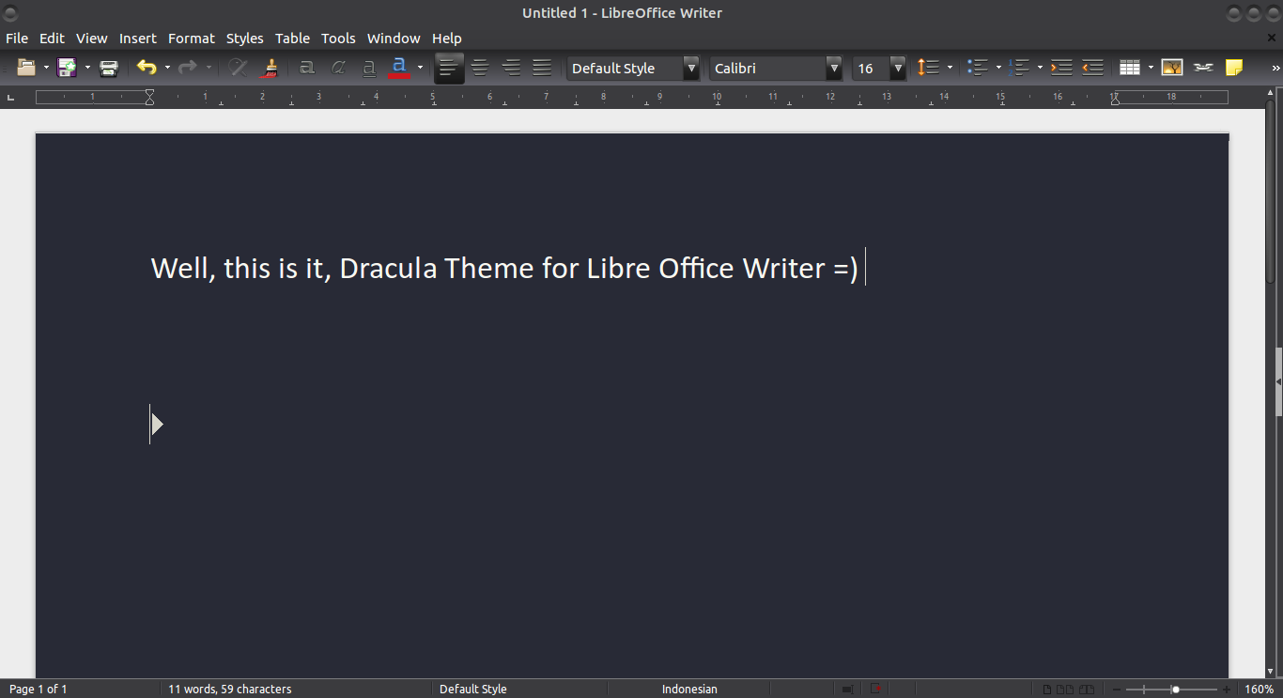

Picture 157: Dracula Theme Libre Office Writer
Recently, i just found GitHub Dracula Theming Project , luckly, in the README.md, the developer published the RGB color value for Dracula theme which is:
Background | Foreground (font color)
40 | 248
42 | 248
54 | 242
#282a36 | f8f8f2

Follow the same method as i have mentioned above, to apply this new color theme for your LibreOffice suite.

Credit and Further Reading
The Hex value that i am using in these tutorial is taken from this sites:
http://www.daossoft.com/operating-system-tips/how-to-protect-your-eyes-form-computer-screen.html
The Document Foundation for their countless effort, to bring Free and Open Source Office-Suite

CHAPTER 21 INTRODUCING TO GRAPHIC IN LIBREOFFICE WRITER
CHAPTER 21
INTRODUCTION TO GRAPHIC
IN LIBREOFFICE WRITER

Copyright © 2016 Azid <paindustry@yahoo.com>
Translated by Risma Fahrul Amin <rismafahrulamin@gmail.com>

When you write a document in LibreOffice Writer, you might want to insert illustration or picture. Applying illustration helps you describing the content, representing visual to the reader, as well as content in magazine or newspaper.

There are 3 type of graphic in LibreOffice Writer:
- Picture such photo, Scanned picture, or wallpaper.
- Diagram.
- Graphical Chart.

Manipulating Picture in LibreOffice Writer
LibreOffice Writer has great facility in manipulating Picture, you could import kind of picture format. The most common format are: JPG, PNG, GIF, and BMP. You can rotate, scale, flip or crop Picture. Besides, you also can edit SmartArt from file Microsoft Office in LibreOffice Writer.
We can easily manipulate picture in Several usage such transforming picture in black white (grayscale). In manipulating Photo or Picture bitmap, we can take advantage from Bitmap Editor GIMP, while in manipulating line drawing (vector) we can take Vector Drawing Inkscape.
Adding Picture in Writer can be done in several ways such:: import file, copy-paste (clipboard), drag and drop or through scanner.

Importing Picture to LibreOffice Writer
- Firstly, click document to determine location of picture
- In Menu bar, click Insert > Image > From File
- On Insert Picture dialog, you can choose picture which will be imported, then there will be Preview and Link option. Check Preview for displaying chosen Picture and check Link if you wan to separate document from picture. Therefore, Picture will not be saved directly onto document which will reduce file capacity. Choose Keep Link to create link from picture or choose Embed Graphic for saving Picture on to document.
Picture 158: Confirmation window when Link Picture want to be added
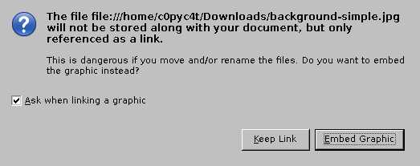

Implementation of link in a Picture has advantages and limitations as following explanation:
Advantages:
- Firstly, you can update Picture without opening the document as long as path/directory and file name has the same as previous picture.
- Second, of course you can also edit picture, and save/overwrite your previous picture.

Limitation:
If you want to share a document with your friend, you should give the related picture, and of course you should know folder which the picture was located. This is
because the document will not display the picture if the path of the picture was changed or modified.

- Finally, click Open for inserting Picture on to document
Picture 159: "Insert Picture" Window Dialog
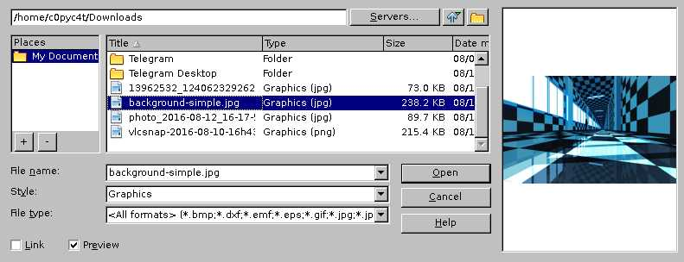

Saving Picture on to Document from Link
If you want to save a picture on to document form link, you can consider this following explanation:
- Firstly, click Edit > Links in Menu Bar.
- If you want to refresh link of a picture after changing a picture with new one just click Update.
- Click Break Link.
- Click Yes for confirmation.
- Save your document.
Picture 160: "Edit Links" Window Dialog
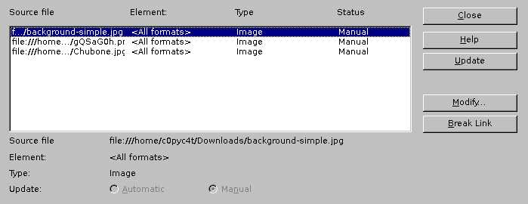

Inserting Picture from Clipboard or Copy-Paste
In LibreOffice Writer, you can do copy-pasting picture from other LibreOffice document or application such as GIMP or Inkscape, it is simple to be done, just using Ctrl + C on source Picture, then Ctrl + V on targeted document, or by right clicking to document the choose Paste.
In Addition, if source Picture whether other LibreOffice document or other application was closed before paste process is done, the Picture cant not be pasted.

Inserting Picture from Scanner
If your scanner has been connected, LibreOffice Writer could process scan command to scanner for adding scanned picture on to document. To proceed, pay attention to following steps:
- Click Insert in Menu bar > Image > Scan > Select Source for choosing connected scanner.
- Click Insert in Menu bar > Image > Scan > Request to process scanning picture.

Adding Picture from Gallery
On Gallery, There are kind of additional image objects such (symbol, icon, background, sign, etc) and also sound clip. You can add your own picture to gallery or install extensions to add Picture onto Gallery. Follow these steps below in adding picture to Gallery.
- Click Gallery icon on Toolbar, or you can Tool in Menu bar > Gallery,
- Then, select the picture.
- To add the picture onto document, you can drag n drop it or right click then choose Insert
Picture 161: Inserting Picture to document from "Gallery"
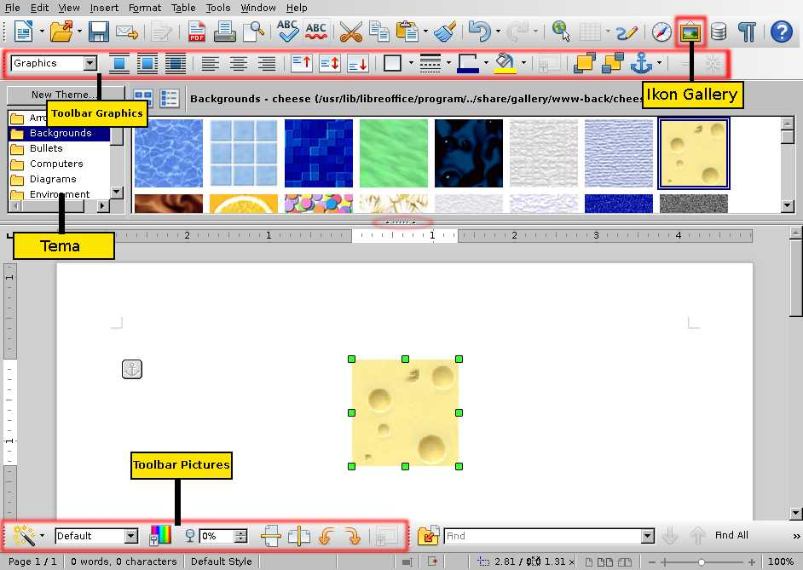

Note:
you can show/hide Gallery by clicking gallery icon.

Modifying Picture
When you add picture onto document, you might need modify a picture to fit the display into document. In this section, we will explain functionality of: Toolbar Picture, resizing, cropping, and rotate a picture.
In LibreOffice Writer, there are several tools which we can use to modify a picture. But, for professional result, it would be better using separate program such GIMP for cropping, resize, rotate or editing color composition from picture then Insert/Import it to LibreOffice Writer.

Graphics Mode
To display toolbar Picture, you can click on the picture or click View in Menu bar > Toolbars > Picture. But, in some circumstance, this menu will not be appeared. This menu will appear as View > Toolbars > Image in newer LibreOffice. Of course, it will have different user interface.
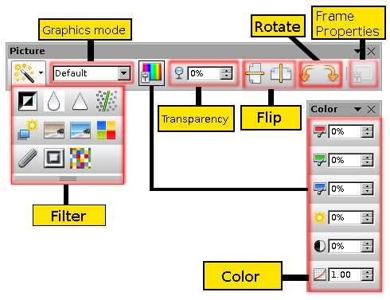

Picture 162: Parts of Toolbar "Picture"
On Graphics mode there are scroll mode and if it is clicked, there will be a list of options as follow:
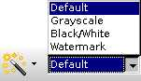

Picture 163: Graphics Mode

Desctiptiom :
Graphics mode | Effect | After Effect
Default | Normal color | 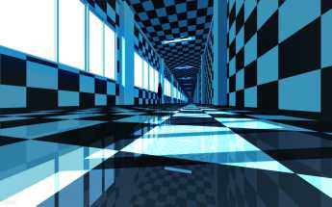
Grayscale | Black and white mode with normal mode | 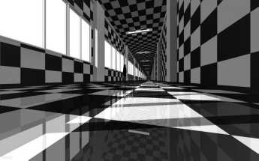
Black/White | Black and white mode with sharper contrast. | 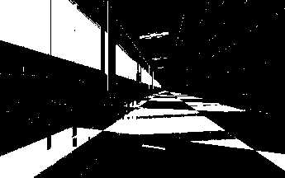
Watermark | Customizing color in white brightness/bright/transparency mode. | 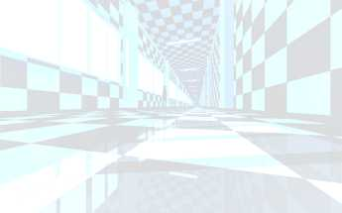

Flip
To flip Picture vertically or horizontally, click on Picture then click one of icons as follow.

Icon | Flip Mode | Effect
 | Flip Vertically | Flip Picture in vertical mode
 | Flip Horizontally | Flip Picture in horizontal mode
Table 13: Flip and its function

Filter
These are available Filter on Toolbar Picture with their function/effect:
Icon | Filter Mode | Effect
 | Invert | Inverting color to negative effect
 | Smooth | Applying blur effect on picture
 | Sharpen | Increasing contrast to picture
 | Remove noise | removing single-pixels from Picture
 | Solarization | Bright color effect
 | Aging | Afternoon effect
 | Posterize | Paint color effect
 | Pop Art | Applying fade effect
 | Charcoal | Wireframe effect
 | Relief | Applying effect from light angle, shadow, surface protruding effect, then it will be relief effect
 | Mosaic | Merge all pixel groups into 1 color area
Table 14: Filter Functions

Note:
Use Ctrl + Z or Alt + Backspace if you want to undo the effect

Color
Toolbar color can be used to customize RGB component (Red, Green, Blue) on picture, including brightness, contrast and gamma.

Note: if the result of your customization seems unsatisfied, use combined button Ctrl + Z to revert your customization

Transparency
This tool is very useful in making watermark effect in a picture. You just need to adjust percentage value on Transparency section.

Crop Picture
When you add a picture onto document, you might need eliminate several side parts of a picture. You might just need certain spot from a picture. These following steps will guide you cropping picture in LibreOffice Writer:
- First, right click on the picture > Picture > choose Crop tab
- By default, Keep Scale option will be applied, if so, the size of picture after being cropped will be decreased based on cropping size, whereas using Keep image size, the cropped area will be as fit as default picture before being cropped. You can also adjust the width and the hieght when using Keep image size on Scale section.
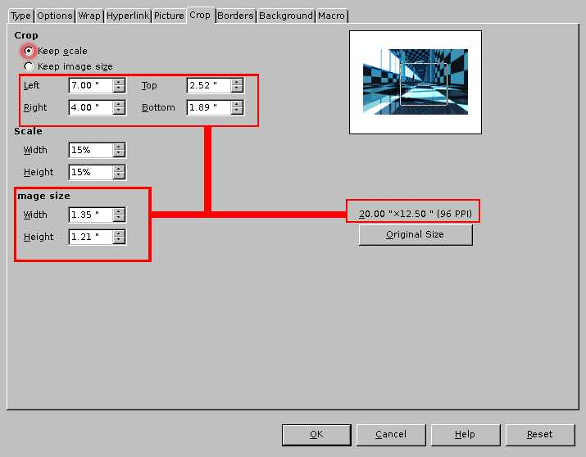
- After cropping was applied, click OK to get the result
Picture 164: "Keep Scale" Cropping mode

Resize Picture
Resize is easy to be applied, you just need to click on the picture, then drag small green box on one of corners of the picture and pull it until you get appropriate size. By default, resize will change just the scale of picture. If you want to adjust the width and the height, press Shift while dragging the picture.

Rotating Picture/Rotate
To rotate Picture, you can use Toolbar Picture
Icon | Name | Effect
 | Rotate 90 right | Rotating Picture 90 clockwise
 | Rotate 90 left | Rotating Picture 90 counter clockwise
Table 15: Rotate and its Function

However, LibreOffice Writer provides limited rotate feature. You can use LibreOffice Draw or Impress to rotate picture, the copy and paste it to LibreOffice Writer.

Applying Drawing Tools in LibreOffice Writer
On Drawing tools, there are variation of shape (line, eclipse, rectangle, arrow, etc). You can use it in making diagram, charts/flowchart, SmartArt and (Fontwork Gallery).
To show Drawing Tools in LibreOffice Writer, click View in Menu bar > Toolbars > Drawing
Picture 165: "Drawing Tools" bar

The steps in adding shape onto document:
- Click on shape which you want to be added.
- Double click, hold and drag pointer to adjust shape size.
Picture 166: Implementation of Drawing Tools
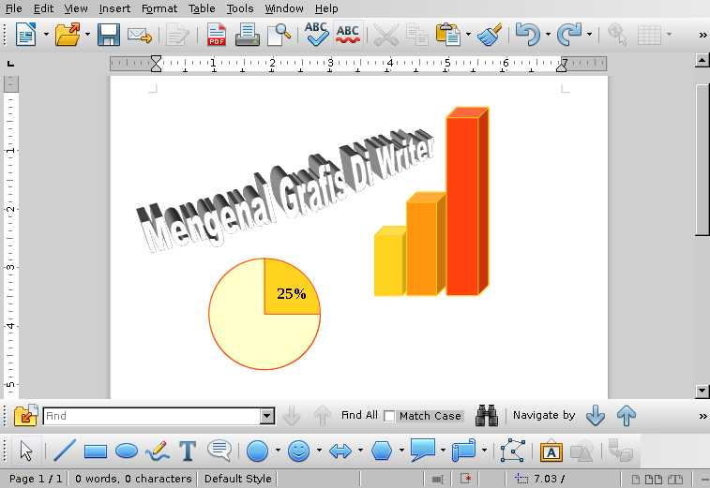

CHAPTER 22 PRINTING ADDRESS LABELS IN LIBREOFFICE WRITER
CHAPTER 22
PRINTING ADDRESS LABELS
IN LIBREOFFICE WRITER

Copyright © Sukamto <kamtono@gmail.com>
Translated by Astrida Atni Ayu Mahardini <astriddini7@gmail.com>

Introduction
Label printing is widely used when we want to send a letter of invitation, bills, notices, promotions or other things. If you intend to send invitations then of course data in the form of your name, address, zip code, phone number or others is urgently needed.

Label menu separates as a new menu and does not become one on the mail merge menu, but to activate it later, you still have to access the mail merge menu to bring up the data that has been stored in the database.

The database on this label is the same as the database used for the mail merge. Mail merge is more devoted to use for mail purposes and email header, such as letters or event on the content of the letter itself. As for the labels for the purposes which are not limited to the Affairs of the letter only. You can use it to provide labels on certain devices such as computers, Office inventory of electronic devices, the inventory table Chair or other things.

Still related to database, you can create a specific database for this label using LibreOffice Calc. See example data that I will use for the purpose of printing the label.
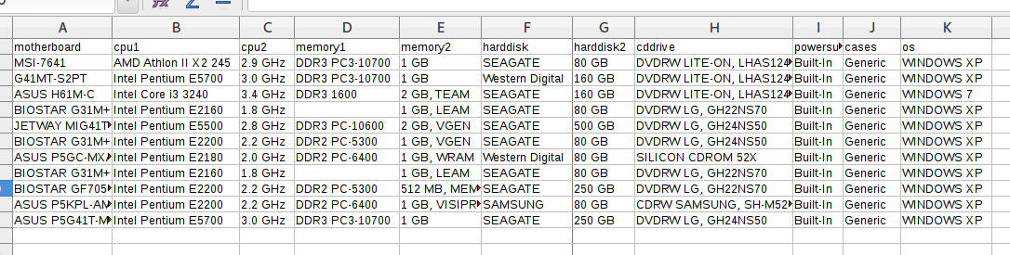
Table 16: Data to be Inserted for the creation of a Label

Be sure to follow naming example columns, it means that the data is not needed as a number, a date, or a column of data that will not be used. make sure it is not included.

Ready, Go !
Discussing label is always associated with a paper label that will be used later, and a little tip from me is to make sure to buy it first, and be sure to use the same brand because it is very possible the existence of differences in precision to the same size. And why should I buy it in advance because we have to do a manual setup format margin, spacing each label, length and width of the label.

In the picture below of one of the local label paper that I used to do printing labels.

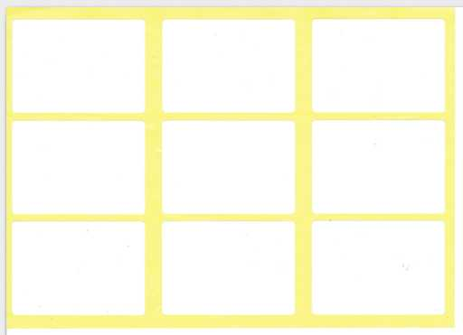
Picture 167: Picture Label

In the example of the label paper, each page has 9 blank label with each length and width is 5.7 cm and 4 cm. Of course with details which I should size so that the respective information that will be printed on the label could be right on it

Define Database!
To start the labels creation on LibreOffice Writer, select menu New > Labels. The first step is to choose the database that we created earlier (1), the next is to select the data table you want to use (2), if you select the database has many tables of data then customize data tables to be used for mail merge. The next step is to enter the field/column in the selected table (3). From the field/column, we start to set up the data which will be printed on the label. In the picture below I display details Sub Menu on the label. For a review, see box number (5) on the menu.
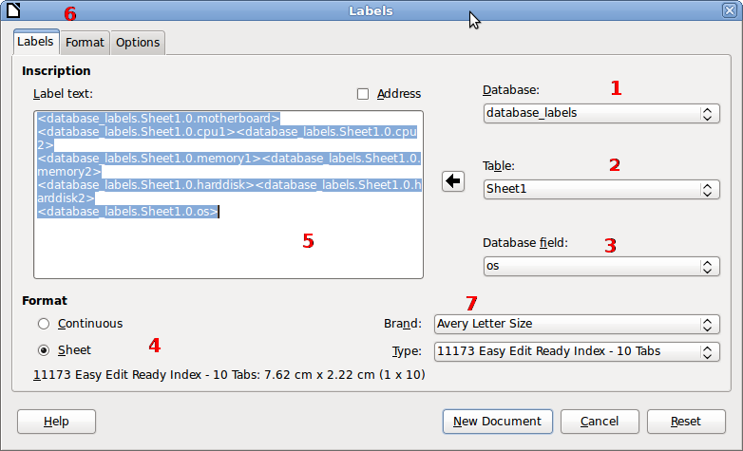
Picture 168: Interface Window Labels on Tab Labels

Paper Layout!
In the previous example, not all existing data in the database is inserted into the label to be printed, bearing the label I would use is not so great. Actually on the menu label itself, there are already some Setup from certain brand label with type that will be used, but due to the brand label is not provided, then at least we should do a Setup for a particular brand and also the type of the brand.
There is some Setup to do any of the following are noteworthy:
- The number of labels every page, the Setup is represented by stuffing Columns and Row. In the example, the label I would use for number of labels every page is a 9 line settings with 3 columns and 3 rows
- Margin, is the distance limits of paper up to the labels that will be used. On the setup it just mentioned the distance from the top margin of the paper (Top Margin) as well as the distance from the left margin (Left Margin).
- Pitch, there are two setup. The first is Horizontal Pitch, it is the distance from the edges of the paper (the left) until the next second-label. As for the Vertical Pitch is measured from the top of the paper up to the second label.
- Label Size, The Label Size, it is the size of the label or an empty area which can be used to do printing. Well on the label that I use, they have label with 4 cm and 5.7 cm wide.
- The width of the paper, and at the moment I am writing this article, the Setup for the paper width on the Page Width and Page Height could not be changed its value corresponds to the length and width of the paper label. the length and width of the paper labels should be 19.3 cm length and 13.8 cm width.
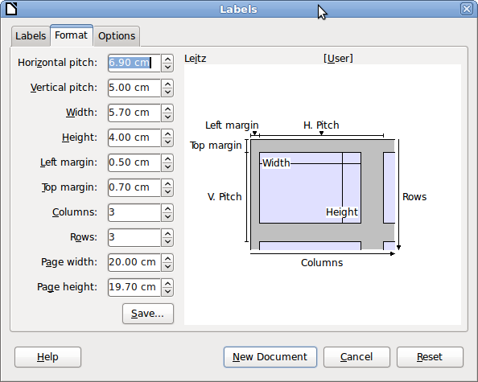
Picture 169: Window Labels interface on the Tab Format

To continue the process, the next is clicking on the New Document button, which automatically generates new file. Then there will be 9 data must be enabled via mail merge.

Mail Merge
As I have mentioned earlier, to bring up the data on the label we have to access the mail merge menu beforehand. Click the Next button to the entire process up to the final steps of mail merge. When you are prompted to choose whether mail merged
documents will be saved or will be directly printed. And here is an illustration of the mail merge process before showing 9 boxes labeled with 3 columns and 3 rows as well as variable data.
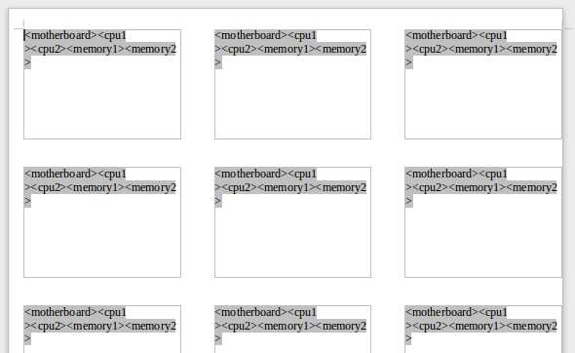
Picture 170: Display the Data in the table Using Mail Merge

Whereas, in the picture below is the result after the mail merge process.
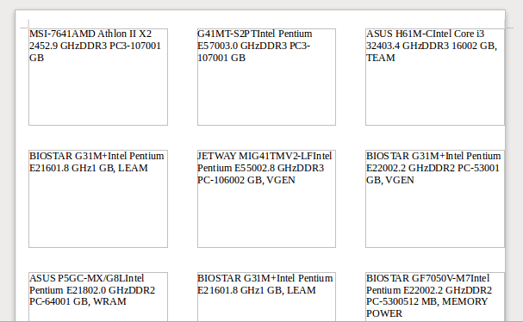
Picture 171: the end result of the process of making Labels

CHAPTER 23 ARABIC BUCKWALTER CONFIGURATION IN LIBRE OFFICE WRITER
CHAPTER 23
ARABIC BUCKWALTER CONFIGURATION
IN LIBRE OFFICE WRITER

Copyright © Buono <kangbuono@gmail.com>
Translated by Azis R. Pratama <azis.pratama@gmail.com>

In this tutorial, I’m gonna share my experience using “Arabic Buckwalter” keyboard-layout, to type Arabic letter by using latin-alphabet. For example a = alif, b = ba, and so on.

Step by steps adding new keyboard-layout (in GNU/Linux box):
First of all, we need to adding new keyboard layout into our GNU/Linux system:
- Open your keyboard preference (it may vary, depends on your current distro & desktop environment). But usually it is accessible via Start Menu > Setting > Keyboard. You can also use app launcher like Albert, Gnome-Do or Synapse in order to fire up the keyboard preferences.

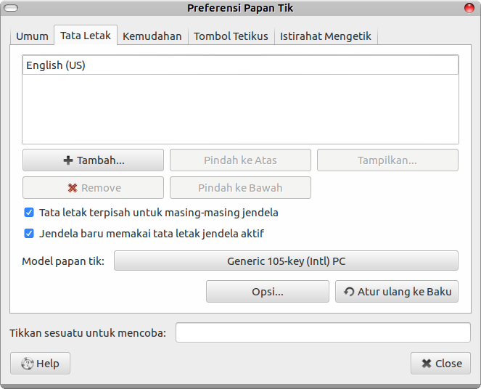

Picture 172: Main Keyboard Control-Panel Preference.
- In the keyboard panel preference, select Layout TAB (Tata Letak in Bahasa) and then, hit “Add” button. You will be given new window configuration (similar to screenshot no. 2 below).
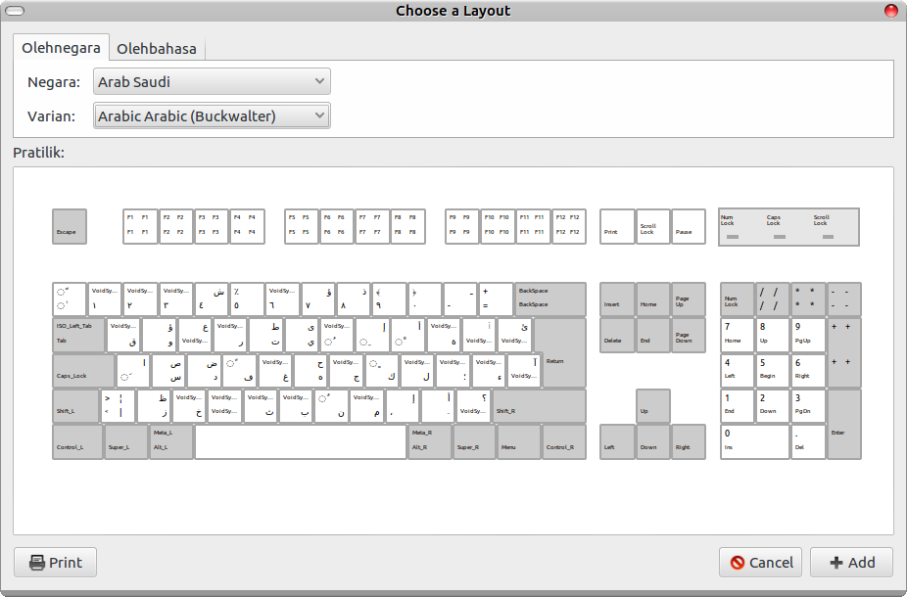
Picture 173: Adding New keyboard-layout (Ubuntu Mate Desktop Environment)
- Click [Add] button, make sure you select “Arabic (Bukwalter)” keyboard layout and then, hit [OK]. (again, it will be vary, depending on your own distro - desktop environment), but i hope you get the idea how to add and select new keyboard configuration.
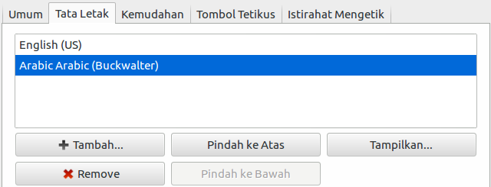
Picture 174: New Arabic (Buckwalter) Keyboard Layout.
4. Usually, after you add new keyboard layout, there will be new “keyboard panel selector” pop up in your taskbar, here is some examples in the two different desktop environment:
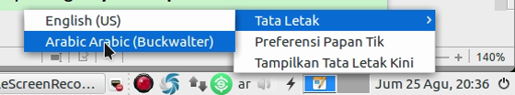
Picture 175: Quickly change keyboard layout using panel in taskbar (Ubuntu Mate)

“Arabic Qwerty” layout Vs. “Arabic Buckwalter” layout
There is some differences between Arabic Qwerty layout and Arabic Buckwalter layout, check this two screenshot below:
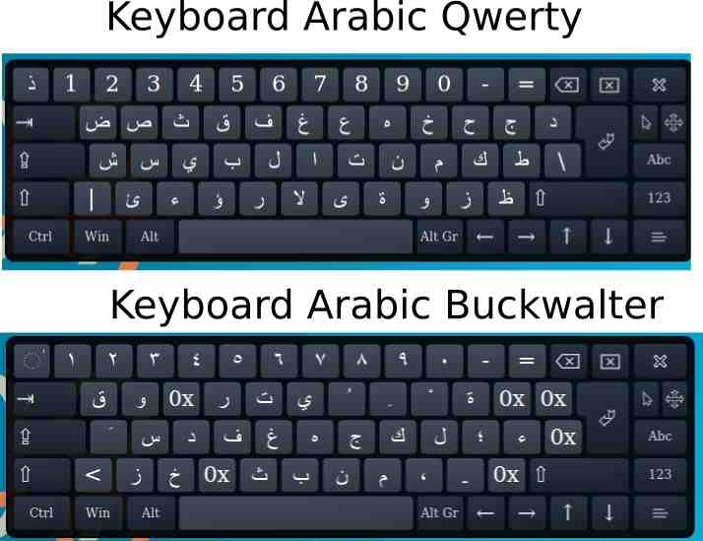
Picture 176: The differences between Arabic Qwerty & Arabic Buckwalter Keyboard Layout.

Also here is the complete letter conversion from latin to Arabic Buckwalter:
Huruf Latin | Arabic Buckwalter | Huruf Latin | Arabic Buckwalter
a | َ | A | ا
s | س | S | ص
d | د | D | ض
f | ف | F | ً
g | غ | G
h | ه | H | ح
j | ج | J
k | ك | K | ٍ
l | ل | L
; | ؛ | :
' | ء | “
q | ق | Q
w | و | W | ؤ
Huruf Latin | Arabic Buckwalter | Huruf Latin | Arabic Buckwalter
e |  | E | ع
r | ر | R
t | ت | T | ط
y | ي | Y | ى
u | ُ | U
i | ِ | I | إ
o | ْ | O | أ
p | ة | P
[ |  | { | ٱ
] |  | } | ئ
\ |  | | | آ
z | ز | Z | ظ
x | خ | X
c |  | C
Huruf Latin | Arabic Buckwalter | Huruf Latin | Arabic Buckwalter
v | ث | V
b | ب | B
n | ن | N | ٌ
m | م | M
, | ، | < | إ
. | ۔ | > | أ
/ |  | ? | ؟
Table 17: Latin to Arabic Buckwalter Table Conversiton

Beginning Typing using Arabic Buckwalter - Keyboard Layout
Before we begin, we need to change the typing method into (right to left). As we know in the Chapter 9 earlier, the keyboard shortcut to change these typing method is: [Ctrl+Shift+D] or Ctrl+Right Shift. To revert back on to default configuration use [Ctrl+Shift+A] or Ctrl+Left Shift.
Beside using right to left method, you can also use “right text alignment” [CTRL+R] , In order to make our Arabic Buckwalter text displayed correctly.


Picture 177: Right Text Alignment [CTRL+R]

From this point, you can easily typing Arabic Letter, please refer to Table No. 1 above, for a correct Latin to Arabic character translation =)
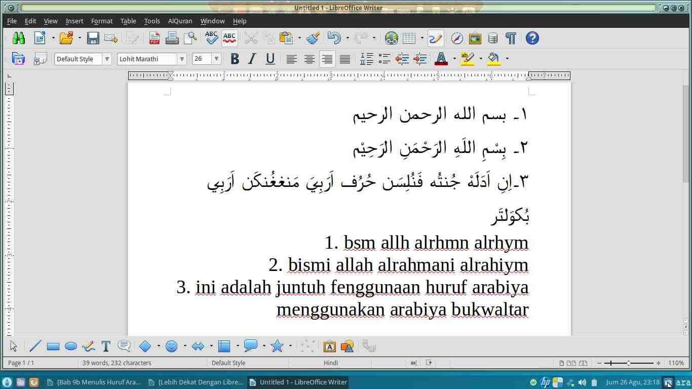
Picture 178: Arabic Buckwalter in Action

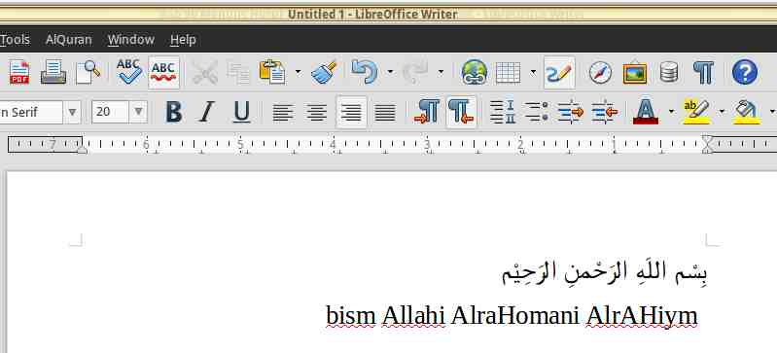
Picture 179: Right to left, typing method.
بِسم اللهِ الرَحمَنِ الراهِيم
Arabic Buckwalter
bism Allahi AlraHani AlrAhiym
Lattin Character

Reference:
https://bokunokeiken.wordpress.com/2014/09/24/input-method-arab-dan-jawa-dengan-cara-indonesia/

CHAPTER 24 LIBREOFFICE MOBILITY
CHAPTER 24
LIBREOFFICE MOBILITY

Copyright © 2016 Rahmat Kafabih (Kafabih/KR) <kafalterbang@gmail.com>
Translated by Muhammad Irwan Andriawan <andriawan2014@gmail.com>

LibreOffice Viewer di Android
In the previous chapter, the writer has explained that LibreOffice is one of alternative Free Office softwares from Microsoft Office. It is free to be used, free to be distributed which means you could share LibreOffice installation files to your friends. Along with rapid development of mobile technology, people tend to be lazy creating document in Desktop computer. In certain condition, such in traffic jam where we have deadline to complete tasks, people commonly prefer to use mobile application to create the document.
Nowadays, LibreOffice has landed on Android operating system to support you productivity in term of document creation. Yet, The Document Foundation as LibreOffice maintainer just published a Viewer. As it has been mentioned on LibreOffice manual wiki, You also could port LibreOffice application editor on Android. Unfortunately, LibreOffice editor is still in development state because of several environments and ecosystems on mobile devices itself.
As it has been mentioned on Google Playstore, LibreOffice Viewer has preview feature, whereas for feature of editing document is considered as experimental feature and it is unstable for daily usage. Your feedback and bug report will be considerably required by The Document Foundation as LibreOffice maintainer for quality improvement.
LibreOffice Viewer supports several file format as follows:
- Open Document Format (odt, ods and odp);
- Microsoft Office 2007/2010/2013 (docx, xlsx and pptx);
- Microsoft Office 97/2000 / XP / 2003 (doc, xls and ppt).
LibreOffice Viewer also offers base editing feature such as modifying words in available paragraph and changing font style like bold and italic style. Editing will be improved in the future along with developer community contributions. Users are also invited in reporting problem, seeking bug and attaching related file report on https://bugs.documentfoundation.org.
LibreOffice Viewer utilize the same basic program as LibreOffice for Microsoft Windows, Apple Mac OS X and GNU/Linux. It is also combined with new front end (Interface and appearance) based on Firefox application for Android, so that reading document on Android will be familiar with LibreOffice in desktop mode. LibreOffice was released under Mozilla Public License v2.

The Contributors
LibreOffice Viewer is developed by collabora dan Igalia, supported by Smoose, with contribution from student who participate in Google Summer of Code in collaboration with The Document Foundation and LibreOffice society. SUSE has given the main foundation in supporting cross platform compatibility and several core component from Mozilla Corporation. Thousand appreciation for independent LibreOffice contributor who has contributed code since 2010.
You could fully contribute as contributor by visiting http://www.libreoffice.org/about-us/credits. besides, you could download LibreOffice Viewer on https://play.google.com/store/apps/details?id=org.documentfoundation.libreoffice.

Interface of LibreOffice Viewer on Android

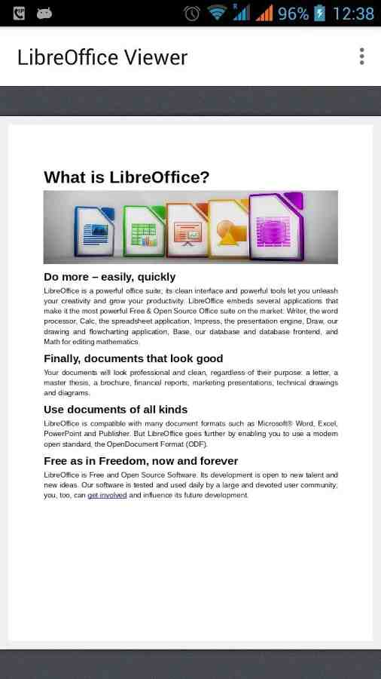

Picture 180: LibreOffice Viewer Appearance when Opening Text Document on Android

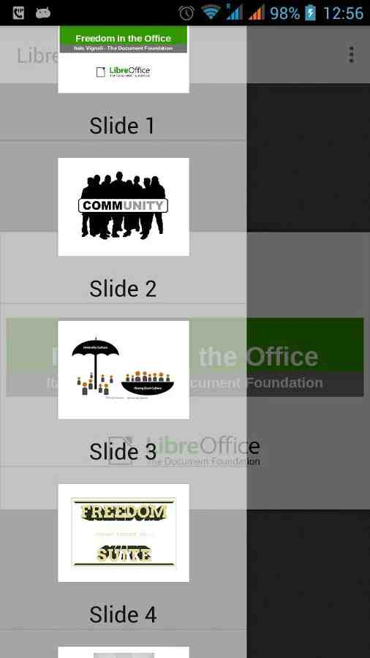

Picture 181: LibreOffice Viewer Appearance when Opening Presentation Document on Android

CHAPTER 25 INSERTING MATH FORMULA ON LIBREOFFICE WRITER
CHAPTER 25
INSERTING MATH FORMULA ON
LIBREOFFICE WRITER

Copyright © 2016 Nur Kholis <khokunsmile@gmail.com>
Translated by Thoriq Kemal <thoriqcemal@gmail.com>

We often found Math Formula in various document, like textbook till essay / thesis. It recently requires us to understand about how to using Math formula or Math equations correctly.
On LibreOffice, To process math equations is already provided separately from LibreOffice Writer, specifically Math. However we still can insert math equations to Writer.

Inserting Math Formula
To insert Math Equations to LibreOffice Writer, we can access menu Insert > Object > Formula. Then Writer will display like figure below.

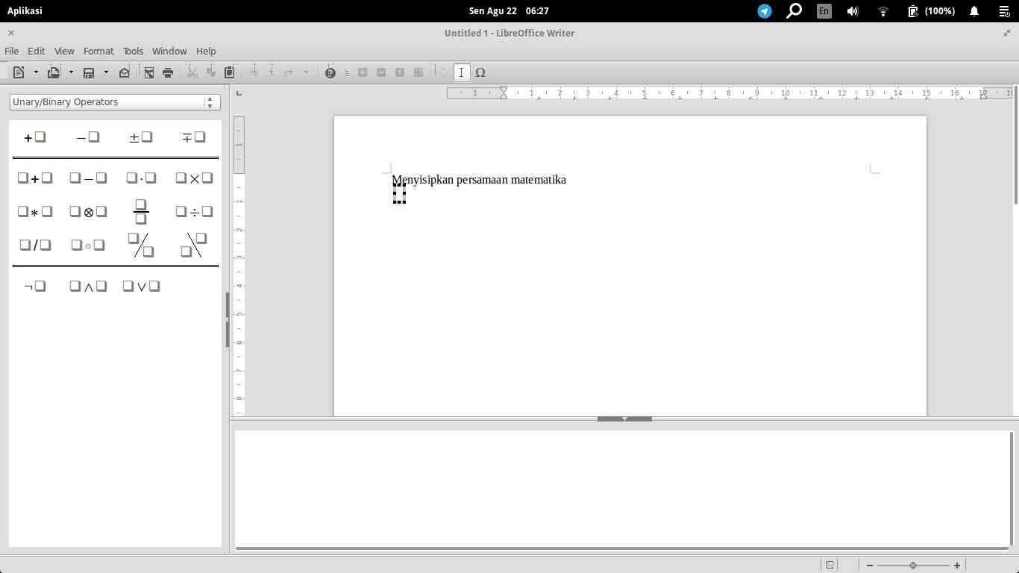
Picture 182: Interface of LibreOffice Math

At the figure above, we can find three main workspaces of LibreOffice Math. In the top section, there is Results Window. The bottom section is Command Window where a place for Math Syntax, and The left side is Elements, a set of math symbols and math operators which already grouped by category.

Then, to Insert Math Formula. There is three methods which is usual to use, such as click & edit syntax and directly type math formula (on math interface or outside math interface)

Method Click and Edit Syntax (on Math Interface)
For Example, we want to insert formula , then the steps is as follows :
- At Command Window, type y =
- Click Category Unary/Binary Operators at Elements panel, then click 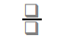
- At Result Window, click twice in the upper box. A place for
- Type 3, then choose Functions category at Elements panel. Click icon.
- At Result Window, click twice where a place for x, then type x.
- Next click twice where a place for power 2, then type 2.
- Next click twice in the lower box. A place for 5, then type 5.
- After finish all above. Click outside the formula box.
At this method, we can also press keyboard shortcut F4 to move from either box to another box.

Directly Typing Method (on Math Interface)
This method is the most effective method, to make some math formulas. Then we just type math notation on Command Window. For example, if we want to insert math equation , then we just type: y={3x^2} over 5 then press Esc.

Directly Typing Method (Outside of Math Interface)
We also need to know, this directly type method can also be done outside of Math Interface. It means that we don’t need to enter Math Interface before we type some formulas. This method can be done as follows :
- Type Math formula which we want insert to the document, for example y={3x^2}over5.
- Block selected Math formula.
- Access menu Insert > Object > Formula.
Automatically, the mentioned Math formula we type before will change to math equation .
From three methods to insert Math formula and Math equations, the last method is the most favorite writer methods. And surely, to easily use this directly type method, we need to understand some syntax which explain on next sub chapter.
By default, every time we edit / change math syntax on Command Window. The results on Results Window will automatically updated. If a result not automatically updated on Results Window, we can press F9 or access menu View > Update, or we can surely View > AutoUpdate Display already checked / activated.

Various Math Formula on LibreOffice Math
To insert Math formula or Math Syntax, there is some syntaxs we need to understand like basic operators (Addition, Subtraction, Multiplication and Division), Fractions, Powers, Roots, Symbols and Matrix. Read more on some table below.

Basic Operators
Symbol for basic math operators can be found on Unary/Binary Operators category.
Result | Syntax | Result | Syntax
 | a + b |  | x > y
 | a - b |  | x >= y
 | a times b |  | x < y
 | a div b |  | x <= y
 | x +-4 |  | x <> y
Table 18: Result and Syntax of Math Basic Operations

Fractions
Symbol for fractions can be found on Unary/Binary Operators category.
Result | Syntax | Result | Syntax
 | a over b
 | a slash b |  | a wideslash b
 | a bslash b |  | a widebslash b
Table 19: Result and Syntax of Fractions

With the following syntax above, we can make Math formulas as follows:
Result | Syntax
 | y = {a+b} over c
 | x = 1+ {1 over {2+{3 over 5}}}
 | y = {{a over b}+c} over d
Table 20: Example of fraction results

Roots
Symbol for roots can be found on Functions category.
Result | Syntax
 | sqrt {n}
 | nroot {n} {m}
Table 21: Result and Syntax of Roots

With the following syntax above, we can make Math formulas as follows:
Result | Syntax
 | y = sqrt{a over{b+c}}
 | y = nroot{5}{a over{b+c}}
Table 22: Example of Roots results

Powers and Index
Symbol for Powers can be found on Functions category.
Result | Syntax
 | x^n
 | y_n
 | func e^{n}
 | exp(n)
Table 23: Result and Syntax of Powers and Index

With the following syntax above, we can make Math formulas as follows:
Result | Syntax
 | x_{1.2} = {-b +-sqrt{b^2 – 4ac}} over {2a}
 | x = {sqrt2}^{{sqrt2}^{ {sqrt2}^... }}
 | C^{n}_{0} = 1
 | f(x)=func e^{2x-3}
Table 24: Example Powers and Index results

Brackets
Brackets can be found on Brackets category.
Result | Syntax
 | {n}
 | (n)
 | [n]
 | ldbracket n rdbracket
 | lbrace n rbrace
 | langle n rangle
 | langle m mline n rangle
 | lceil n rceil
 | lfloor n rfloor
 | lfloor n rfloor
 | ldline n rdline
Table 25: Result and Syntax of Brackets

At table above, we can understand that sign “{” and “}” can’t directly generate brackets sign.
However, to type brackets like table above can’t adjust / fit height of notation which flanked. Therefore we need to add “left” before left bracket and “right” before right bracket. Refer to the following example!
Result | Syntax
 | y = (1+a over b)^2
 | y = left (1+a over b right)^2
Table 26: Comparison of usual brackets and adjusting brackets

If we want to displays only one brackets, we can implement few method as follows!
Result | Syntax
 | f(x)= \langle {ax} over {b}
 | f(x) = left lbrace { stack{""ax+b # ""0 # ""-x }}right none
Table 27: displaying one brackets

Limit, Sum, Product, and Integral
Typing sigma notation, limit, or integral can be found on Operator category.
Result | Syntax
 | lim from {x toward a} f(x)
 | sum from {x = k} to{n} U_k
 | prod from {x = k} to{n} U_k
 | int f(x) dx
 | int from a to b f(x) dx
Table 28: Result and Syntax of Limit operators, Sum, Product and Integral

With the following syntax above, we can make Math formulas as follows:
Result | Syntax
 | lim from{x toward {4 over 3}}{ { 6x^2+7x-20 } over { sqrt{9x^2-24x+16} }}
 | sum from {k=0} to {infinity} {1 over {1+k+fact{k}}}
 | int from 0 to infinity {{sin(x)} over x dx} = %pi over 2
Table 29: Example Limit Operators, Sum, dan Integral

Trigonometry
Typing trigonometry notation can be found on Functions category.
Result | Syntax | Result | Syntax
 | sin(x) | y | "cosec"(x)
 | cos(x) |  | "sec"(x)
 | tan(x) |  | cot(x)
Table 30: Result and Syntax of Trigonometry functions

With the following syntax above, we can make Math formulas as follows:
Result | Syntax
 | sin left({2%pi-5}over{8}right)
 | {tan (x+sqrt{3})} over {1 + tan(x - sqrt{3})}
Table 31: Example Trigonometry functions

Logarithm
Typing logarithm notation can be found on Functions category.
Result | Syntax | Result | Syntax
 | log (x) |  | log_b (n)
 | ln (x) |  | {log (n)} lsup b
Table 32: Result and Syntax of Logarithm functions

With the following syntax above, we can make Math formulas as follows:
Result | Syntax
 | {log (b)} lsup a cdot {log (c)} lsup b = {log (c)} lsup a
 | f(t) = {ln(t)-1} over {t}
Table 33: Example Logarithm functions

Matrix
Inserting matrix, can be found on Formats category. However, only limited for matrix size. for more than that, Refer to the following example !
Result | Syntax
 | matrix{ a # b ## c # d }
 | matrix{ a # b # c ## d # e # f }
 | matrix{ a # b ## c # d ## e # f }
 | left ( matrix{ a # b ## c # d } right )
 | left lline matrix{ a # b ## c # d } right rline
Table 34: Result and Syntax of Matrix

Make sure that each column separated by one hash tag (#) and each row separated by two hash tag (##). Then, we can make more than matrix size.
Result | Syntax
 | A^{-1}={1}over{size*0.6 left lline matrix{ a # b ## c # d } right rline} times left ( matrix{ d # -b ## -c # a } right )
Table 35: Example Matrix equation

Symbols
There are two methods to insert symbol, specifically access menu Tools > Symbols and directly type some symbols. If we use first method, then will display dialog box as follows :
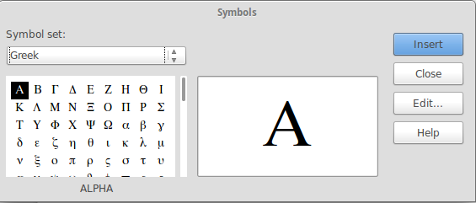
Picture 183: Interface of LibreOffice Math

On Symbol Set, we can choose Greek symbol for Greece symbols, iGreek for Greece symbols italic version, and Special for special symbols. Choose symbols which you want insert, then click Insert. Last click Close, to close Symbols dialog box.
And the second method, we can directly type the name of the following symbols through dialog box. Begins with “%” sign. For example, typing %alpha will resultsymbol.
More for symbol syntax can be found in the following table :
Symbol | Syntax | Symbol | Syntax
 | %alpha |  | %ALPHA
 | %beta |  | %BETA
 | %gamma |  | %GAMMA
 | %delta |  | %DELTA
 | %epsilon |  | %EPSILON
 | %zeta |  | %ZETA
 | %eta |  | %ETA
 | %theta |  | %THETA
 | %iota |  | %IOTA
 | %kappa |  | %KAPPA
 | %lambda |  | %LAMBDA
 | %mu |  | %MU
 | %nu |  | %NU
 | %xi |  | %XI
 | %omicron |  | %OMICRON
 | %pi |  | %PI
 | %rho |  | %RHO
 | %sigma |  | %SIGMA
 | %tau |  | %TAU
 | %upsilon |  | %UPSILON
 | %phi |  | %PHI
 | %chi |  | %CHI
 | %psi |  | %PSI
 | %omega |  | %OMEGA
 | %vartheta |  | %varpi
 | %varrho |  | %varsigma
Table 36: Result and Syntax for Greece symbols

for symbols on iGreek subsets, yo just adding “i” in the beginning of symbol name. For example, “%itheta” for producing.
for Specials subset you can use following table syntax:
Special | Syntax | Special | Syntax
 | %perthousand |  | %tendto
 | %element |  | %noelement
 | %identical |  | %notequal
 | %and |  | %or
 | %angle |  | %Ux2221
Table 37: Result and Syntax for some special characters

Inserting New Rows, Space, and Formula
In Writing Formula, maybe we realize the distance of some characters is too tight. However with directly pressing space on keyboard will not affect space on formula. Therefore we can using {} , ` , ~ , or "<space>" (space which flanked with quotes) to give space on formula. For complete example you can use following table syntax:
Result | Syntax | Information
 | a+b | Using Space won’t  affect Formula
 | a + b | Using Space won’t  affect Formula
 | a{}+b | Give little space  before “+” sign
 | a`+b | Give little space  before “+” sign
 | a~+b | Give one space  before “+” sign
 | a" "+b | Give one space  before “+” sign
Table 38: Few example methods to give space on Math Formula

Sometimes typing Math Formula we need more than one row. As well as using Space, pressing Enter on Command Window never generate new line / row on the following Math formula. To do that, we using “newline” syntax to start new line.
Result | Syntax
y=2x+5+3 newline
y=2x+8
Table 39: Generating new line on Math Formula

When we notice it, the result of math Formula will automatically arranged to center alignment. That will look not fit if we use for typing solution of Math equation. Therefore we can set alignment using alignl to align left and alignr to align right. For complete example you can use following table syntax:
Result | Syntax
alignl y=2x+5+3 newline
alignl y=2x+8
alignr y=2x+5+3 newline
alignr y=2x+8
Table 40: Set Left Align and Right Align on Math Formula

Typing more complex solution, using newline and spacing will make syntax has already written seems very complicated. Therefore we can combine with matrix. For complete example you can use following table syntax:
Result | Syntax
matrix{
alignr y-y_1 #"="# alignl m(x-x_1) ##
alignr y-5 #"="# alignl 2(x-3) ##
alignr y-5 #"="# alignl 2x-6 ##
alignr y #"="# alignl 2x-6+5 ##
alignr y #"="# alignl 2x-1 }
Table 41: example of writing solution (step-by-step)

Inserting certain attributes
Sometimes formula we already typed give lacking / not satisfy result or not accord with our expectations. With Attribute category we can set result, whether size, type, font color and another expected attribute.
Result | Syntax | Keterangan
 | 2+bold{3}=5 | Bold number 3
 | 2+italic{3}=5 | Italic number 3
 | underline{2+3}=5 | Add Underline on 2+3
 | overline{AB}+overline{BC}=overline{AC} | Add Overline (Upper line) on AB, BC, dan AC
 | font sans {sin{%pi over 4}}= font serif {cos {%pi over4}} | Change font  become Sans, and onbecome Serif.
 | color red {log(x)}=1 | Give red color on
 | size 18 x | Change font size to 18 pt
Table 42: Giving some additional Attributes on Math Formula
By using Attribute, we can improve Math formula result which sometimes lacking. Especially when typing fragments. Look at example below !

Result | Syntax
 | x_{1.2} = {{-b +-sqrt{b^2 – 4ac}} over {2a}}
 | Size 8 {x_{1.2} = {{-b +-sqrt{b^2 – 4ac}} over {2a}} }
 | size*0.7{x_{1.2} = {{-b +-sqrt{b^2 – 4ac}} over {2a}} }
 | size-5{x_{1.2} = {{-b +-sqrt{b^2 – 4ac}} over {2a}} }
 | x_{1.2}=size*0.6{{{-b+-sqrt{b^2-4ac}}over{2a}}}
Table 43: Example to adjust font size on Math formula

Note that we can adjust font size on formula very easily and very dynamic.
- At the first row, by default font size on formula is 12pt
- At the second row, we set font size become 8pt using size 8 command.
- At the third row, we change font size become 70% of default font size, (12pt*70%=8.4pt) using size*0.7 command.
- At the fourth row, we reduce font 5 point from default font size (12pt-5pt = 7pt) using size -5 command.
- At the fifth row, font size onusing defaut font size, andwe reduce to 60% default size.

Discovering another Syntax Math Formula
From few examples above, actually there are still some notations which not explained in here. All of following notations can be accessed through Elements. Through Elements, we can also discover existing syntax.
For example we will write absolute equation. Then we choose Functions category and  icon. It will give result on Command Window that those symbols for “absolute value” have “abs” syntax on Command Window.
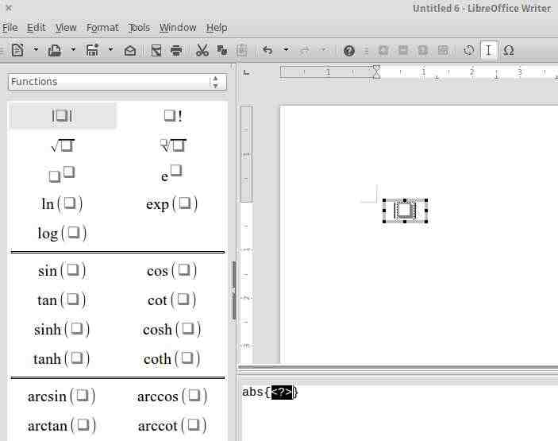
Picture 184: Discovering Syntax of Math Formula

CHAPTER 26 PRINTING DOCUMENTS ON LIBREOFFICE WRITER
CHAPTER 26
PRINTING DOCUMENTS
ON LIBREOFFICE WRITER

Copyright © 2016 Buono <kangbuono@gmail.com>
Translated by <ari>

After a document is created and finished, the last step you might want to do is to print it. On LibreOffice, documents we have created can be printed as PDF files or we can print them on papers.
Printing documents as PDF files was explained on chapter 14. Sometime, we want to keep LibreOffice documents as PDF when we want to print them on other computers that might not have LibreOffice installed, like at print shops. So we can keep our documents formatting that might be changed by other Word Processor applications if we saved them on an editable format.
PDF format is also used as soft copy on documents exchanges. For example, Indonesian Government’s Ministry of Communication and Information in its 2013 regulation requires all of the official documents must be either on open document format (odf) or as portable data format (pdf).

Steps on Printing Documents
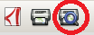
Before printing a document on papers, make sure the document is already final, you can see how will it looks on paper from print preview. From menu File > Print Preview or click shortcut on toolbar.
You can see document print preview in this image:
Picture 185: Example of Print Preview
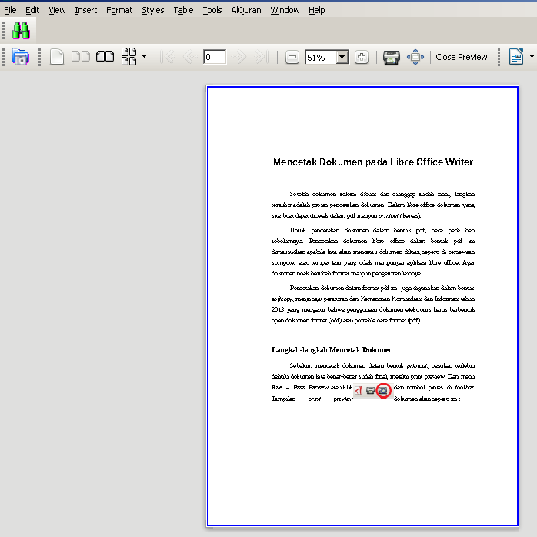

Printer Settings
- You can access printer settings from Start Menu > Setting > Printer or from search menu, type “printer” (without quotes).
- Then double click the printer you want to use. Set printer as your usual work requires.

Note: For printing in F4 size, you can use legal size instead. It is possible to add settings to /etc/cups/ppd/ but it does not always works and may produce errors.
Picture 186: Printer Properties windows
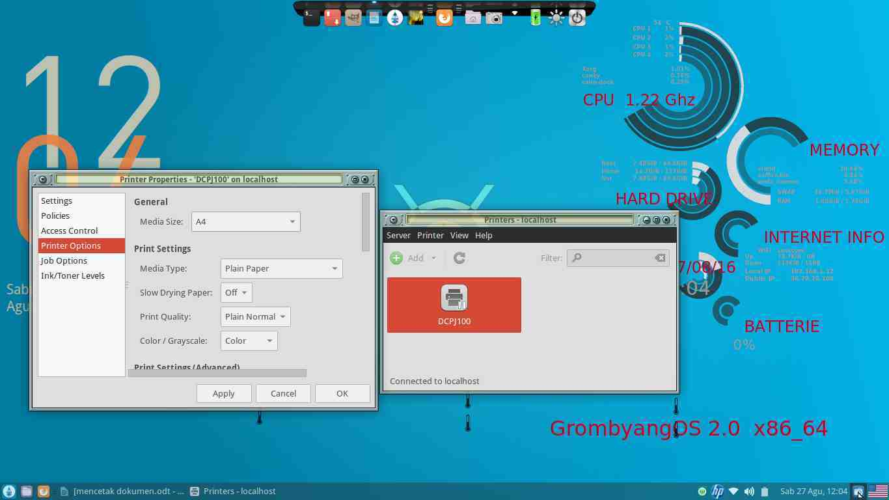

Printing Documents
- You can print documents from File > Print. By using Ctrl + P keyboard shortcut or by clicking this icon on toolbar.

- You will be presented with this window:
Picture 187: Print window
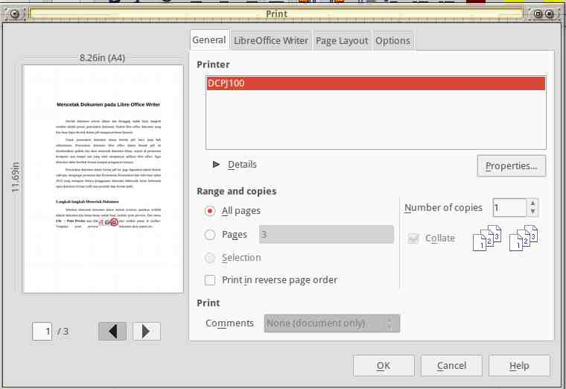

- The next step is to set Properties according the type and orientation of the paper you use.
Picture 188: Printer Properties window
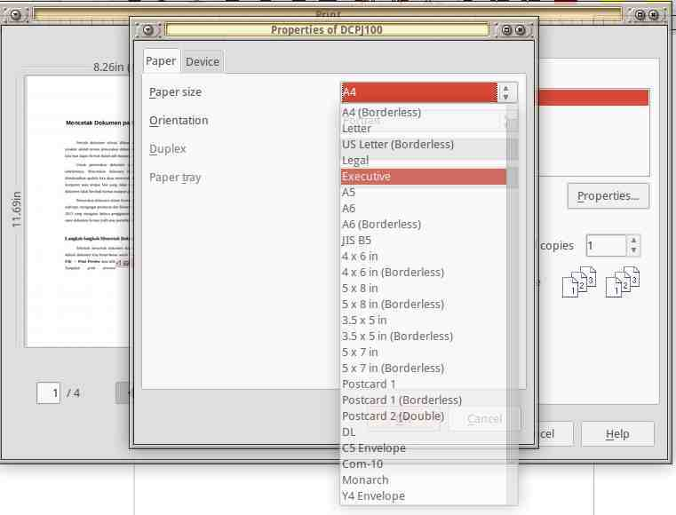

- Then click OK and Print.

Adding F4 Paper on Printer Settings
I (writer) have never manually added extra settings to print documents on F4 paper. By selecting legal in place of F4 size I have never encountered any problem when printing from LibreOffice Writer, LibreOffice Calc, or LibreOffice Impress. Adding manually paper size is not recommended because its risk introducing some problems.
But, if you want to try it yourself, here is the steps:
- On command line, enter cd /etc/cups/ppd/ to move to printer settings files directory. Inside you will find configuration files for your printers. In this example the file is DCPJ100.ppd. You should adjust accordingly.
Picture 189: The view of Nautilus /etc/cups/ppd/
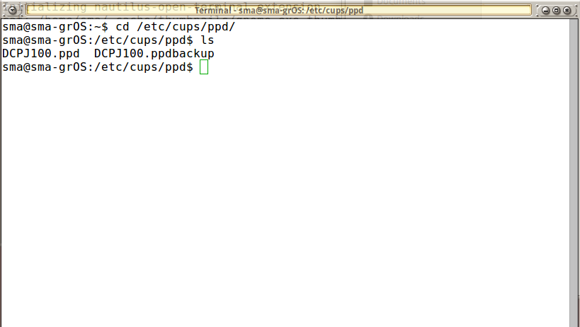Picture 1: Tampilan terminal /etc/cups/ppd/
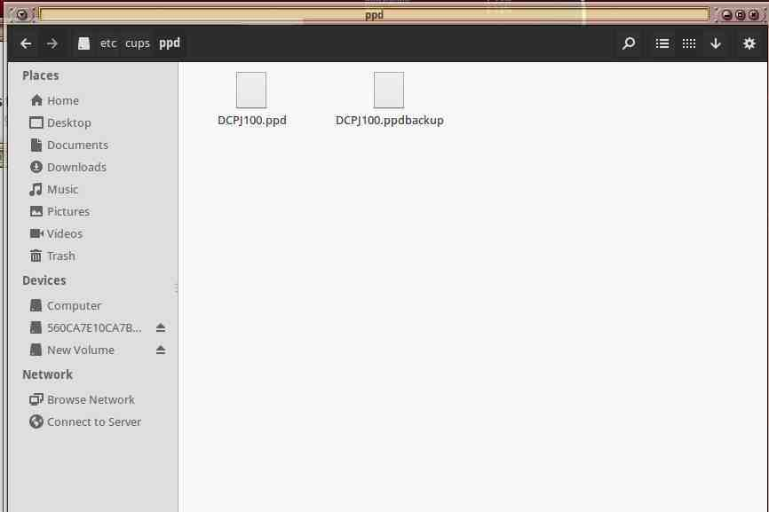

- Backup the original files, so you can restore them if necessary. From command line :
cp /etc/cups/ppd/DCPJ100.ppd /etc/cups/ppd/DCPJ100.ppd.bak
- Edit the ppd file, we are using Gedit text editor here.
sudo gedit DCPJ100.ppd
Picture 190: Ppd file in Gedit text editor.
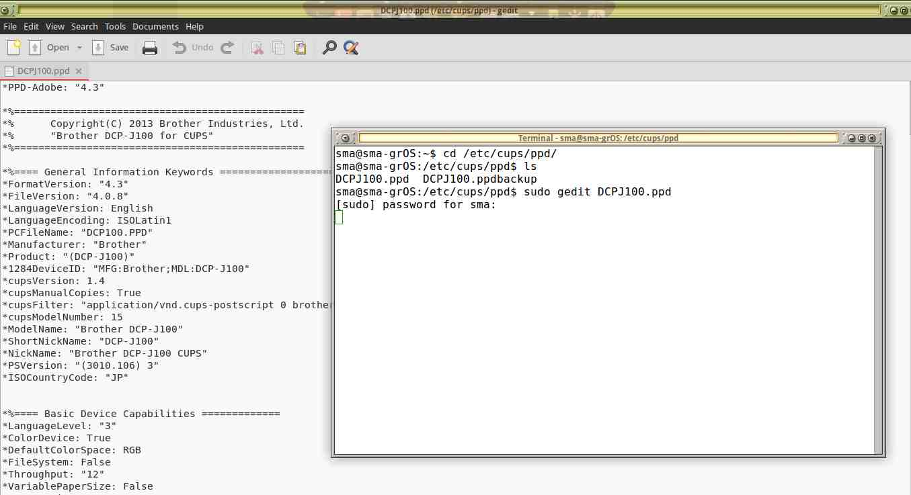

- In Gedit, press CTRL+H to open Replace dialog window. Type 1008 in Search for box and type 936 in Replace with box. Save and then Close.

Picture 191: Find and Replace window on Gedit
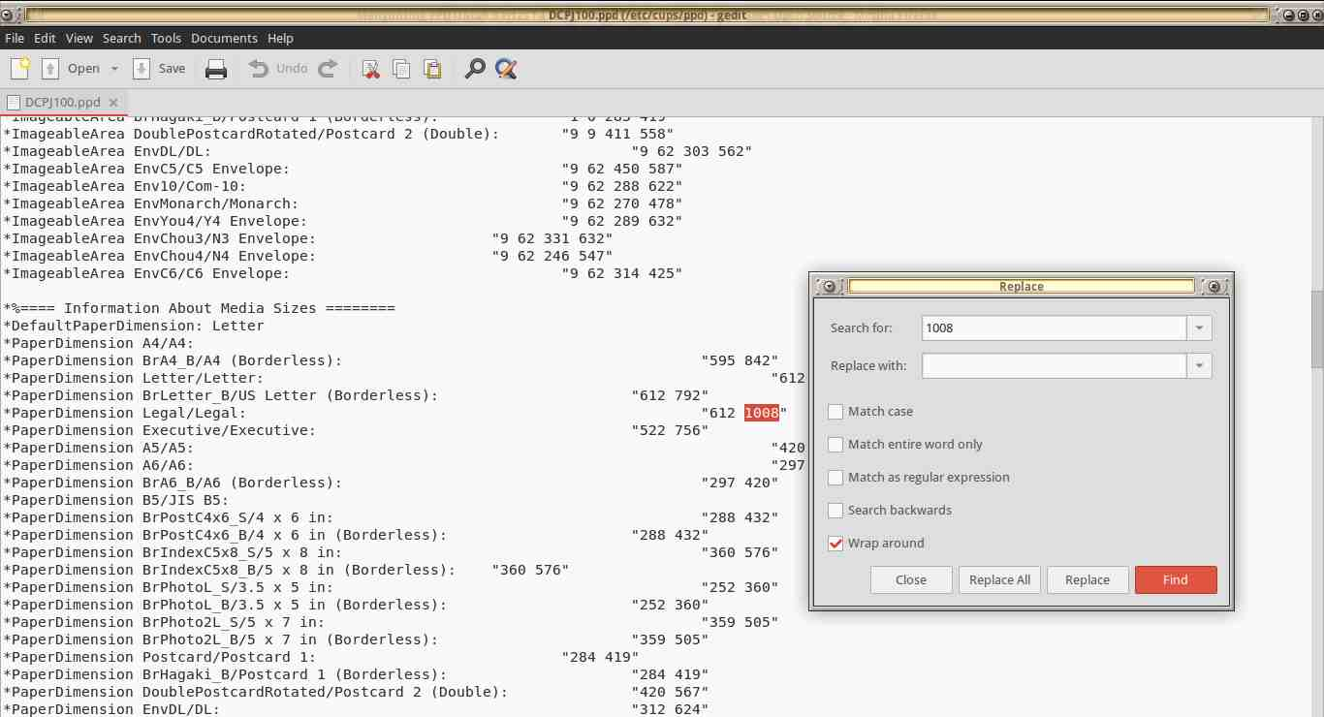

Picture 192: Gedit view after the values are replaced
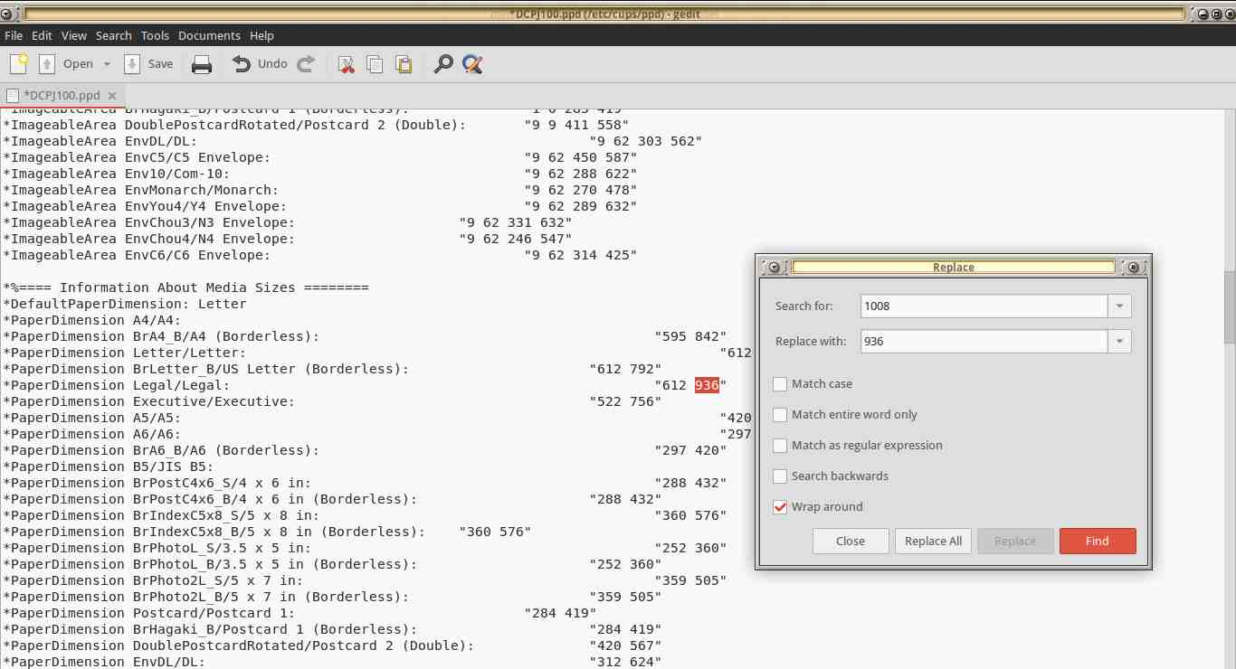

- Restart running CUPS service by typing in command line sudo /etc/init.d/cups restart
- Done. Before using the new setting, you need to close all of active LibreOffice instances. You can now select the size Legal when you print on F4 paper.

CHAPTER 27 WORKING WITH LIBREOFFICE EXTENSION
CHAPTER 27
WORKING WITH LIBREOFFICE
EXTENSION

Copyright © 2016 Nur Kholis <khokunsmile@gmail.com >
Translated by Muhammad Irwan Andriawan <andriawan2014@gmail.com>

Extension is an add-on tools which can separately install or uninstall from LibreOffice main program. Extension could create new formulas or functions which improve existing functionality of functions.

Getting Extensions
To obtain LibreOffice Extension, We could access following link http://extensions.libreoffice.org/extension-center. There are various extensions for all LibreOffice components, include LibreOffice Writer.

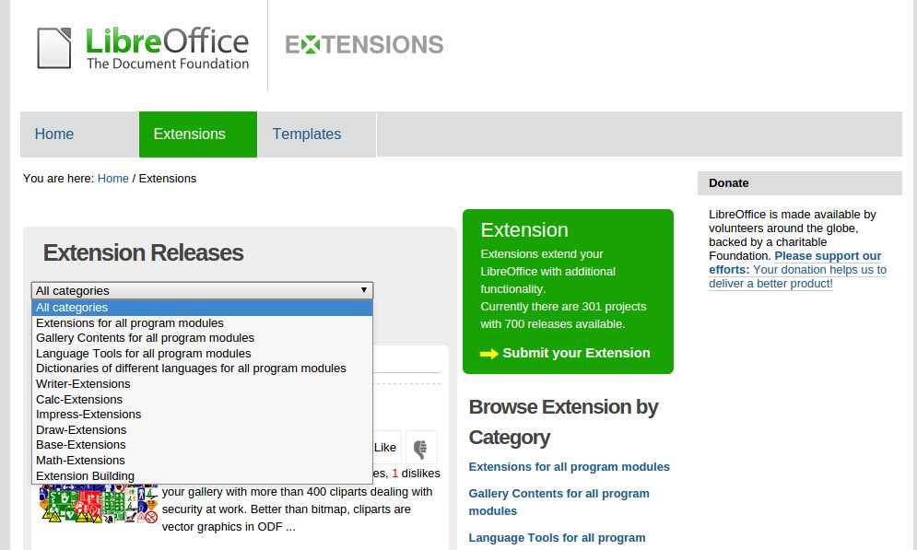
Picture 193: Choosing Extension by certain category

Downloaded Extension has “.oxt” file format. This Extension is ready to install on LibreOffice.

Installing Extension
To install and activate Extension, double click the extension which would be installed to. There will be a pop up window contains installation confirmation of Extension as following illustration:

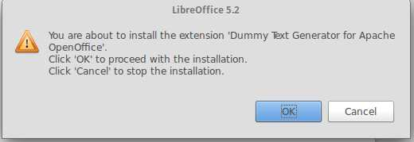
Picture 194: Installation confirmation of Extension

Click OK button to continue to Extension Software License Agreement window. In this occasion, we would be asked to read License Agreement from the Extension. Navigate to the last section or click Scroll Down button to read whole License. Accept button would be activated, just click Accept button.
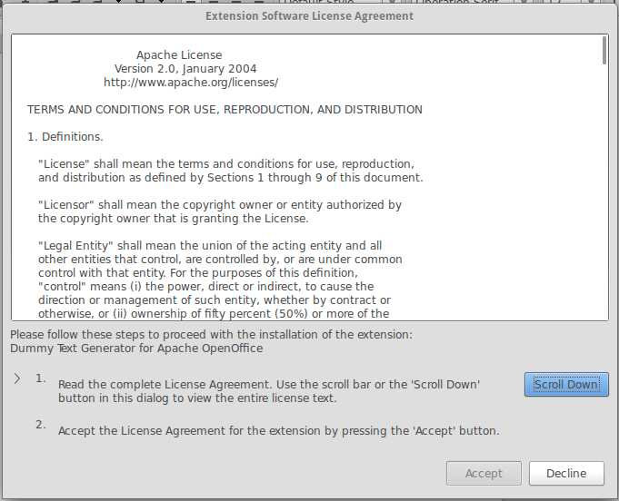
Picture 195: Extension Software License Agreement window

Take a couple of time, until installation process is done as following illustration.
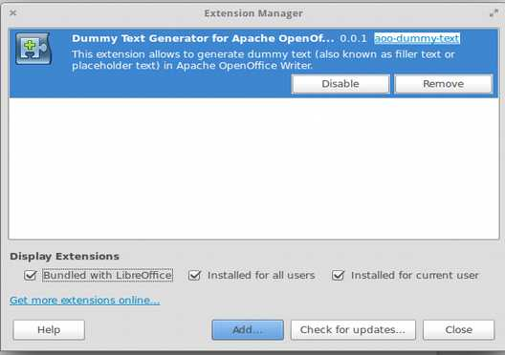
Picture 196: Extension Manager Window

we could add other extensions by clicking Add… button then choose other extension which we would be installed. Click Close button for closing Extension Manager window, then re-run LibreOffice Writer. The Installed Extension is ready to be used.

Managing Extension
To find out what Extension is enabled on LibreOffice Writer, we could check it on Extension Manager window as previous illustration above. To open Extension Manager window, we could navigate to menu bar Tools > Extension or use shortcut keyboard Ctrl+Alt+E. Make sure “Bundled with LibreOffice”, “Installed for all user”, and “Installed for current user” on Display Extensions are checked for displaying all installed extensions.
When we choose one of available extension, there are 2 available options, they are Disable and Remove. If we choose Disable, selected Extension would be disabled, without uninstall it. To enable selected Extension click Enable button. If we choose Remove option, The selected Extension would be disabled then remove it from Extension list. We need to re-install to activate removed extension.
In some circumstance, while we install, uninstall, remove or disable an extension, there would be unexpected condition such freezing extension state, or even crash state which caused LibreOffice issues force close. These occasion due to an extension is made by third party which potentially could not cover compatibility issue from The extension itself. Thus, we strongly recommend saving all opened documents before managing extension.

Several Example of LibreOffice Writer Extension
This following example of various extensions which could be installed on LibreOffice writer. Several extensions might be not working as we are expected.

Clipart Gallery of Danger Signs
This extension contains collection of clipart danger signs. After installing this extension, we could view it through Insert > Media > Gallery or through right-side panel, choose Sidebar setting icon > Gallery. You could download it on http://extensions.libreoffice.org/extension-center/gallery-of-danger-signs.
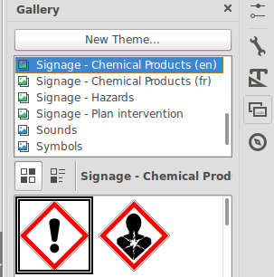
Picture 197: Collections of Clipart Danger Signs

TexMath
If we often work with LaTeX and want to insert mathematical notation such LaTex-based document, this extension is very powerful for alternative solution. To enable this extension, we have to install texlive first.
After Installing this extension successfully, this extension icon would appear 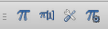 which contains interface for inserting mathematical notation, configuring TexMaths, and recompiling existing mathematical notation.
We just need to click the icon then it would appear input formula window. Type formula which we want to insert then click LaTeX. Similar to LibreOffice Math, we also could directly type mathematical notation on LibreOffice Writer by blocking selected formula, then click Icon .
You could download TexMath extension on website http://extensions.libreoffice.org/extension-center/texmaths-1.

Dummy Text Generator
If we delight to create template, we might be familiar with dummy text such as Lorem ipsum. With this extension, we could easily generate dummy text through Insert > Dummy Text. But, for generating Lorem ipsum template, we need Internet connection.
You could download Dummy Text Creator extension on https://www.arielch.org/aoo/aoo-dummy-text/ .

Dmath
This extension is very helpful in Drawing mathematical objects such as, angle, triangle, Nominal line, Cartesian coordinates, etc. After installing this extension, there will be a new menu Dmath and toolbar icon which contains kind of mathematical object feature.
You could download Dummy Dmath extension on http://extensions.libreoffice.org/extension-center/dmaths.

Writer Rotation Tool
This extension is a-must extension on LibreOffice Writer. Through this extension, we could rotate picture which we have inserted on to LibreOffice directly with mouse.
To rotate desired picture, click selected picture, then click icon on toolbar, the picture would be rotated by mouse. You could download Writer Rotation Tool on http://extensions.libreoffice.org/extension-center/writerrotationtool.

CHAPTER 28 WORKING WITH TRACK CHANGES
CHAPTER 28
WORKING WITH TRACK CHANGES

Copyright © 2016 Muhammad Irwan Andriawan <andriawan2014@gmail.com>
Translated by Muhammad Irwan Andriawan <andriawan2014@gmail.com>

Track Changes
Track changes is a subheading menu in LibreOffice writer. You can easily find it on Edit Menu Bar. There is slight different naming menu in LibreOffice writer under version 4 especially in Edit menu. In Earlier version 4, Track changes appears as Changes in Edit menu. But, in the latest version 5, it uses Track changes. both has identical usage.
Literally, track changes has meaning jejak perubahan in Bahasa. Track changes has great functionality in:
- Recording changes in a document
- Making collaborative editing easier

Recording changes in a document
Track changes feature is not activated yet by default. To activate it, navigate to menu bar Edit > Track Changes/ Changes > Record Changes. If you want to make it simple, Just use shortcut key combination Ctrl + Shift + E.
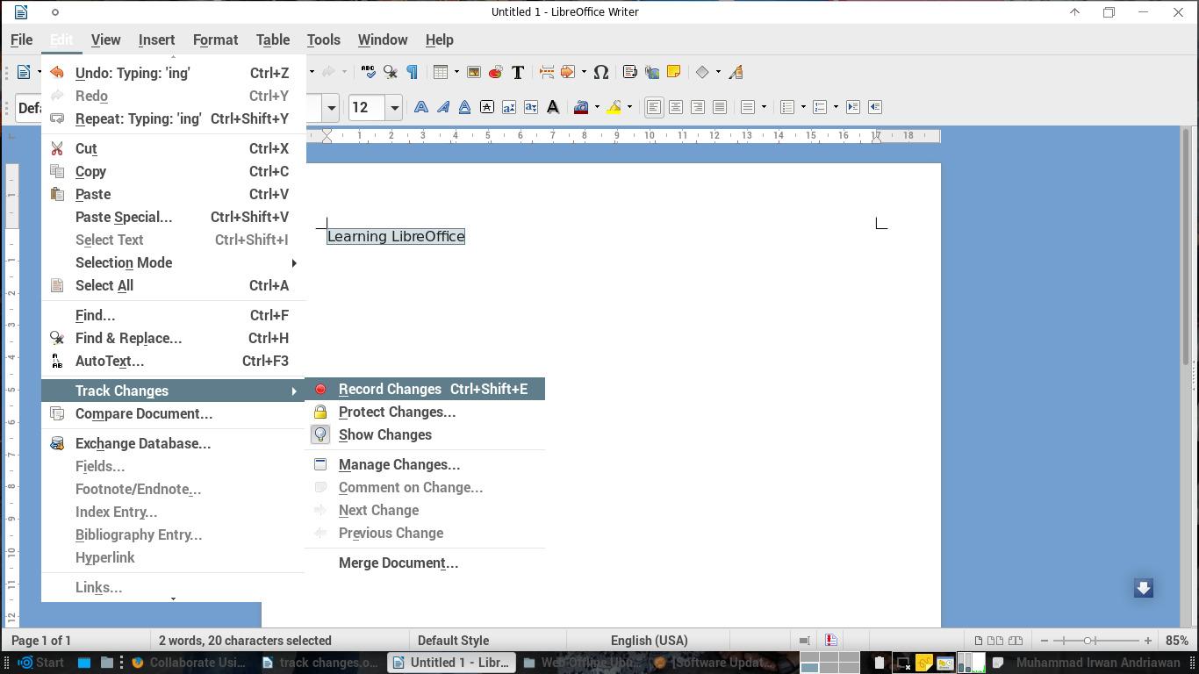
Picture 198: Track Changes Feature

After track changes was enabled, Document will have special record history. It can be identify from underlined phrase in Illustration below.
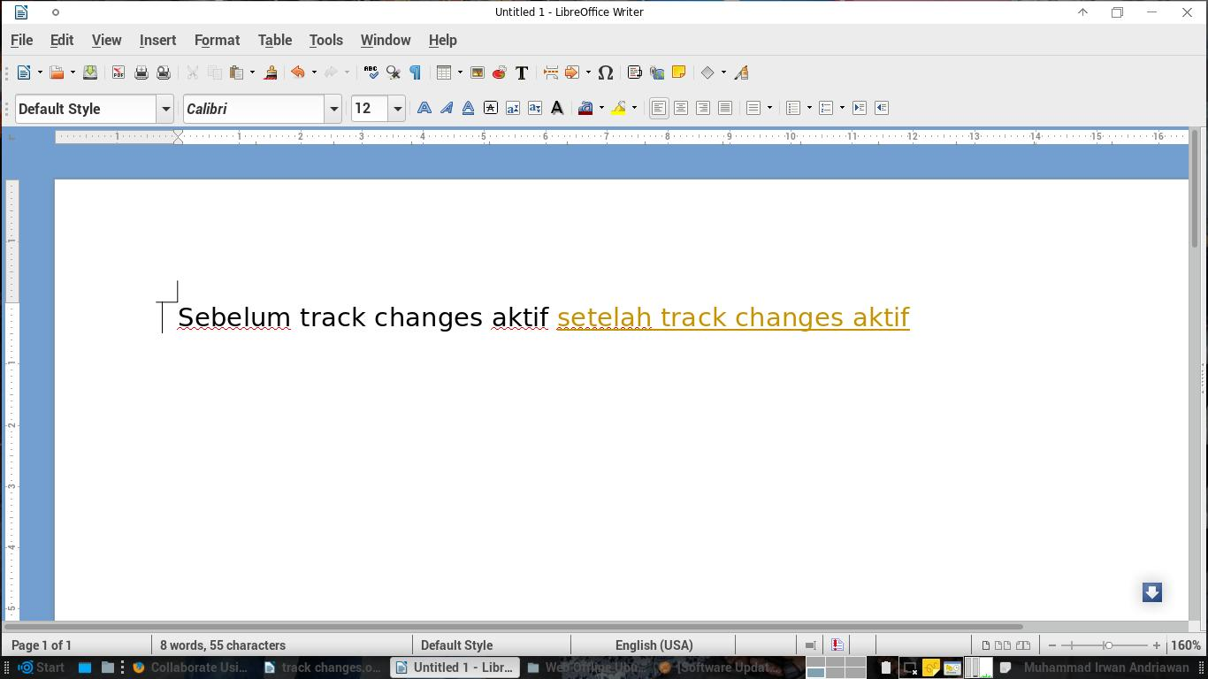
Picture 199: Modified Document while Record Changes was enabled

In certain circumstance, we could not see special mark underlined and golden font effect. It is because we do not enable show changes feature yet. Navigate to menu Edit > Track Changes/Changes > Show changes if you want to activate it.
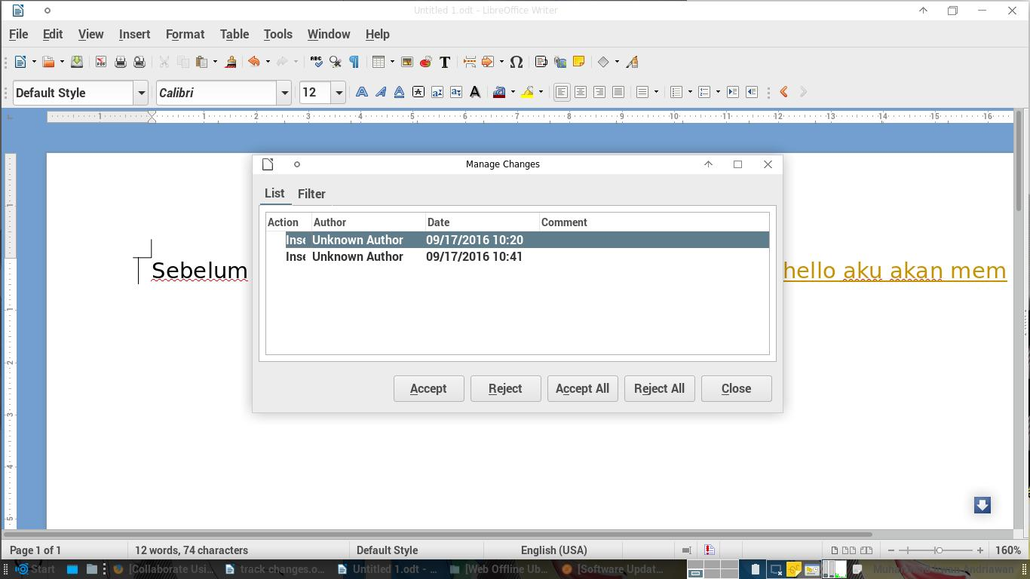
Picture 200: Manage Changes Window

Simply said, track changes records everything changes you have been made. It could be font color usage, font style, size and content of document itself. But, in advanced usage, track changes can help us organizing document in well manner. We can track changes in Manage Changes Feature.
You can access Manages Changes in menu Edit > Track Changes/Changes > Manages changes. Manage Changes will appear serving you detail information about all changes in two tab menu List and Filter. In tab menu List, you can find Action, Author, Date and Comment.
1 | Action | What changes which we has been made
2 | Insertion | Changes which related to insertion
3 | Deletion | Changes which related to deletion
4 | Author | Identity of Changes editor
5 | Date | Changes date
6 | Comment | Additional Information related to changes

In tab Filter, you could do filtering information related to changes
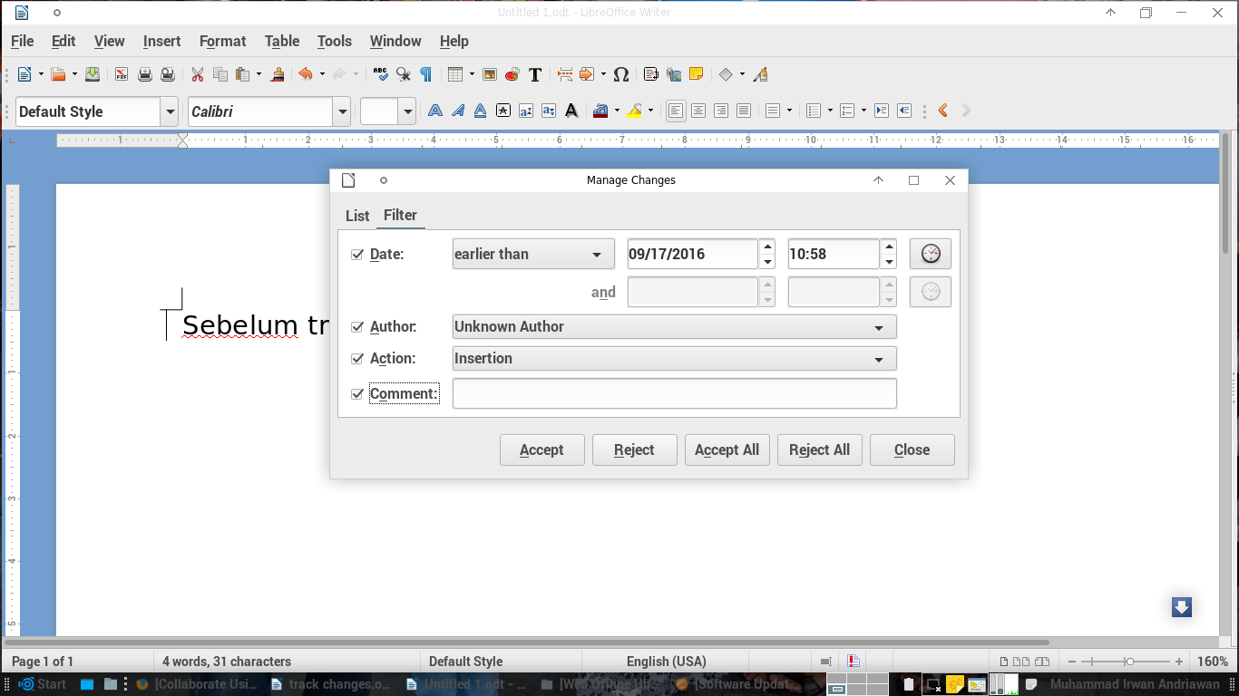
Picture 201: Tab Menu Filter

besides tab menu, there are 5 common button in Manage Changes, they are Accept, Reject, Accept All, Reject All, and Close.
1 | Accept | Accept certain changes to be part of document. When someone else try to make a changes, all his change will be recorded in the list. You as an owner of the document could accept it as a part of document
2 | Reject | In contrary with accept button, reject button deny changes made in document. When you decide to reject certain changes, the document will clear the changes from list and also from content of document itself.
3 | Accept All | This button has the same functionality with accept button, but it will accept all changes record in the list.
4 | Reject All | This button has the same functionality with reject button, but it will deny all changes record in the list.
5 | Close | Close Manage Changes window

Making collaborative editing easier
Advanced implementation of track changes/changes feature could be the best alternative in collaborative document editing. This term will match following circumstance:
- You are an editor or writer who conducting collaborative project and your team spread out in different location.
- You are a graduate student who are in Thesis writing project. You have high scheduled Lecturer as your thesis supervisor
Through track changes feature collaborative editing and writing could possibly be done. In addition, all the feature will make people easily tracking changes in document. It surely makes editing and writing in LibreOffice writer more productive.

CHAPTER 29 MAKING CHART IN LIBREOFFICE WRITER
CHAPTER 29
MAKING CHART
IN LIBREOFFICE WRITER

Copyright © 2016 Taufik Mulyana <nothinux@nothinux.id>
Translated by Muhammad Irwan Andriawan <andriawan2014@gmail.com>

Chart is 2D graphical object which represent value or result in bar, line column chart. If you have assignment to create a graphical chart from certain data, you could Chart feature in LibreOffice. LibreOffice could possibly present graphical data. It makes you easily analyze data and get trend visually.
This following steps will guide you creating graphical chart in LibreOffice Writer:
- Firstly, run your LibreOffice Writer.
- Next, choose Insert menu in menu bar then choose Chart or you could make it fast by clicking chart button on toolbar. You will be automatically served a chart wizard.

Picture 202: Button Chart on Toolbar

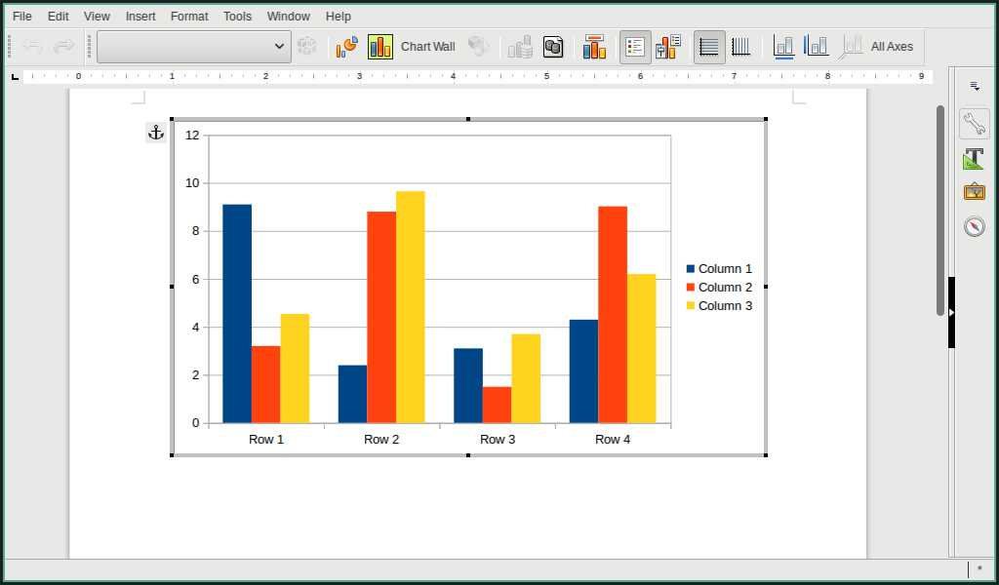
Picture 203: Chart preview

- For instance, we will create graphical data with following information below
Data Pengguna Sistem Operasi PT. Indonesia Merdeka
Nama Sistem Operasi | Tahun 2012 | Tahun 2013 | Tahun 2014 | Tahun 2015
GNU/Linux | 54 | 56 | 60 | 80
OSX | 70 | 75 | 72 | 94
Windows | 144 | 162 | 176 | 215

Table 44: Tabel Data Pengguna Sistem Operasi

- To transform data into chart, choose View menu in menu bar, then choose Data Table, you will be served by form such below.
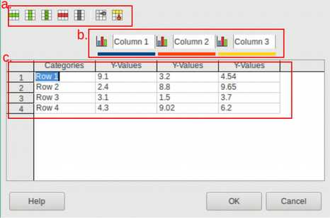
Picture 204: Data Table Form

Brief explanation from illustration above:
- Several option for customizing row.
- Name from column as reference in creating chart.
- Collection of data for creating chart.

- Next step, you could fulfill certain data from previous table such following illustration below.
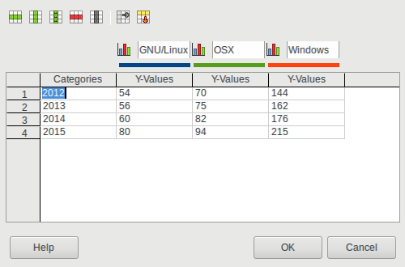
Picture 205: Form Data Table

- Finally, just click OK, you can take following result below.
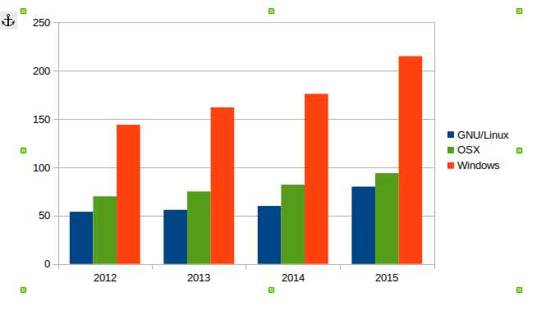
Picture 206: Chart preview

- You could change chart type by choosing Format in menu bar then choose chart type.
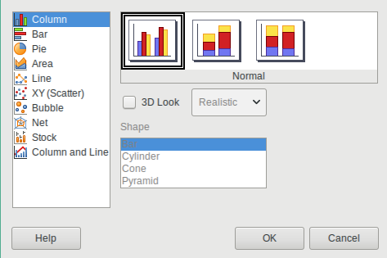
Picture 207: Kind of Chart type

- You can examine variation of interesting chart type. For instance, we will implement chart with Line style.
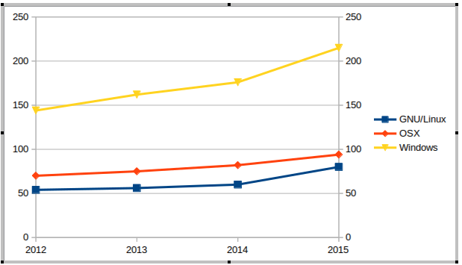
Picture 208: Chart Line type

CHANGELOG
CHANGELOG

This Changelog was written by Taufik Hidayat <yumtaufik1997@gmail.com> as coordinator of Getting Closer With LibreOffice Writer writing project

29 June 2016:
- "Getting Closer With LibreOffice Writer" writing project was started and announced on Telegram group Belajar GNU/Linux Indonesia and Belajar LibreOffice Indonesia.

29 June 2016:
- " Getting Closer With LibreOffice Writer" Changelog was created

16 July 2016 <Rev.1>:
- " Getting Closer With LibreOffice Writer" was started to write.

21 July 2016 <Rev.2>:
- New chapters was added:
- CHAPTER 1 INTRODUCING TO LIBREOFFICE by Ade Malsasa Akbar <teknoloid@gmail.com>,
- CHAPTER 2 INTRODUCING TO LIBREOFFICE WRITER INTERFACE by Muhammad Yuga Nugraha <myugan59@gmail.com>,
- CHAPTER 3 HEADING by Ade Malsasa Akbar <teknoloid@gmail.com>,
- CHAPTER 4 SHORTCUTS ON LIBREOFFICE WRITER by Ade Malsasa Akbar <teknoloid@gmail.com>,
- CHAPTER 5 COMPATIBILITY by Mochammad Nur Afandi <muh.afandi.fandi@gmail.com>,
- CHAPTER 6 HOW TO WRITE ARABIC IN LIBREOFFICE WRITER by Mukafi <kakafi30@gmail.com>,
- CHAPTER 7 CREATING AN AUTOMATIC TABLE OF CONTENT by Taufik Hidayat <yumtaufik1997@gmail.com>,
- CHAPTER 8 PAGE FORMATTING by Anto Samalona <ansamsoftdev@gmail.com>,
- CHAPTER 9 INSERTING PICTURE ON LIBREOFFICE WRITER by Taufik Hidayat <yumtaufik1997@gmail.com>
- CHAPTER 10 CREATING TABLE ON LIBREOFFICE WRITER by Taufik Hidayat <yumtaufik1997@gmail.com>.

22 July 2016 <Rev.3>:
- New chapter was added: CHAPTER 11 SAVING THE DOCUMENT AS A PDF FILE by Taufik Hidayat <yumtaufik1997@gmail.com>.

28 July 2016 <Rev. 4>:
- New chapters was added:
- CHAPTER 12 INSERTING HEADER AND FOOTER IN LIBREOFFICE WRITER by Sasongko Bawono <sasongko262@gmail.com>, dan
- CHAPTER 13 SAVING DOCUMENT by Sasongko Bawono <sasongko262@gmail.com>.

04 August 2016 <Rev.5>:
- New chapter was added: CHAPTER 14 MAKINGE LINE SPACING ON LIBREOFFICE WRITER by Taufik Hidayat <yumtaufik1997@gmail.com>.

08 August 2016 <Rev.6>:
- New chapter was added:, CHAPTER 15 FIND AND SMART REPLACE WITH REGULAR EXPRESSION by Ade Malsasa Akbar <teknoloid@gmail.com>.

11 August 2016 <Rev.7>:
- New chapter was added:, CHAPTER 16 INTRODUCING TO LIBREOFFICE
- WRITER SIDEBAR by Mukafi <kakafi30@gmail.com>, dan
- Adding footer Getting Closer With LibreOffice Writer.

12 August 2016 <Rev.7>:
- Restructuring CHAPTERS based on 2, 4, 5, 6 revisions :
- CHAPTER 1 INTRODUCTION TO LIBREOFFICE by Ade Malsasa Akbar <teknoloid@gmail.com>
- CHAPTER 2 INTRODUCING TO LIBREOFFICE WRITER INTERFACE by Muhammad Yuga Nugraha <myugan59@gmail.com>
- CHAPTER 3 HEADING by Ade Malsasa Akbar <teknoloid@gmail.com> was changed to be CHAPTER 5
- CHAPTER 4 SHORTCUTS ON LIBREOFFICE WRITER by Ade Malsasa Akbar <teknoloid@gmail.com> was changed to be CHAPTER 6
- CHAPTER 5 COMPATABILITY by Mochammad Nur Afandi <muh.afandi.fandi@gmail.com> was changed to be CHAPTER 7
- CHAPTER 6 HOW TO WRITE ARABIC IN LIBREOFFICE WRITER by Mukafi <kakafi30@gmail.com> was changed to be CHAPTER 8
- CHAPTER 7 CREATING AN AUTOMATIC TABLE OF CONTENT by Taufik Hidayat <yumtaufik1997@gmail.com> was changed to be CHAPTER 9
- CHAPTER 10 PAGE FORMATTING by Anto Samalona <ansamsoftdev@gmail.com>,
- CHAPTER 11 INSERTING PICTURE ON LIBREOFFICE WRITER by Taufik Hidayat <yumtaufik1997@gmail.com>,
- CHAPTER 12 CREATING TABLE ON LIBREOFFICE WRITER by Taufik Hidayat <yumtaufik1997@gmail.com>.
- CHAPTER 16 SIDEBAR by Mukafi <kakafi 30@gmail.com> was changed to be CHAPTER 3
- CHAPTER 12 INSERTING HEADER AND FOOTER IN LIBREOFFICE WRITER by Sasongko Bawono <sasongko262@gmail.com> was changed to be CHAPTER 14
- CHAPTER 13 SAVING DOCUMENT by Sasongko Bawono <sasongko262@gmail.com> was changed to be CHAPTER 15
- CHAPTER 14 MAKING LINE SPACING ON LIBREOFFICE WRITER by Taufik Hidayat <yumtaufik1997@gmail.com> was changed to be CHAPTER 16
- CHAPTER 15 FIND AND SMART REPLACE WITH REGULAR EXPRESSION by Ade Malsasa Akbar <teknoloid@gmail.com> was changed to be CHAPTER 17

13 August 2016 <Rev.7.1>:
- Adding new term in technical guide preparation section, it was LibreOffice version which would be used to contribute. It should be in default appearance.

14 August 2016 <Rev.8>:
- Adding new CHAPTER, CHAPTER 17 GETTING FAMILIAR WITH SUB-SUB MENU IN LIBREOFFICE WRITER MENU by Taufik Hidayat <yumtaufik1997@gmail.com>,
- Restructuring CHAPTERS, CHAPTER 17 was changed to be CHAPTER 4 followed by CHAPTER 4 to be CHAPTER 5
- Restructuring the writer’s names. They were changed to be the contributors
- Adding editor and cover contributor’s name. They are Farah Clara <farah@biawaktamvan.web.id> dan Ade Malsasa Akbar
- Updating number of page target from 100 pages to be 150 pages

19 August 2016 <Rev.8>:
- Adding new CHAPTER, CHAPTER 18 MAIL MERGE IN LIBREOFFICE WRITER by Nur Kholis <khokunsmile@gmail.com>
- Adding new CHAPTER, CHAPTER 19 EYE PROTECTION PAPER IN LIBREOFFICE WRITER by Azis Pratama Akbar <aziz.pratama@gmail.com>.
20 August 2016 <Rev.8>:
- Changing The Contributors section in Editor and Language editor. Editor is Nur Kholis <khokunsmile@gmail.com> and Language Editor is Farah Clara <farah@biawaktamvan.web.id>.

22 August 2016 <Rev.8>:
- Changing Technical Book Preparation section in The number of the book which previously 150 to be 160 pages.

24 August 2016 <Rev.9>:
- Adding new CHAPTER, CHAPTER 20 INTRODUCTION TO GRAPHIC EDITING IN LIBREOFFICE WRITER by Azid <paindustry@yahoo.com>,
- Changing Technical Book Preparation section in The number of the book which previously 160 to be 170 pages.
- Changing several names in CHAPTER 4 in term of Sub-Sub Menu on Menu Bar LibreOffice Writer by Taufik Hidayat <yumtaufik1997@gmail.com> . They were changed to be Menu Bar in LibreOffice Writer.

25 August 2016 <Rev.10>:
- Adding new CHAPTER, CHAPTER 21 INTRODUCING TO OPENDOCUMENT FORMAT by Ade Malsasa Akbar <teknoloid@gmail.com>,
- Changing Technical Book Preparation section in The number of the book which previously 170 to be 180 pages.
- Restructuring CHAPTERS based on 7, 8, 9 revisions:
  - CHAPTER 1 INTRODUCTION TO LIBREOFFICE by Ade Malsasa Akbar <teknoloid@gmail.com>
  - CHAPTER 2 INTRODUCING TO LIBREOFFICE WRITER INTERFACE by Muhammad Yuga Nugraha <myugan59@gmail.com> was changed to be CHAPTER 3
  - CHAPTER 3 SIDEBAR by Mukafi <kakafi 30@gmail.com> was changed to be CHAPTER 4
  - CHAPTER 4 GETTING FAMILIAR WITH SUB-SUB MENU IN LIBREOFFICE WRITER MENU by Taufik Hidayat <yumtaufik1997@gmail.com> was changed to be CHAPTER 5
  - CHAPTER 5 HEADING by Ade Malsasa Akbar <teknoloid@gmail.com> was changed to be CHAPTER 6
  - CHAPTER 6 SHORTCUTS ON LIBREOFFICE WRITER by Ade Malsasa Akbar <teknoloid@gmail.com> was changed to be CHAPTER 7
  - CHAPTER 7 COMPATIBILITY by Mochammad Nur Afandi <muh.afandi.fandi@gmail.com> was changed to be CHAPTER 8
  - CHAPTER 8 HOW TO WRITE ARABIC IN LIBREOFFICE WRITER by Mukafi <kakafi30@gmail.com> was changed to be CHAPTER 9
  - CHAPTER 9 CREATING AN AUTOMATIC TABLE OF CONTENT by Taufik Hidayat <yumtaufik1997@gmail.com> was changed to be CHAPTER 10
  - CHAPTER 10 PAGE FORMATTING by Anto Samalona <ansamsoftdev@gmail.com> was changed to be CHAPTER 11
  - CHAPTER 11 tentang Menyisipkan Picture pada LibreOffice Writer oleh Taufik Hidayat <yumtaufik1997@gmail.com> menjadi CHAPTER 12,
  - CHAPTER 12 INSERTING PICTURE ON LIBREOFFICE WRITER by Taufik Hidayat <yumtaufik1997@gmail.com> was changed to be CHAPTER 13,
  - CHAPTER 13 SAVING THE DOCUMENT AS A PDF FILE by Taufik Hidayat <yumtaufik1997@gmail.com> was changed to be CHAPTER 14
  - CHAPTER 14 INSERTING HEADER AND FOOTER IN LIBREOFFICE WRITER by Sasongko Bawono <sasongko262@gmail.com> was changed to be CHAPTER 15
  - CHAPTER 15 SAVING DOCUMENT by Sasongko Bawono <sasongko262@gmail.com> was changed to be CHAPTER 16
  - CHAPTER 16 MAKING LINE SPACING ON LIBREOFFICE WRITER by Taufik Hidayat <yumtaufik1997@gmail.com> was changed to be CHAPTER 17
  - CHAPTER 17 FIND AND SMART REPLACE WITH REGULAR EXPRESSION by Ade Malsasa Akbar <teknoloid@gmail.com> was changed to be CHAPTER 18
  - CHAPTER 18 MAIL MERGE IN LIBREOFFICE WRITER by Nur Kholis <khokunsmile@gmail.com> was changed to be CHAPTER 19
  - CHAPTER 19 EYE PROTECTION PAPER IN LIBREOFFICE WRITER by Azis Pratama Akbar <aziz.pratama@gmail.com> was changed to be CHAPTER 20
  - CHAPTER 20 INTRODUCTION TO GRAPHIC EDITING IN LIBREOFFICE WRITER by Azid <paindustry@yahoo.com> was changed to be CHAPTER 21
  - CHAPTER 21 INTRODUCING TO OPENDOCUMENT FORMAT by Ade Malsasa Akbaar <teknoloid@gmail.com> was changed to be CHAPTER 2.

26 August 2016 <Rev.11>:
- Adding new CHAPTER, CHAPTER 22 PRINTING ADDRESS LABELS IN LIBREOFFICE WRITER by Sukamto <kamtono@gmail.com>,
- Changing Technical Book Preparation section in The number of the book which previously 170 to be 200 pages and changing deadline of project from 30 August 2016 to 20 September 2016.

27 August 2016 <Rev.12>:
- Adding new CHAPTER, CHAPTER 23 ARABIC BUCKWALTER CONFIGURATION IN LIBRE OFFICE WRITER by Buono <kangbuono@gmail.com>
- Adding new CHAPTER, CHAPTER 24 LIBREOFFICE MOBILITY by Rahmat Kafabih (Kafabih/KR) <kafalterbang@gmail.com>

28 August 2016 <Rev 13>:
- Adding new CHAPTER, CHAPTER 25 INSERTING MATH FORMULA ON LIBREOFFICE WRITER by Nur Kholis <khokunsmile@gmail.com>
- Adding new CHAPTER, CHAPTER 26 PRINTING DOCUMENTS ON LIBREOFFICE WRITER by Buono <kangbuono@gmail.com>
- Changing Technical Book Preparation section in The number of the book which previously 200 to be 210 pages

01 September 2016 <Rev.14>:
- Adding new CHAPTER, CHAPTER 27 WORKING WITH LIBREOFFICE EXTENSION by Nur Kholis <khokunsmile@gmail.com>,
- Changing Technical Book Preparation section in The number of the book which previously 210 to be 210 pages

12 September 2016 <Rev.15>:
- Changing The Contributors section in adding sub section Language Editor
- Adding new sub CHAPTER sub in CHAPTER 1 by Ade Malsasa Akbar <teknoloid@gmail.com>
- Language editing in CHAPTER 1 by Ahmad Romadhon Hidayatullah <reaamina@gmail.com> dan Ade Malsasa Akbar <teknoloid@gmail.com>
- Language editing in CHAPTER 2 by Ade Malsasa Akbar <teknoloid@gmail.com>

18 September 2016 <Rev.16>:
- Changing The Contributors section in Language editing CHAPTER 21 by Nugroho <nugroho.redbuff@gmail.com>
- Adding new CHAPTER CHAPTER 28 WORKING WITH TRACK CHANGES by Muhammad Irwan Andriawan <andriawan2014@gmail.com>
- Changing Technical Book Preparation section in deadline from 20 September 2016 to be 20 October 2016,
- Changing sub Deadline in Preface in term of deadline from 20 September 2016 to be 30 October 2016.

24 September 2016 <Rev.16>:
- Changing The Contributors section in Language editing CHAPTER 1 until CHAPTER 4 by Faiq Aminuddin <dampuawang@gmail.com>

7 October 2016 <Rev.17>:
- Changing The Contributors section in Language editing CHAPTER 14 by Ahmad Romadhon Hidayatullah <reaamina@gmail.com>
- Changing The Contributors section in Language editing CHAPTER 5 until CHAPTER 7 by Faiq Aminuddin <dampuawang@gmail.com>.
20 October 2016 <Rev.18>:
- Changing The Contributors section in Language editing CHAPTER 7 by Taufik Hidayat <yumtaufik1997@gmail.com>.
23 October 2016 <Rev.19>:
- Changing The Contributors section in Layout editing CHAPTER 5 by Andhika Prasetyo <chupunk3@gmail.com> and CHAPTER 4 by Taufik Hidayat <yumtaufik1997@gmail.com>
- Changing The Contributors section in adding new book editor in sub CHAPTER by Taufik Hidayat <yumtaufik1997@gmail.com> and Abdul Aziz <ingejosmu1048576@gmail.com>,
- Adding new CHAPTER, CHAPTER 29 MAKING CHART IN LIBREOFFICE WRITER by Taufik Mulyana <nothinux.id>

24 October 2016 <Rev.20>:
- Updating Preface in term of cover contributors, Language editor, Book editor and CHAPTER contributors and also promoting the usage of free software after Bibliography

29 October 2016 (Rev.20):
- Updating The Contributors section in sub CHAPTER Book editor CHAPTER until CHAPTER 29 by Faiq Aminuddin <dampuawang@gmail.com>,
- Layout editing by Taufik Hidayat <yumtaufik1997@gmail.com>,
- Updating Preface in the number of pages from 219 to be 235 pages.

30 October 2016 (Final):
- Updating book layout by Taufik Hidayat <yumtaufik1997@gmail.com> for mobile version
- Releasing printed ready book by Taufik Hidayat <yumtaufik1997@gmail.com>,
- Releasing mobile version book by Taufik Hidayat <yumtaufik1997@gmail.com>,
- The book was released in 30 October 2016.

TRANSLATION CHANGELOG
TRANSLATION CHANGELOG

This Changelog was written by Muhammad Irwan Andriawan <andriawan2014@gmail.com> as coordinator of Getting Closer With LibreOffice Writer translation project book. The books was translated from Bahasa Indonesia to English. This changelog was made to differ Writing project and Translation project in one book.

28 July 2017:
- Translation project was initiated by Muhammad Irwan Andriawan <andriawan2014@gmail.com> followed by creation of Telegram group “Project Translasi”
- Muhammad Irwan Andriawan <andriawan2014@gmail.com> uploaded the first translation of Preface, The Contributors, Technical Book Preparation sections to the group.

29 July 2017:
- The translated CHAPTER 8 COMPATIBILITY was submitted by Mochammad Nur Afandi <localanu@gmail.com> to Telegram group
- Muhammad Irwan Andriawan reviewed The translated CHAPTER 8 COMPATIBILITY from Mochammad Nur Afandi <localanu@gmail.com>
- Taufik Hidayat <yumtaufik1997@gmail.com> uploaded master file of Getting Closer With LibreOffice Writer book in Bahasa for reference. It would be a reference in translating chapters in English.

31 July 2017:
- The translated CHAPTER 1 INTRODUCTION TO LIBREOFFICE was submitted by Muhammad Fathurridlo <mfathurridlo@gmail.com> to Telegram group

1 August 2017:
- Muhammad Irwan Andriawan <andriawan2014@gmail.com> submitted The translated CHAPTER 28 WORKING WITH TRACK CHANGES to Telegram group
- Muhammad Irwan Andriawan <andriawan2014@gmail.com> reviewed The translated CHAPTER 1 INTRODUCTION TO LIBREOFFICE from Muhammad Fathurridlo <mfathurridlo@gmail.com>
- Muhammad Fathurridlo <mfathurridlo@gmail.com > accepted review The translated CHAPTER 1 INTRODUCTION TO LIBREOFFICE from Muhammad Irwan Andriawan <andriawan2014@gmail.com>

4 August 2017:
- Raymon Rahmadhani <raymon.rahmadhani@gmail.com> submitted The translated CHAPTER 2 INTRODUCING TO OPENDOCUMENT FORMAT to Telegram group
- Muhammad Irwan Andriawan <andriawan2014@gmail.com> reviewed The translated CHAPTER 2 INTRODUCING TO OPENDOCUMENT FORMAT from Raymon Rahmadhani <raymon.rahmadhani@gmail.com>
- Muhammad Fathurridlo <mfathurridlo@gmail.com> submitted The translated CHAPTER 3 INTRODUCING TO LIBREOFFICE WRITER INTERFACE and CHAPTER 4 INTRODUCING TO LIBREOFFICE WRITER SIDEBAR to Telegram group
- Muhammad Irwan Andriawan <andriawan2014@gmail.com> reviewed The translated CHAPTER 3 and CHAPTER 4 from Muhammad Fathurridlo <mfathurridlo@gmail.com>
- Muhammad Irwan Andriawan <andriawan2014@gmail.com> submitted the translated CHAPTER 29 MAKING CHART IN LIBREOFFICE WRITER to Telegram group
- Raymon Rahmadhani <raymon.rahmadhani@gmail.com> reviewed the translated CHAPTER 29 MAKING CHART IN LIBREOFFICE WRITER from Muhammad Irwan Andriawan <andriawan2014@gmail.com>

6 August 2017:
- Ilham Akbar <ilhamsahil05@gmail.com> submitted the translated CHAPTER 6 HEADING to Telegram group
- Muhammad Irwan Andriawan <andriawan2014@gmail.com> reviewed the translated CHAPTER 6 HEADING from Ilham Akbar <ilhamsahil05@gmail.com>
- kucingsebelah <meongpus@hi2.in> submitted the translated CHAPTER 11 PAGE FORMATTING to Telegram group
- Ilham Akbar <ilhamsahil05@gmail.com> submitted the translated CHAPTER 7 SHORTCUTS ON LIBREOFFICE WRITER to Telegram group
- Thoriq Kemal <thoriqcemal@gmail.com> submitted the translated CHAPTER 12 INSERTING PICTURE ON LIBREOFFICE WRITER and CHAPTER 13 CREATING TABLE ON LIBREOFFICE WRITER to Telegram group
- Raymon Rahmadhani <raymon.rahmadhani@gmail.com> accepted feedback from Muhammad Irwan Andriawan <andriawan2014@gmail.com> on The translated CHAPTER 2 INTRODUCING TO OPENDOCUMENT FORMAT to Telegram group
- Muhammad Irwan Andriawan <andriawan2014@gmail.com> submitted the translated CHAPTER 27 WORKING WITH LIBREOFFICE EXTENSION to Telegram group
- <ari> submitted the translated CHAPTER 26 PRINTING DOCUMENTS ON LIBREOFFICE WRITER to Telegram group
- Muhammad Irwan Andriawan <andriawan2014@gmail.com> reviewed the translated CHAPTER 7 SHORTCUTS ON LIBREOFFICE WRITER from Ilham Akbar <ilhamsahil05@gmail.com>
- Muhammad Irwan Andriawan <andriawan2014@gmail.com> reviewed the translated CHAPTER 11 PAGE FORMATTING from kucingsebelah <meongpus@hi2.in>
- Muhammad Fathurridlo <mfathurridlo@gmail.com> was accepted feedback from Muhammad Irwan Andriawan <andriawan2014@gmail.com> on The translated CHAPTER 3 INTRODUCING TO LIBREOFFICE WRITER
- INTERFACE and CHAPTER 4 INTRODUCING TO LIBREOFFICE WRITER SIDEBAR

7 August 2017:
- Raymon Rahmadhani <raymon.rahmadhani@gmail.com> submitted The translated CHAPTER 9 HOW TO WRITE ARABIC IN LIBREOFFICE WRITER to Telegram group
- Raymon Rahmadhani <raymon.rahmadhani@gmail.com> submitted The translated CHAPTER 10 CREATING AN AUTOMATIC TABLE OF CONTENT to Telegram group
- Thoriq Kemal <thoriqcemal@gmail.com> submitted the translated CHAPTER 25 INSERTING MATH FORMULA ON LIBREOFFICE WRITER to Telegram group
- Ilham Akbar <ilhamsahil05@gmail.com> submitted the translated CHAPTER 14 SAVING THE DOCUMENT AS A PDF FILE to Telegram group

8 August 2017:
- Muhammad Irwan Andriawan <andriawan2014@gmail.com> reviewed the translated CHAPTER 26 PRINTING DOCUMENTS ON LIBREOFFICE WRITER from <ari>
- Astrida Atni Ayu Mahardini <astriddini7@gmail.com> submitted the translated CHAPTER 5 GETTING ACQUAINTED WITH THE MENU BAR IN LIBREOFFICE WRITER to Telegram group
- Muhammad Irwan Andriawan <andriawan2014@gmail.com> reviewed the translated CHAPTER 10 CREATING AN AUTOMATIC TABLE OF CONTENT from Raymon Rahmadhani <raymon.rahmadhani@gmail.com>
- Muhammad Irwan Andriawan <andriawan2014@gmail.com> reviewed the translated CHAPTER 25 INSERTING MATH FORMULA ON LIBREOFFICE WRITER from Thoriq Kemal <thoriqcemal@gmail.com>

10 August 2017:
- Raymon Rahmadhani <raymon.rahmadhani@gmail.com> submitted revision of the translated CHAPTER 10 CREATING AN AUTOMATIC TABLE OF CONTENT from Raymon Rahmadhani <raymon.rahmadhani@gmail.com> to Telegram group

13 August 2017:
- Muhammad Irwan Andriawan <andriawan2014@gmail.com> reviewed the translated CHAPTER 12 INSERTING PICTURE ON LIBREOFFICE WRITER and CHAPTER 13 CREATING TABLE ON LIBREOFFICE WRITER from Thoriq Kemal <thoriqcemal@gmail.com>
- Muhammad Irwan Andriawan <andriawan2014@gmail.com> reviewed the translated CHAPTER 14 SAVING THE DOCUMENT AS A PDF FILE from Ilham Akbar <ilhamsahil05@gmail.com>
- Muhammad Irwan Andriawan <andriawan2014@gmail.com> reviewed the translated CHAPTER 5 GETTING ACQUAINTED WITH THE MENU BAR IN LIBREOFFICE WRITER from Astrida Atni Ayu Mahardini <astriddini7@gmail.com>

15 August 2017:
- Muhammad Irwan Andriawan <andriawan2014@gmail.com> submitted the translated CHAPTER 24 LIBREOFFICE MOBILITY to Telegram group

20 August 2017:
- Astrida Atni Ayu Mahardini <astriddini7@gmail.com> submitted the translated CHAPTER 17 MAKING LINE SPACING ON LIBREOFFICE WRITER and CHAPTER 18 FIND AND SMART REPLACE WITH REGULAR EXPRESSION to Telegram group

21 August 2017:
- Muhammad Irwan Andriawan <andriawan2014@gmail.com> reviewed the translated CHAPTER 17 MAKING LINE SPACING ON LIBREOFFICE WRITER from Astrida Atni Ayu Mahardini <astriddini7@gmail.com>
- Azis R. Pratama <azis.pratama@gmail.com> submitted the translated CHAPTER 20 EYE PROTECTION PAPER IN LIBREOFFICE WRITER to Telegram group

22 August 2017:
- Muhammad Irwan Andriawan <andriawan2014@gmail.com> reviewed the translated CHAPTER 18 FIND AND SMART REPLACE WITH REGULAR EXPRESSION from Astrida Atni Ayu Mahardini <astriddini7@gmail.com>
- Muhammad Irwan Andriawan <andriawan2014@gmail.com> reviewed the translated CHAPTER 20 EYE PROTECTION PAPER IN LIBREOFFICE WRITER from Azis R. Pratama <azis.pratama@gmail.com>

25 August 2017:
- Azis R. Pratama <azis.pratama@gmail.com> submitted the translated CHAPTER 23 ARABIC BUCKWALTER CONFIGURATION IN LIBRE OFFICE WRITER to Telegram group

27 August 2017:
- kucingsebelah <meongpus@hi2.in> submitted the translated CHAPTER 16 SAVING DOCUMENT to Telegram group

29 August 2017:
- Faiq Aminuddin <faiq.aminuddin.demak@gmail.com> submitted the translated CHAPTER 15 INSERTING HEADER AND FOOTER IN LIBREOFFICE WRITER to Muhammad Irwan Andriawan <andriawan2014@gmail.com>

1 September 2017:
- Astrida Atni Ayu Mahardini <astriddini7@gmail.com> submitted the translated CHAPTER 19 MAIL MERGE IN LIBREOFFICE WRITER and
- CHAPTER 22 PRINTING ADDRESS LABELS IN LIBREOFFICE WRITER to Telegram group

3 September 2017:
- Muhammad Irwan Andriawan <andriawan2014@gmail.com> reviewed the translated CHAPTER 16 SAVING DOCUMENT from kucingsebelah <meongpus@hi2.in>
- Muhammad Irwan Andriawan <andriawan2014@gmail.com> reviewed the translated CHAPTER 15 INSERTING HEADER AND FOOTER IN LIBREOFFICE WRITER from Faiq Aminuddin <faiq.aminuddin.demak@gmail.com>
- Muhammad Irwan Andriawan <andriawan2014@gmail.com> reviewed the translated CHAPTER 23 ARABIC BUCKWALTER CONFIGURATION IN LIBRE OFFICE WRITER from Azis R. Pratama <azis.pratama@gmail.com>
- Muhammad Irwan Andriawan <andriawan2014@gmail.com> reviewed the translated CHAPTER 22 PRINTING ADDRESS LABELS IN LIBREOFFICE WRITER from Astrida Atni Ayu Mahardini <astriddini7@gmail.com>
- Muhammad Irwan Andriawan <andriawan2014@gmail.com> reviewed the translated CHAPTER 19 MAIL MERGE IN LIBREOFFICE WRITER from Astrida Atni Ayu Mahardini <astriddini7@gmail.com>

20 September 2017:
- Risma Fahrul Amin <rismafahrulamin@gmail.com> submitted the translated CHAPTER 21 INTRODUCING TO GRAPHIC IN LIBREOFFICE WRITER to Muhammad Irwan Andriawan <andriawan2014@gmail.com>

20 October 2017:
- Muhammad Irwan Andriawan <andriawan2014@gmail.com> changed original cover of the book

2 November 2017:
- Muhammad Irwan Andriawan <andriawan2014@gmail.com> released the final translated book

http://acciejie.blogspot.co.id/2013/03/membaca-grafik-tabel-dan-bentuk.html diakses pada 22 Juli 2016
https://youtu.be/82zki30bQWU for applied Dracula color theme in video format.
http://github.com/dracula/dracula-theme

